**guildKraft**

**Functional Guide**



**By**

**digiBilitz Technologies Pvt Ltd**.

**Table of Content**

1 Introduction 7

2 Registration module 17

3 Login module 18

4 Admin Role – Dashboard 18

5 Event Organizer – Dashboard 19

6 Area Chair - Dashboard 20

7 Forgot Password 20

8 My Profile 21

8.1 Edit Profile 21

8.2 Change Password 21

8.3 Profile details 21

8.4 Plan and Package 21

8.5 Security 22

9 Index page 22

10 Advertise Management 23

10.1 Manage Issues 23

10.1.1 Create Issues 23

10.1.2 List / Edit / Delete Issues 24

10.2 Advertisement 24

10.2.1 My Request Status 24

10.3 Manage Media 25

10.3.1 Create Media Type 25

10.3.2 Delete / List / Edit Media Type 26

10.4 Manage Display Types 27

10.4.1 Create Display Type 27

10.4.2 Delete / List / Edit Display Type 28

10.5 Manage Advertisement Requests 28

10.5.1 List advertisement Requests 28

10.6 Manage Dimensions 29

10.6.1 Create Dimension Type 29

10.6.2 Delete / List / Edit Dimension Type 30

10.7 Manage Display sub Types 31

10.7.1 Create Display Sub Type 31

10.7.2 Delete / List / Edit Display sub Type 32

11 Artifact Management 33

11.1 Manage Framework Level 33

11.1.1 Artifact Mappings 33

11.1.2 Group Level Master 34

11.1.3 Mapping View Point Master 34

12 Customer Support Management 36

12.1 Manage Customer 36

12.1.1 Search 36

13 Life Cycle Management 37

13.1 Life Cycle Process 37

13.1.1 Create Life Cycle Process 37

14 Meetings and Events 38

14.1 Events 38

14.1.1 View All Event Report 38

14.2 Manage Event Registrations 39

14.2.1 Event Requests 39

14.2.2 List Event Requests 39

14.2.3 List Omnibus Requests 40

14.3 Membership 41

14.3.1 Apply Refund 41

14.3.2 Refund Request List 41

14.4 Manage EDU Registration 43

14.4.1 Manage EDU Organizer Event List 43

14.5 Manage OE Price Items 43

14.5.1 Add New OE Price Item 43

14.5.2 List All OE Price Items 44

14.5.3 List OE Fixed Price Items 45

14.5.4 Set OE Fixed Price Items 45

14.6 Annual Convention Registration 46

14.6.1 List Annual Meeting Registration 46

14.7 Manage Role 47

14.7.1 Assign Roles Securities 47

14.7.2 Assign Roles to user 47

14.7.3 Maintain Roles 49

14.7.4 Mapping Role with Entities 50

14.8 Manage Member Registration 51

14.8.1 List Registered Members 51

14.8.2 New Member Registration 51

14.8.3 Search members and Users 52

14.9 Manage Event Types 52

14.9.1 Add Event Type 52

14.9.2 List Event Type 53

14.10 Manage Event Result Data 54

14.10.1 Map Event Result Field with Type 54

14.10.2 Upload Event Result 55

14.11 EDU Activity Registration 55

14.11.1 EDU Activity Registration 55

14.11.2 List Activity Request 57

14.11.3 List User Request 57

14.12 Manage Event Registration Price 58

14.12.1 List All Event Registration Price 58

14.12.2 Set Event Registration Price 59

14.13 EDU Activity User Registration 59

14.13.1 Apply EDU Activity 59

14.13.2 List EDU Activity Requests 60

14.14 Manage Event Divisions 61

14.14.1 Add Event Divisions 61

14.14.2 List Event Divisions 61

14.15 Area and Area Chair Mapping 63

14.15.1 Listing Area Chair and Area Person 63

14.15.2 Mapping Area Chair and Area Person 64

14.15.3 Mapping Area State Zip 64

14.16 Manage Event Registration Data 65

14.16.1 List Uploaded Event Registration Data 65

14.16.2 Map Event Level with Membership type 66

14.16.3 Upload Event Registration Data 66

14.16.4 Validate Qualification 67

14.17 Event Calendar 67

14.17.1 Search Event 67

14.17.2 View Event Calendars 68

14.17.3 View My Event Registrations 69

14.18 My Events 69

14.18.1 Approve Event Registrations 69

14.18.2 List Posted Events 70

14.18.3 Register New Events 71

14.18.4 View Event Details 71

14.19 Join and Renew 72

14.19.1 Join as Member 72

14.19.2 Renew/Upgrade My Membership 72

14.20 Manage Annual Meetings 73

14.20.1 List Annual Convention Registrations 73

14.20.2 List Annual Meeting price 73

14.20.3 Set Annual Meeting price 75

14.20.4 Set Annual Meeting Registration Date 75

14.21 Manage Event Levels 76

14.21.1 Add Event Level 76

14.21.2 List Event Level 77

14.21.3 Map Event Level 78

15 Membership Management 79

15.1 My Refund 79

15.1.1 Apply Refund 79

15.1.2 List refunds 79

15.1.3 My Refunds 80

15.2 Manage Member Registration 80

15.2.1 List Registered Members 80

15.2.2 New Member Registration 81

15.2.3 Search Members and Users 81

15.3 Manage User Registration 83

15.3.1 List Registered Users 83

15.4 Manage Refund Request 84

15.4.1 Approved Refund Request 84

15.4.2 List All Over Payments 84

15.4.3 Pending Refund Requests 85

15.5 Manage Membership Types 86

15.5.1 List of Human Members 86

16 Online Entries 87

16.1 OE Result 87

16.1.1 List OE Result 87

16.2 Manage OE Price Items 87

16.2.1 Add New OE Price Items 87

16.2.2 List All OE Price Items 88

16.2.3 List OE Fixed Price Details 89

16.2.4 Set OE Fixed Price Details 89

16.3 Manage Qualification Matrix 90

16.3.1 Create Qualification Validation 90

16.3.2 Map Championship Levels 91

16.3.3 View Qualification Matrix 91

16.4 Event Calendar 92

16.4.1 Search Events 92

16.4.2 View Event Calendar 93

16.5 Manage Provisional Event Calendar 93

16.5.1 Approve Provisional Calendar 93

16.5.2 Create Provisional Calendar 94

17 Process Management 95

17.1 Business Process 95

17.1.1 Business Process Voting List 95

17.1.2 List of Business Processes 96

17.1.3 Move BP Life Cycle Stage 97

18 Report Management 98

18.1 Events 98

18.1.1 View All Report Events 98

18.2 Members 99

18.2.1 View All Membership Report 99

19 Reports 100

19.1 Manage Additional Reports 100

19.1.1 Report List 100

19.1.1.1 Daily sales Report 100

19.1.1.2 Monthly Sales Report 102

19.1.1.3 Yearly Sales Report – Area Wise 103

20 Role Management 104

20.1 Manage Mapping 104

20.1.1 Mapping Entity with Privileges 104

20.1.2 Mapping Privileges with Permission 104

20.1.3 Mapping Role with Entities 105

20.1.4 Mapping Role with entities and Privileges 106

20.2 Privileges 106

20.2.1 Create privileges 106

20.2.2 Edit List of Privileges 107

20.3 Manage Role 108

20.3.1 Assign Roles Securities 108

20.3.2 Assign Roles To User 109

20.3.3 Maintain Roles 110

20.3.4 Mapping Role with Entities 110

20.4 Manage Entity 111

20.4.1 Create Entities 111

20.4.2 View edit List of Entities 112

20.5 Permission 113

20.5.1 Create Permission 113

20.5.2 Edit List of Permission 113

21 Service Management 114

21.1 Web Service 114

21.1.1 BS Voting List 114

21.1.2 List of Business services 115

21.1.3 Move BS Life Cycle Stage 116

# Introduction

**Following are the steps to create a dynamic web project guildKraft:**

**Step 1:** Open the eclipse and create Dynamic Web Project. Like this.

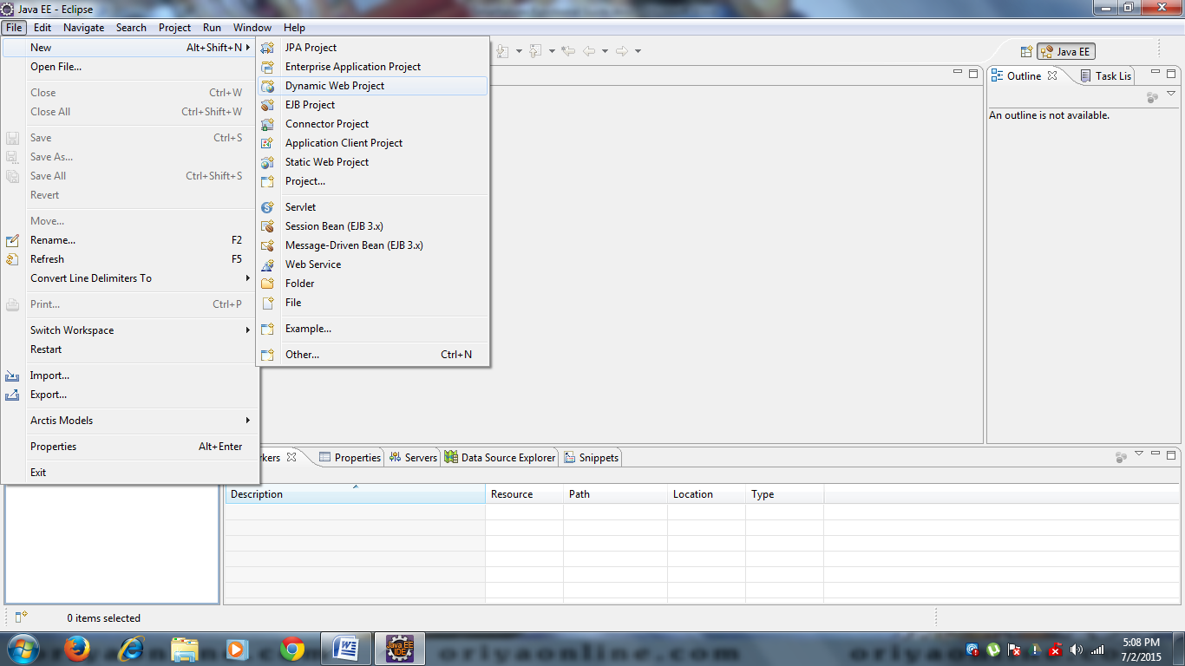

**Step 2:** Enter project name and set Target run time.

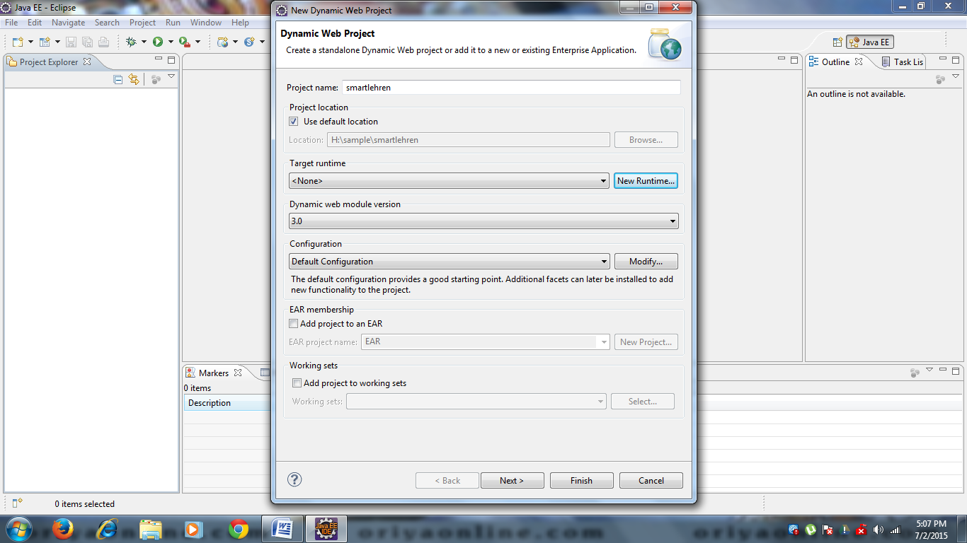

**Step 3:** if click New Runtime following screen will appear and select JBoss4.2 and click Next Button.

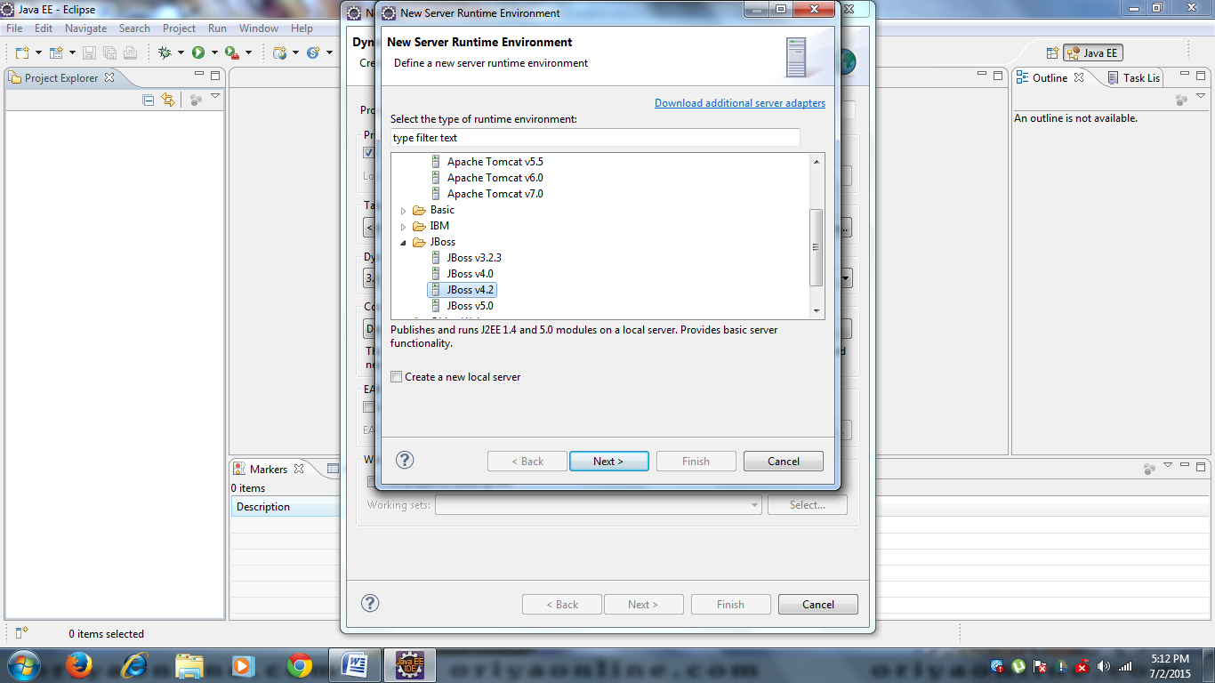

**Step 4:**Click Browse button and select JBoss folder from your Drive then click finish.

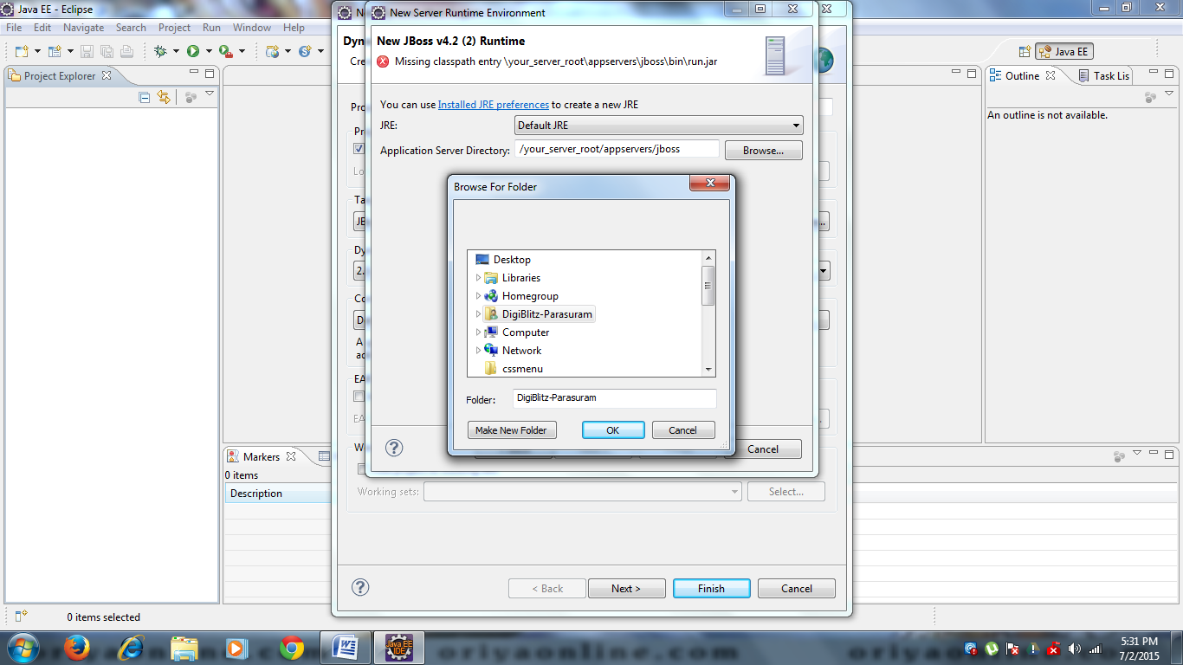

**Step 5:** After select Runtime screen will be like this and click Finish.

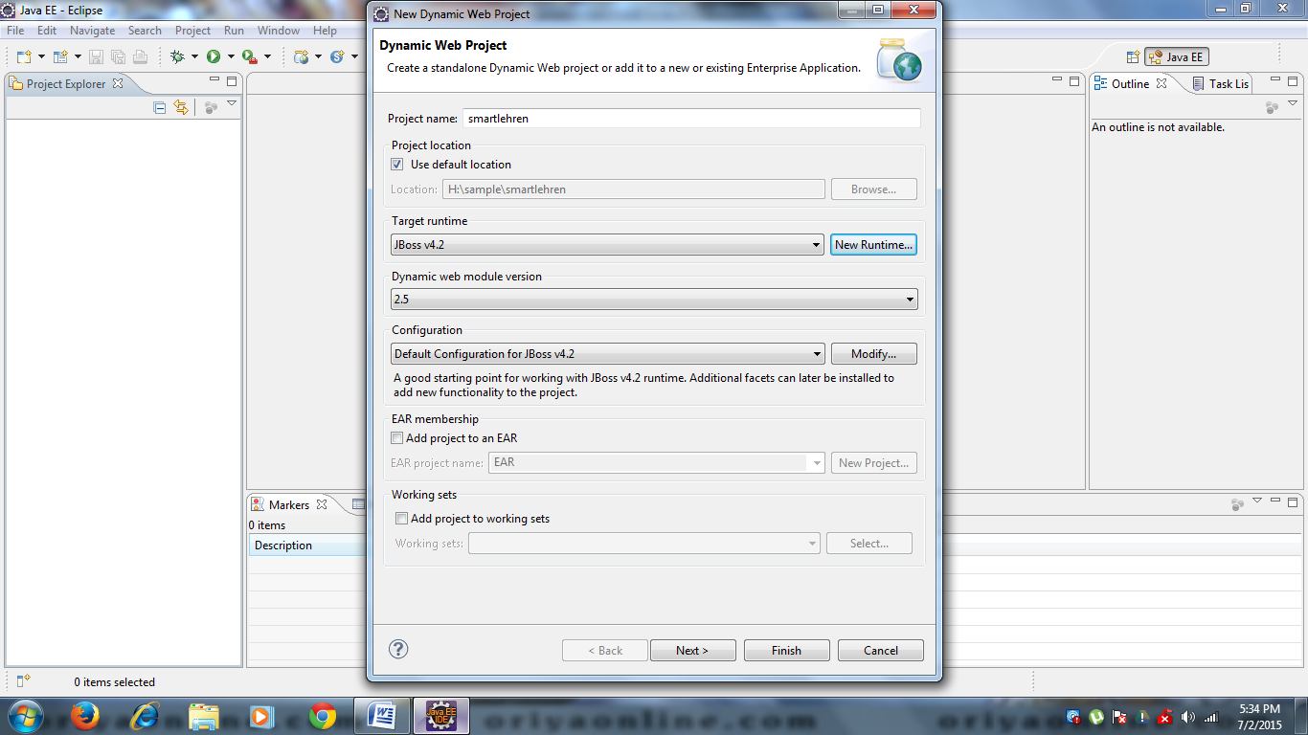

**Step 6:**Now guildKraft Project work space is ready.

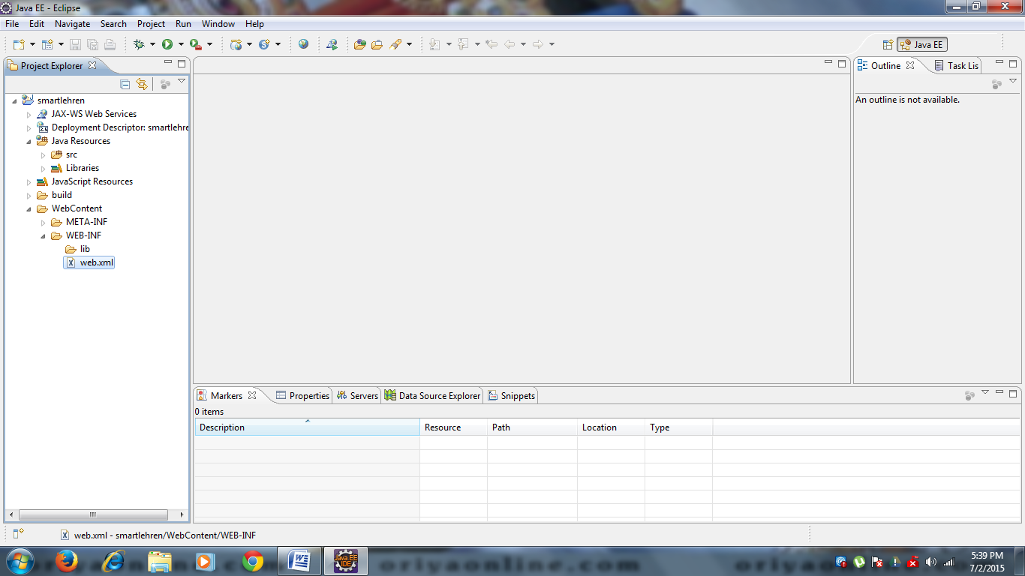

**Step 7:** Open web.xml file. web.xml file is main important for project. It will handle servlet mapping. Add this following code.

<?xml version="1.0" encoding="UTF-8"?>

<web-app id="WebApp_ID" version="2.4" xmlns="http://java.sun.com/xml/ns/j2ee" xmlns:xsi="http://www.w3.org/2001/XMLSchema-instance" xsi:schemaLocation="http://java.sun.com/xml/ns/j2ee http://java.sun.com/xml/ns/j2ee/web-app_2_4.xsd">

<display-name>Main Application</display-name>

<servlet>

<servlet-name>spring</servlet-name>

<servlet-class>org.springframework.web.servlet.DispatcherServlet</servlet-class>

<init-param>

<param-name>spring</param-name>

<param-value>/WEB-INF/spring-servlet.xml</param-value>

</init-param>

<load-on-startup>1</load-on-startup>

</servlet>

<servlet-mapping>

<servlet-name>spring</servlet-name>

<url-pattern>*.html</url-pattern>

</servlet-mapping>

<welcome-file-list>

<welcome-file>

frmHome.jsp

</welcome-file>

</welcome-file-list>

</web-app>

**Step 8:** add spring-servlet.xml in WebContent\WEB-INF\... it is Spring MVC Controller

<?xml version="1.0" encoding="UTF-8"?>

<beans xmlns="http://www.springframework.org/schema/beans"

xmlns:xsi="http://www.w3.org/2001/XMLSchema-instance"

xsi:schemaLocation="http://www.springframework.org/schema/beans http://www.springframework.org/schema/beans/spring-beans-2.5.xsd">

<!-- General -->

<bean name="/login.html" class="com.login.action.KlgLoginAction"/>

<bean name="/roles.html" class="com.role.action.KlgRoleAction"/>

<bean name="/user.html" class="com.user.action.KlgUserAction"/>

<bean name="/logout.html" class="com.logout.action.KlgLogoutAction"/>

<bean name="/SearchList.html" class="com.user.action.KlgSearchAction"/>

<!-- Ajax -->

<bean name="/UsrSignupAjax.html" class="com.user.action.UsrSignupAjaxAction"/>

<bean name="/SysMgmt.html" class="com.hpsystinet.action.KlgHpSystinetAction"/>

<bean name="/ExterApp.html" class="com.external.action.ExternalApplicationAction"/>

<bean name="/artifactMapping.html" class="com.artifact.action.KlgArtifactAction"/>

<bean name="/MemberRegiList.html"

class="com.membership.action.GldkftMembershipAction"/>

<bean name="/memberMaster.html" class="com.membership.action.GldkftMembershipListAction"/>

<bean name="/MembershipReg.html" class="com.membership.action.GldkftMembershipRegistrationAction"/>

<bean name="/UserRegList.html" class="com.membership.action.GldkftMemberUserListAction"/>

<bean name="/insertMembershipReg.html" class="com.membership.action.GldkftMembershipRegInsertAction"/>

<bean name="/AdvertisePrice.html" class="com.adv.action.GldkftActionAdvertisePrice"/>

<bean name="/advertisement.html" class="com.adv.action.GldkftActionAdvertisement"/>

<bean name="/advertiseAdmin.html" class="com.adv.action.GldkftActionAdvertiseAdmin"/>

<bean name="/calender.html" class="com.oec.action.calendarAction"/>

<bean name="/OECalendar.html" class="com.oec.action.OnlineEntriesCalendarAction"/>

<bean name="/entrylist.html" class="com.oec.action.OnlineEntriesListAction"/>

<bean name="/OEEValidate.html" class="com.oec.action.OEEValidationAction"/>

<bean name="/OEEValidateView.html" class="com.oee.action.OEEValidationViewAction"/>

<bean name="/OEEAddPrice.html" class="com.oee.action.AddPriceAction"/>

<bean name="/OEEAddTrainer.html" class="com.oee.action.AddTrainerAction"/>

<bean name="/ChampLevel.html" class="com.oee.action.OEEMapChampionshipLevel"/>

<bean name="/validation.html" class="com.oee.action.EventEntryValidationAction"/>

<bean name="/OEEPriceItem.html" class="com.oee.action.PriceItemAction"/>

<bean name="/upload.html" class="com.oee.action.UploadResultsAction"/>

<bean name="/payment.html" class="com.oee.action.EventEntryPaymentAction"/>

<bean name="/paymentConfirm.html" class="com.oee.action.EventEntryPaymentConfirmAction"/>

<bean name="/OEEAddFixedPrice.html" class="com.oee.action.AddFixedPriceAction"/>

<bean name="/OEMOrgCompReg.html" class="com.oem.action.OrgCompRegListAction"/>

<bean name="/ParticipantList.html" class="com.oem.action.ParticipantCompRegListAction"/>

<bean name="/OEROrgCompRes.html" class="com.oer.action.OrgCompResultAction"/>

<bean name="/ParticipantResult.html" class="com.oer.action.ParticipantCompResultAction"/>

<bean name="/orgAndStaffResultList.html" class="com.oer.action.OrgStaffCompResultAction"/>

<!--Meetings and events-->

<bean name="/eventtype.html" class="com.mee.action.master.ActionEventType"/>

<bean name="/actionDivisionEventType.html" class="com.mee.action.master.DivisionEventTypeMasterAction"/>

<bean name="/EventOrgRenewal.html" class="com.mee.action.ActionEventOrgRenewal"/>

<bean name="/eventRegList.html" class="com.mee.action.EventRegListing"/>

<bean name="/OrganizerHLCEventReg.html" class="com.mee.action.OrganizerHLCEventRegAction"/>

<bean name="/AnnualRegList.html" class="com.mee.action.AdminAnnualRegListAction"/>

<bean name="/addPriceMasterList.html" class="com.mee.action.AddMeePriceDetailMasterAction"/>

<bean name="/SetDateMaster.html" class="com.mee.action.AdminSetDateMasterAction"/>

<bean name="/actionEventLevel.html" class="com.mee.action.master.EventLevelMasterAction"/>

<bean name="/EvntLvlTypeMap.html" class="com.mrm.action.EventLvlTypMapAction"/>

<bean name="/meeAjaxPriceMasterList.html" class="com.mee.action.AjaxPriceDetailMaster"/>

<bean name="/horseRegExcelData.html" class="com.mee.action.UploadRegDataAction"/>

<bean name="/map.html" class="com.mee.action.MemEventLevelMapAction"/>

<bean name="/mapValidate.html" class="com.mrm.action.MapValidationAction"/>

<bean name="/IcpOrgRegFrm.html" class="com.mee.action.IcpOrgRegAction"/>

<bean name="/listAdminOrg.html" class="com.mee.action.AdminOrgListingAction"/>

<bean name="/IcpOrgRegList.html" class="com.mee.action.IcpOrgRegListAction"/>

<bean name="/recap.html" class="com.mee.action.ActionOrganiserRecap"/>

<bean name="/eventRegPriceCRUD.html" class="com.mee.action.EventRegPriceAction"/>

<bean name="/meeting.html" class="com.mee.action.ActionMeeting"/>

<bean name="/annualConRegAction.html" class="com.mee.action.AnnualConRegAction"/>

<bean name="/AnnualAdditionalTckt.html" class="com.mee.action.AnnualAdditionalTckt"/>

<bean name="/IcpUsrMeetList.html" class="com.mee.action.UsrMeetListAction"/>

<bean name="/IcpUsrList.html" class="com.mee.action.UserIcpListAction"/>

<bean name="/horseCompDataMap.html" class="com.mee.action.HorseCompDataMapping"/>

<bean name="/eduActivity.html" class="com.mee.action.ActionMadhurai"/>

<bean name="/annConRegInsert.html" class="com.mee.action.AnnConRegInsertAction"/>

<!-- Report -->

<bean name="/reportList.html" class="com.report.action.GldkftReportList"/>

<bean name="/createGraphByXLS.html" class="com.report.action.GldkftcreateGraphByXLS"/>

<bean name="/createSalesGraph.html" class="com.report.action.GldkftcreateSalesGraph"/>

<bean name="/humanMemberReport.html" class="com.report.action.GldkfthumanMemberReport"/>

<bean name="/horseMemberReport.html" class="com.report.action.GldkfthorseMemberReport"/>

<bean name="/MakeChart.html" class="com.report.action.AccTransAction"/>

<bean name="/generateReports.html" class="com.report.action.ActionReport"/>

<bean name="/HumanMemberReports.html" class="com.report.action.HumanMemberReports"/>

<bean name="/DonationReport.html" class="com.report.action.DonationReports"/>

<bean name="/HorseMemberReports.html" class="com.report.action.HorseMemberReports"/>

<bean name="/eventReportsGeneration.html" class="com.report.action.EventReports"/>

<bean name="/salesReport.html" class="com.report.action.SalesReport"/>

<bean name="/purchaseRequisitionReport.html" class="com.report.action.PurchaseRequisitionReport"/>

<bean name="/showEventReportList.html" class="com.report.action.GldkftshowEventReportList"/>

<bean name="/showMemberReportList.html" class="com.report.action.GldkftshowMemberReportList"/>

<bean name="/showFinanceReportList.html" class="com.report.action.GldkftshowFinanceReportList"/>

<bean name="/eventReport.html" class="com.report.action.GldkfteventReport"/>

<bean name="/areaGraph.html" class="com.report.action.GldkftareaGraph"/>

<bean name="/memberGraph.html" class="com.report.action.GldkftmemberGraph"/>

<bean name="/showReportTypes.html" class="com.report.action.GldkftshowReportTypes"/>

<bean name="/salesReportByValue.html" class="com.report.action.GldkftsalesReportByValue"/>

<bean name="/salesReportByVolume.html" class="com.report.action.GldkftsalesReportByVolume"/>

<bean name="/showSalesReportByValue.html" class="com.report.action.GldkftshowSalesReportByValue"/>

<bean name="/showSalesReportByVolume.html" class="com.report.action.GldkftshowSalesReportByVolume"/>

<bean name="/purchaseRequition.html" class="com.report.action.GldkftpurchaseRequition"/>

<bean name="/showPurchaseRequisitionReport.html" class="com.report.action.GldkftshowPurchaseRequisitionReport"/>

<bean name="/showAllReports.html" class="com.report.action.GldkftshowAllReports"/>

<bean name="/stockRequirement.html" class="com.report.action.GldkftstockRequirement"/>

<bean name="/paypal.html" class="com.paypal.action.PayPalAction"/>

<bean name="/signUp.html" class="com.login.action.GldSignUpAction"/>

<!--bean name="/jbpmProcess.html" class="com.sample.Test"/-->

<bean id="viewResolver" class="org.springframework.web.servlet.view.InternalResourceViewResolver">

<property name="viewClass" value="org.springframework.web.servlet.view.JstlView"/>

<property name="prefix" value="/jsp/"/>

<property name="suffix" value=".jsp"/>

</bean>

<!--bean id="mailSender" class="org.springframework.mail.javamail.JavaMailSenderImpl">

<property name="host" value="smtp.gmail.com" />

<property name="port" value="587" />

<property name="username" value="dhivya.ab@gmail.com" />

<property name="password" value="mmbalraaj" />

<property name="javaMailProperties">

<props>

<prop key="mail.smtp.auth">true</prop>

<prop key="mail.smtp.starttls.enable">true</prop>

</props>

</property>

</bean>

<bean id="mailMail" class="com.mkyong.common.MailMail">

<property name="mailSender" ref="mailSender" />

</bean-->

</beans>

**Step 9:** Create jsp folder in WebContent like this

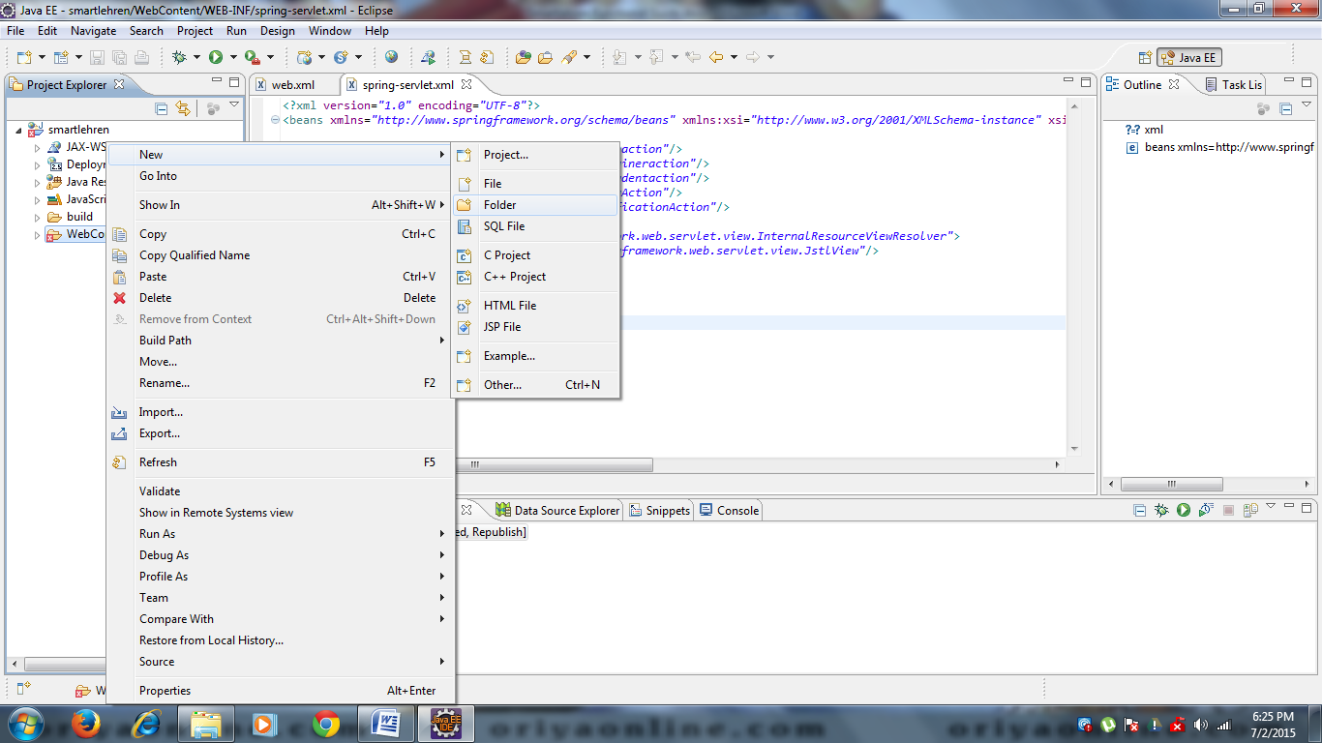

**Step 10:** Create *.jsp file in jsp folder for home page. This jsp file need to set in web.xml like this.

Example login page.

<welcome-file-list>

<welcome-file>

jsp/frmHome.jsp

</welcome-file>

</welcome-file-list>

**Step 11**: Home page will display. You can do login, if already registered and also user register in this page. If you click register button following screen will display. This action will occur from home.jsp

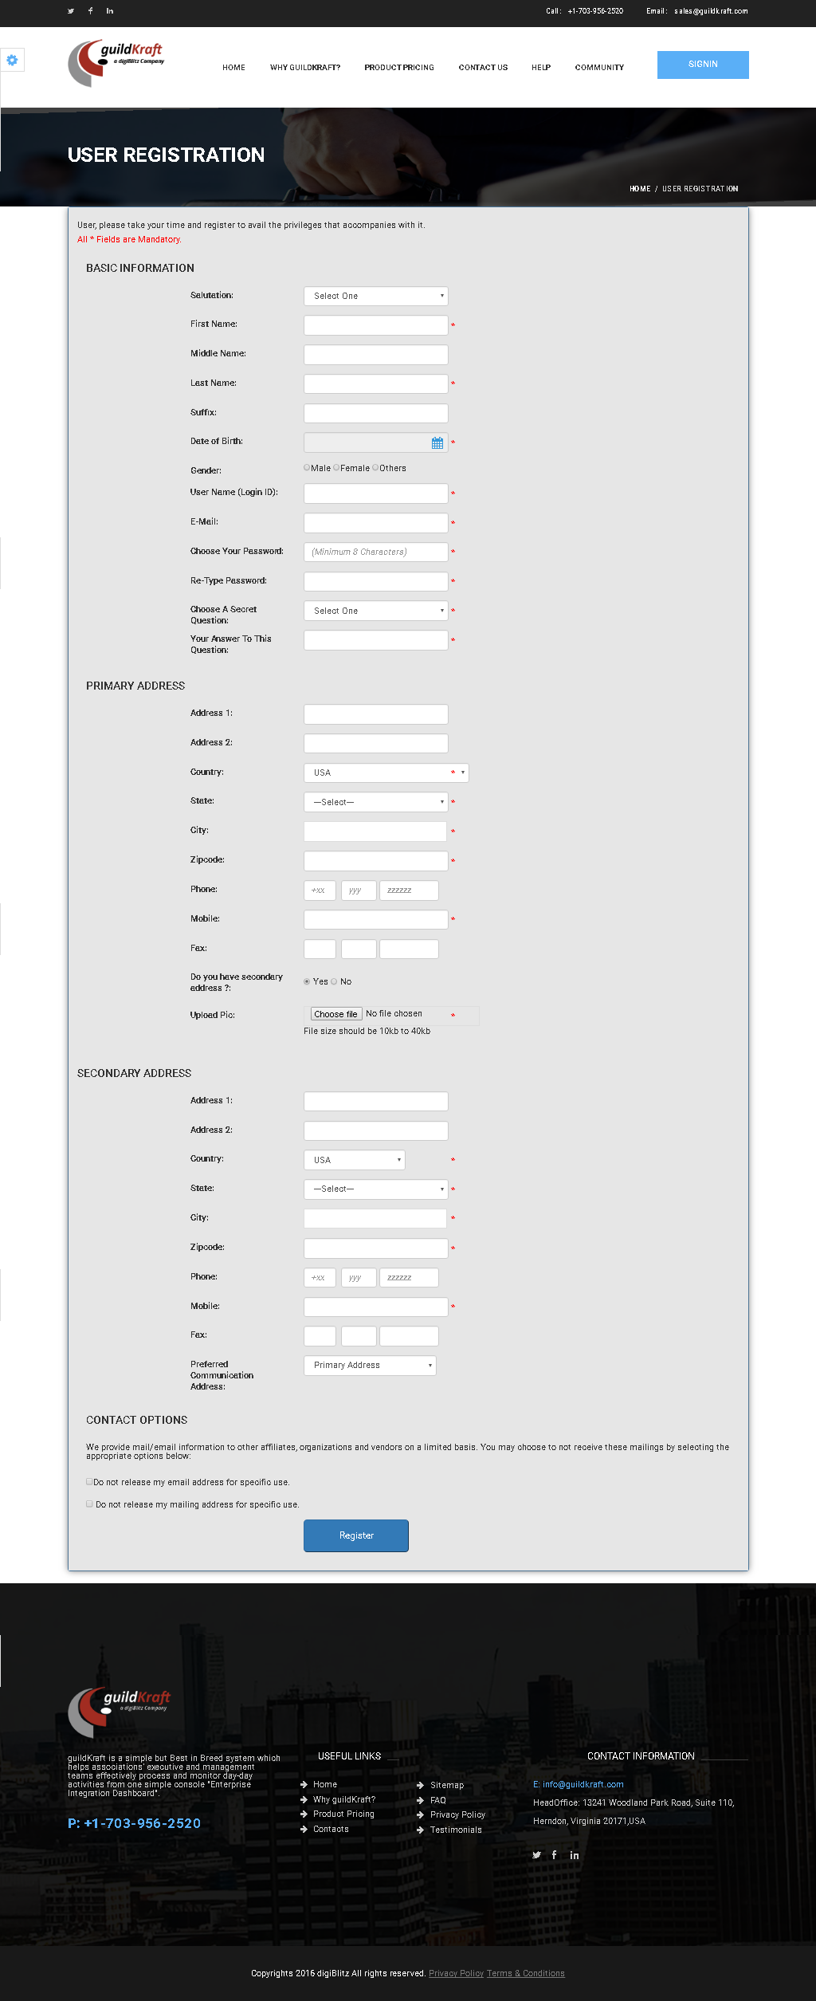

You should enter mandatory fields and click Register button. This home.jsp contain form action login.html. Servlet will pass login.html to spring controller, then spring controller will handle action class.

<bean name="/login.html" class="com.login.action.KlgLoginAction"/>

Here spring controller will call Loginaction.java under the com. spring package. Loginaction.java will do process. All input data will pass from login action to database through using this method db. Usercreate (username,password,firstname,…….); db.usercreate() method will explored in userDB.java under the com.util package. userDB.java will save all data in tbluserMasterl table in database.

**Spring MVC – Architecture:**

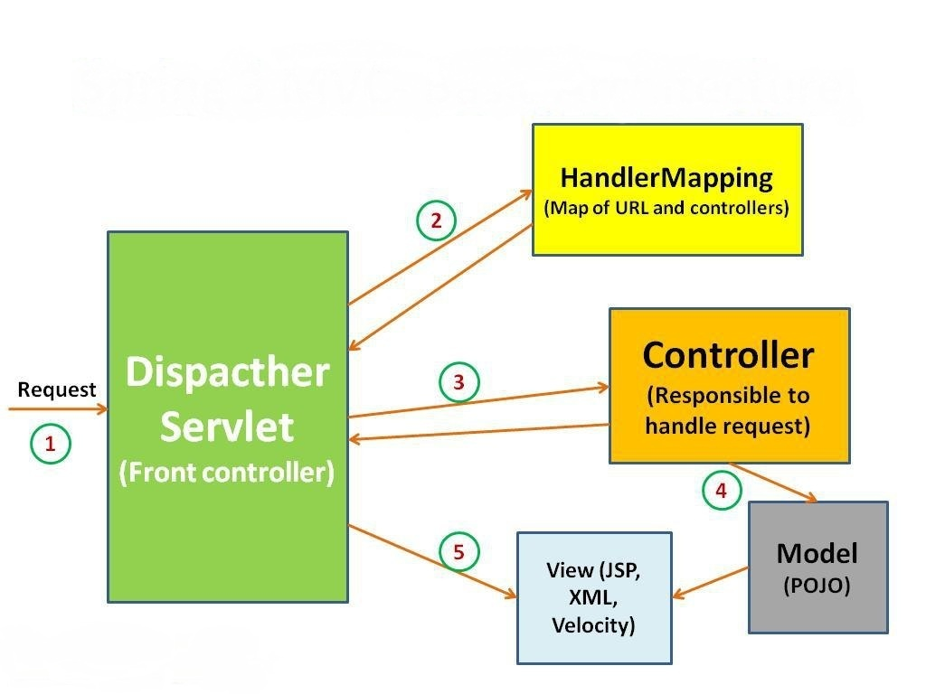

# Registration module

**Description:** Registration module contain all basic information about user. User should enter all basic information in frmmemberuserRegistration.jsp.

**Java:** frmmemberuserRegistration.jsp will call klgLoginaction.java file. More than one jsp file can call java class. Java class will identify all jsp page via process name. java class will call method name: createuser(….,….,….,…)

**Database:** createuser(….,….,….,…) method name described in userDB.java. here all user data will store in tblUserMaster table under TEST Database.

|  |  |  |
| --- | --- | --- |
| **Action** | **DB File** | **Table Name** |
| frmmemberuserRegistration.jsp file will call **klgLoginAction.java** with Process name Register**.** Action class will find Process name and pass values through this method db.getuser_status (username,password,..) touserDB.java. | GeneralDBAction.java will pass values and store in database Table. | tblUserMaster |

# Login module

**Description:** willget username and password from user through frmmemberuserRegistration.jsp and check this username and password exist or not in tblUserMaster database table. not existing user cant access this system.

|  |  |  |
| --- | --- | --- |
| **Action** | **DB File** | **Table Name** |
| login.jsp file will call **klgUserAction.java** with event name Process**.** Action class will find event name and pass values through this method db.getuser_status (username,  password) toGeneralDBAction.java. | GeneralDBAction.java will pass values and store in database Table. | tblUserMaster |

# Admin Role – Dashboard

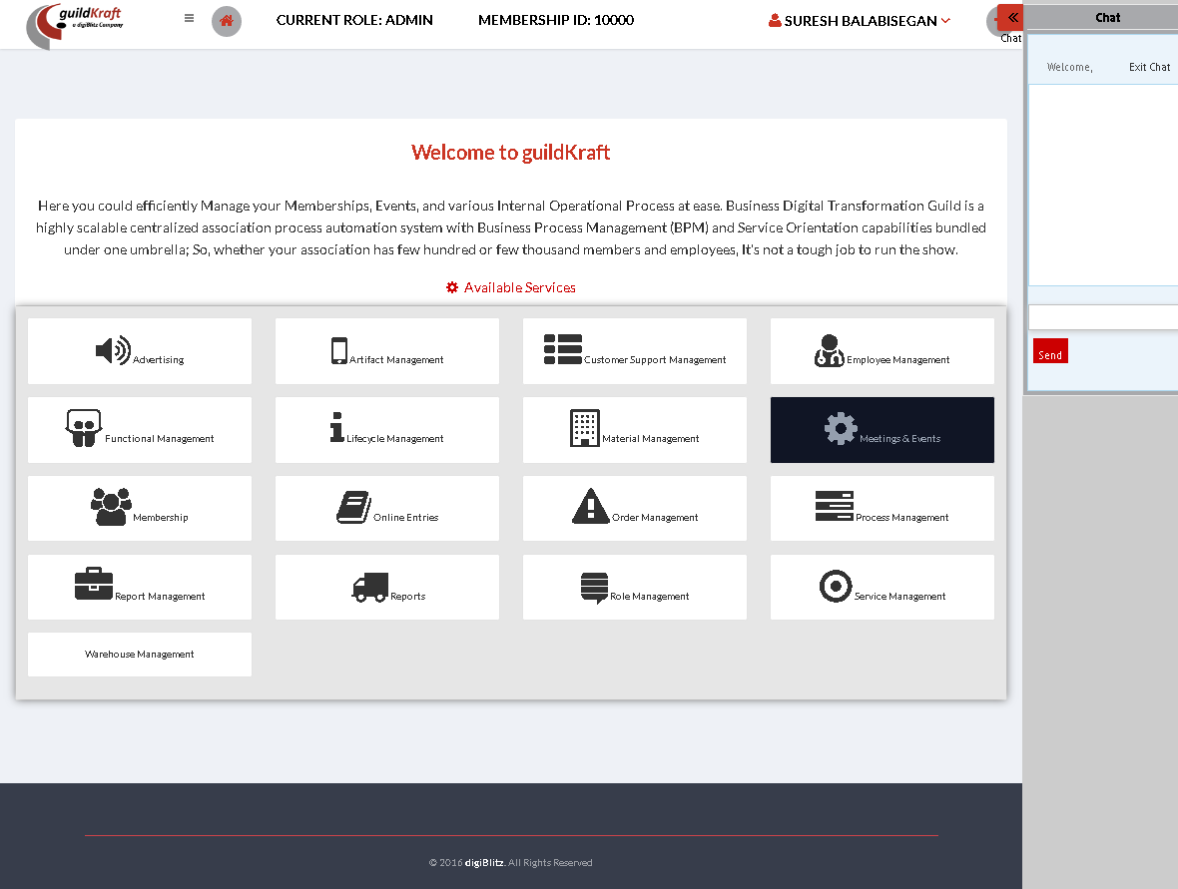

|  |  |  |
| --- | --- | --- |
| **Action** | **DB File** | **Table Name** |
| frmmemberuserRegistration.jsp file will call **klgLoginAction.java** with event name Process**.** Action class will find event name and pass values through this method db.getuser_status (username,  password) toGeneralDBAction.java. | GeneralDBAction.java will pass values and store in database Table. | tblUserMaster |

# Event Organizer – Dashboard

This is the dashboard page for Event organizer.They have two permission.

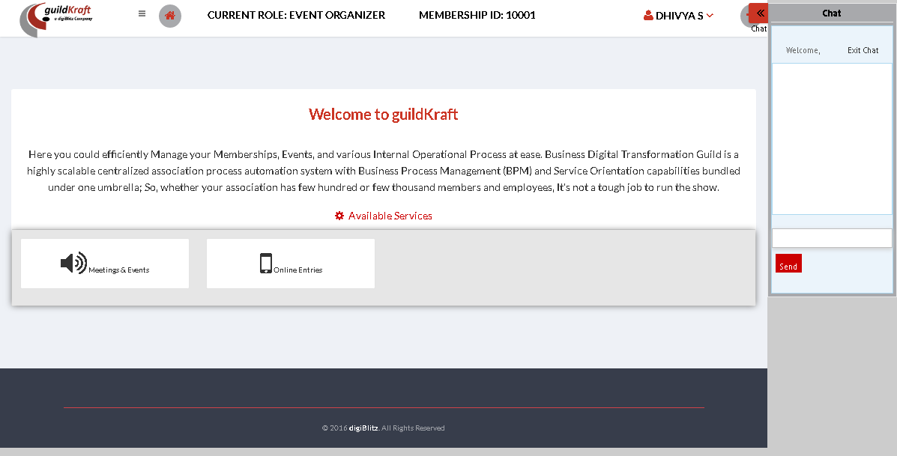

|  |  |  |
| --- | --- | --- |
| **Action** | **DB File** | **Table Name** |
| frmmemberuserRegistration.jsp file will call **klgLoginAction.java** with event name Process**.** Action class will find event name and pass values through this method db.getuser_status (username,  password) toGeneralDBAction.java. | GeneralDBAction.java will pass values and store in database Table. | tblUserMaster |

# Area Chair - Dashboard

|  |  |  |
| --- | --- | --- |
| **Action** | **DB File** | **Table Name** |
| frmmemberuserRegistration.jsp file will call **klgLoginAction.java** with event name Process**.** Action class will find event name and pass values through this method db.getuser_status (username,  password) toGeneralDBAction.java. | GeneralDBAction.java will pass values and store in database Table. | tblUserMaster |

# Forgot Password

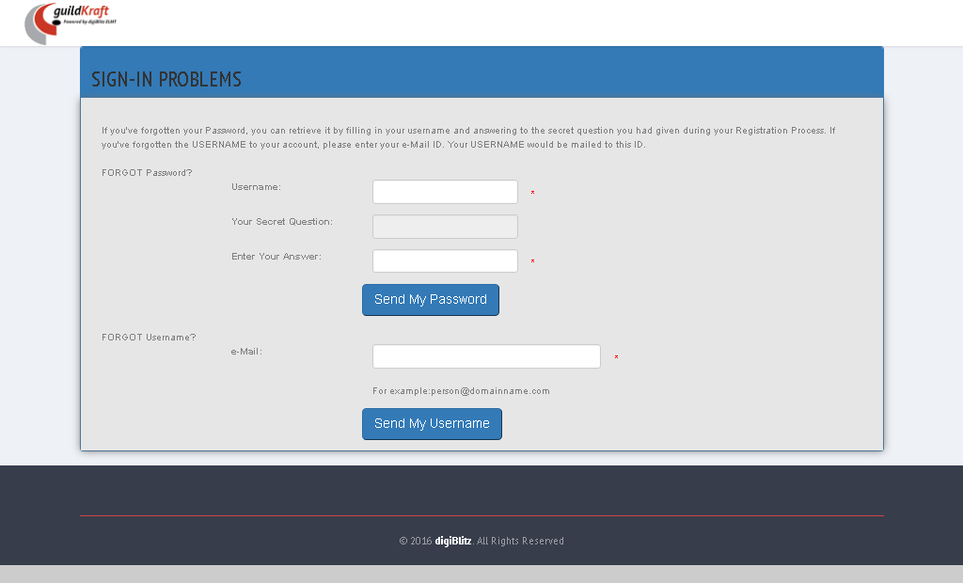 If the customer forgets his/her password they cannot access their account. So they can rest their password, by clicking on forgot password button and change their password, so that they can access their account.

|  |  |  |
| --- | --- | --- |
| **Action** | **DB File** | **Table Name** |
| frmRolMCreateRole.jsp file will call **klgRoleAction.java** with event name **role.** Action class will find event name and pass values through this method db.addrole(role_name); touserDB.java. | userDB.java will pass values and save in database table. | tblrole |

# My Profile

## Edit Profile

Edit the existing registered data of the user

|  |  |  |
| --- | --- | --- |
| **Action** | **DB File** | **Table Name** |
| frmEditMemberUserSignUp.jsp file will call KlgUserAction**.java** with event name **edit.** | -- | -- |

## Change Password

|  |  |  |
| --- | --- | --- |
| **Action** | **DB File** | **Table Name** |
| frmChangePassword.jsp file will call KlgUserAction**.java** with event name **initchgPwd.** | GeneralDBAction.java will pass values and store in database Table. | tblSignUpDetails – get details of the user. |

## Profile details

|  |  |  |
| --- | --- | --- |
| **Action** | **DB File** | **Table Name** |
| profiledetails.jsp file will call KlgUserAction**.java** with event name **profiledetails.** | GeneralDBAction.java will pass values and store in database Table. | tblSignUpDetails – get details of the user. |

## Plan and Package

|  |  |  |
| --- | --- | --- |
| **Action** | **DB File** | **Table Name** |
| productpackage.jsp file will call KlgUserAction**.java** with event name **product_package.** | GeneralDBAction.java will pass values and store in database Table. | tblSignUpDetails – get details of the user. |

## Security

|  |  |  |
| --- | --- | --- |
| **Action** | **DB File** | **Table Name** |
| security.jsp file will call KlgUserAction**.java** with event name **security.** | GeneralDBAction.java will pass values and store in database Table. | tblSignUpDetails – get details of the user.  tblLastloginDetails – get login details of the user |

# Index page

|  |  |  |
| --- | --- | --- |
| **Action** | **DB File** | **Table Name** |
| index.jsp file will call **KlgLoginAction.java** with event name **initIndex.** | GeneralDBAction.java will pass values and store in database Table. | tblUserMaster |

# 

# Advertise Management

## Manage Issues

### Create Issues

In this permission select the media type which is given below in the drop down and user can create issue name.

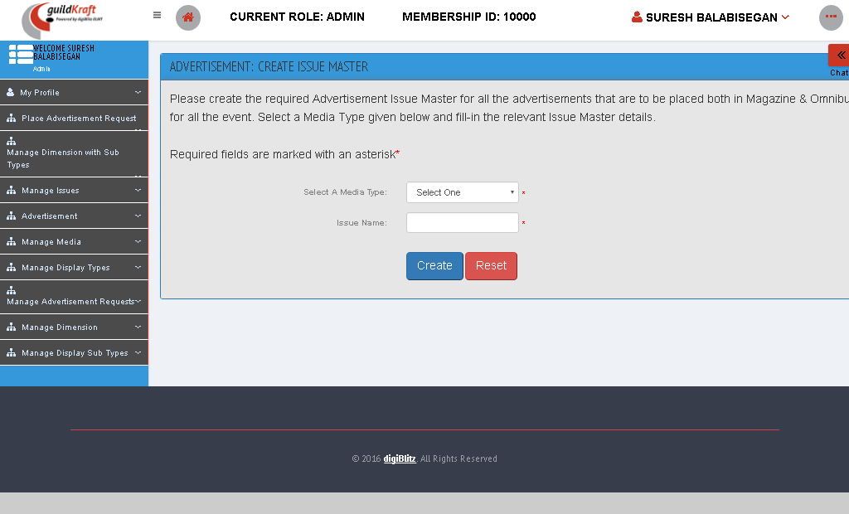

|  |  |  |
| --- | --- | --- |
| **Action** | **DB File** | **Table Name** |
| frmAdvIssueAdd.jspfile will call **GldkftActionAdvertisement.java** with event name **advIssueAdd.** | GeneralDBAction.java will pass values and save in database table. | tblAdvIssueMaster |

### List / Edit / Delete Issues

This permission is used for List the created issue. It is possible to edit or delete the issue.

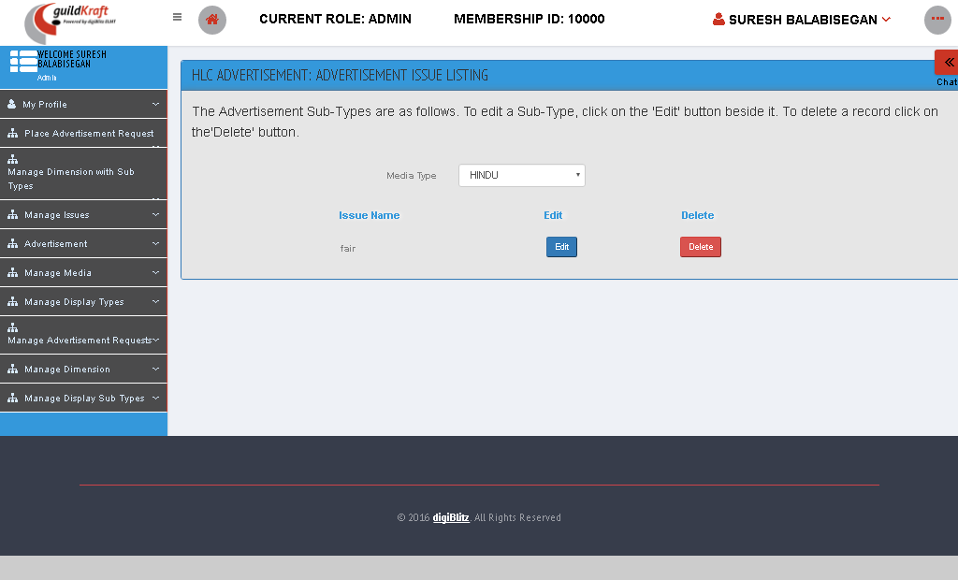

|  |  |  |
| --- | --- | --- |
| **Action** | **DB File** | **Table Name** |
| frmAdvIssueList.jsp file will call **GldkftActionAdvertisement.java** with event name **advIssueLst.** | GeneralDBAction.java will pass values and save in database table. | tblAdvMediaMaster |

## Advertisement

### My Request Status

Advertisement posted by the customer can be viewed in this permission.

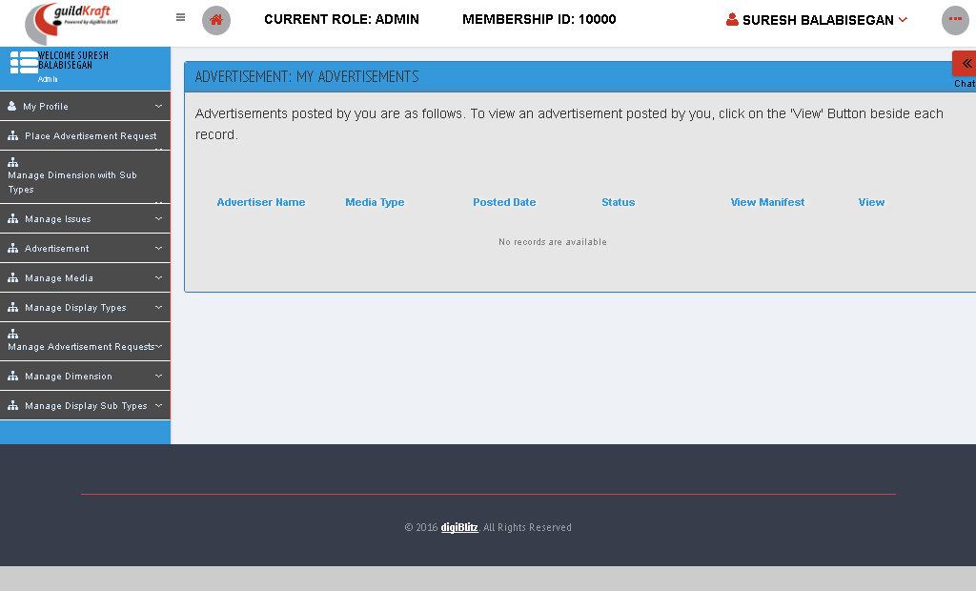

|  |  |  |
| --- | --- | --- |
| **Action** | **DB File** | **Table Name** |
| frmAdvMyRequest.jsp file will call GldkftActionAdvertisePrice**.java** with event name **userStatus.** | -- | -- |

## Manage Media

### Create Media Type

In this permission media type can be created by clicking on the add button.

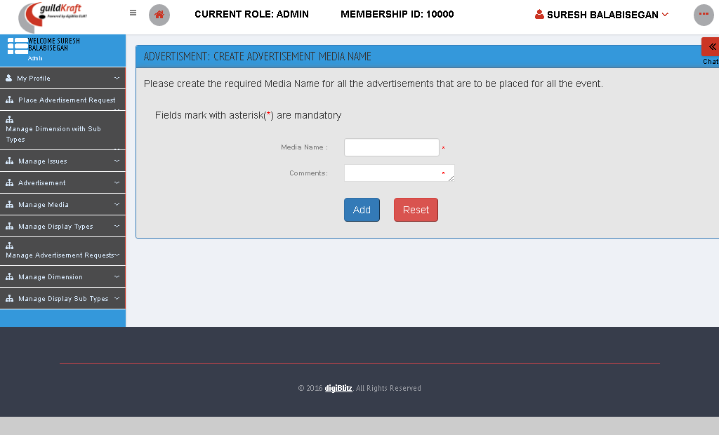

|  |  |  |
| --- | --- | --- |
| **Action** | **DB File** | **Table Name** |
| frmAdvMediaAdd.jsp file will call GldkftActionAdvertisement**.java** with event name **advMediaPlanAddNew.** | GeneralDBAction.java will pass values and save in database table. | tblAdvMediaMaster |

### Delete / List / Edit Media Type

The media types that are available will be listed here and the unwanted media type can be deleted here. This can be simply done by clicking on the delete button.

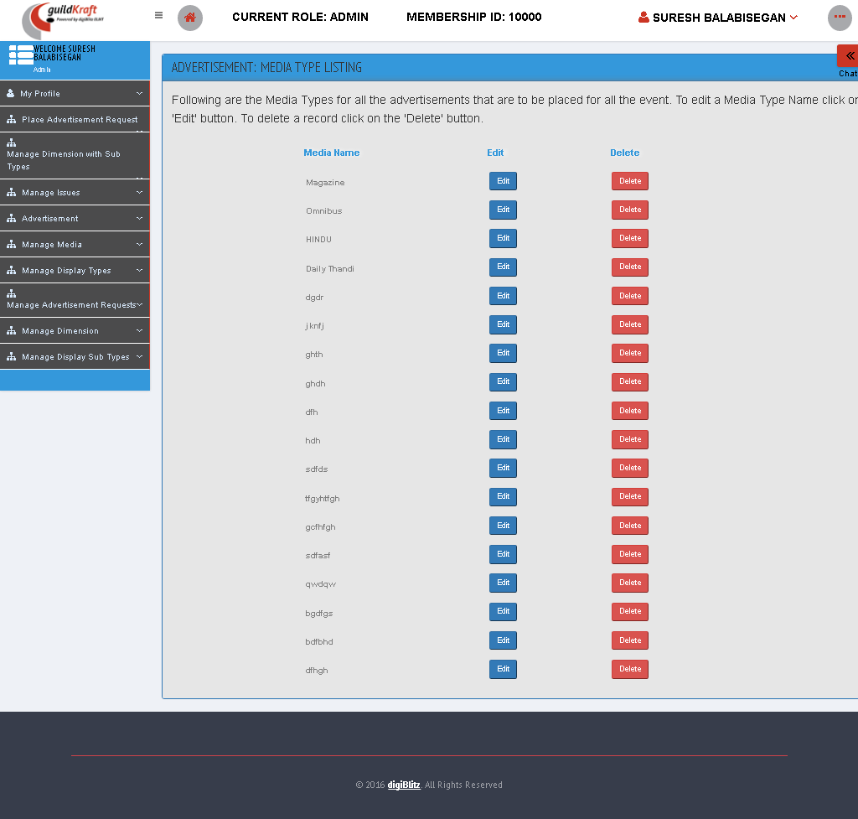

|  |  |  |
| --- | --- | --- |
| **Action** | **DB File** | **Table Name** |
| frmAdvMediaList.jsp file will call GldkftActionAdvertisement**.java** with event name **advMediaLst.** | GeneralDBAction.java will pass values and save in database table. | tblAdvMediaMaster |

## Manage Display Types

### Create Display Type

In this permission we can create the display type for which default name will be **“Media type”** which can be rewritten with the advertisement name and description.

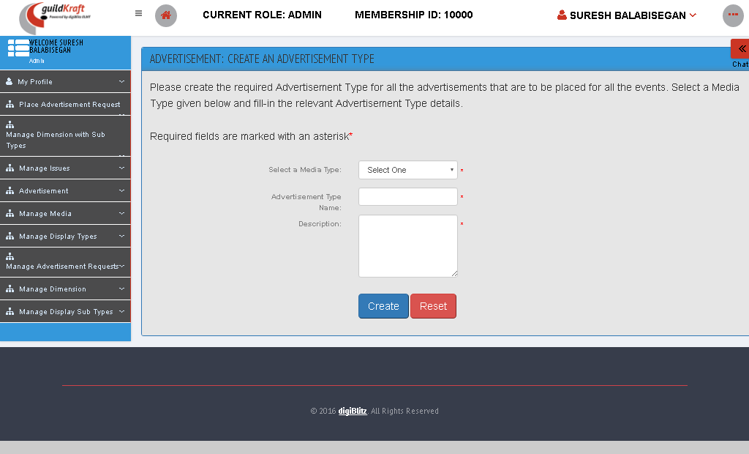

|  |  |  |
| --- | --- | --- |
| **Action** | **DB File** | **Table Name** |
| frmAdvDisplayTypeAdd.jsp file will call GldkftActionAdvertisement**.java** with event name **advDispTypeAdd.** | GeneralDBAction.java will pass values and save in database table. | tblAdvDisplayTypeMaster |

### Delete / List / Edit Display Type

Unwanted subdivisions inside the display type will be deleted under this permission.

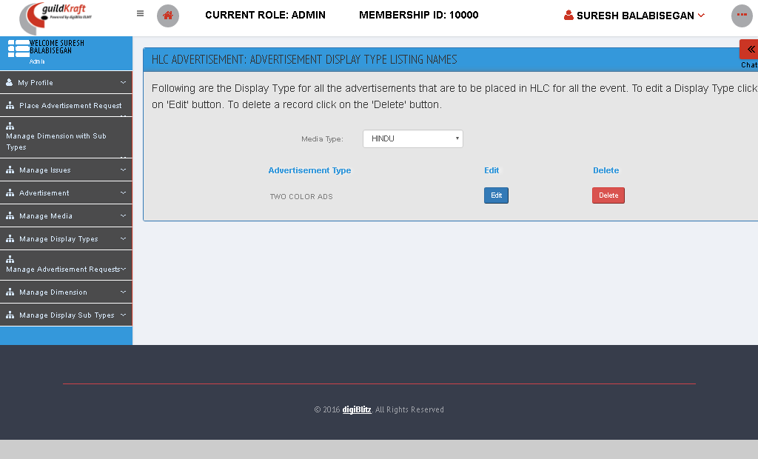

|  |  |  |
| --- | --- | --- |
| **Action** | **DB File** | **Table Name** |
| frmAdvDisplayTypeList.jsp file will call GldkftActionAdvertisement**.java** with event name **advDispTypeLst.** | GeneralDBAction.java will pass values and save in database table. | tblAdvDisplayTypeMaster |

## Manage Advertisement Requests

### List advertisement Requests

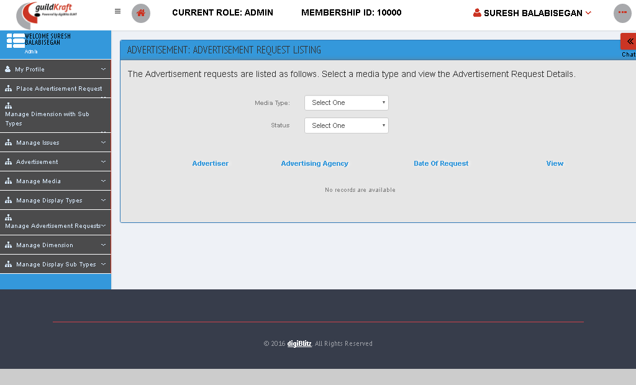In this permission we can see the advertisement requests given by other participants.

|  |  |  |
| --- | --- | --- |
| **Action** | **DB File** | **Table Name** |
| frmAdvAdminRequestView.jsp file will call GldkftActionAdvertiseAdmin**.java** with event name **AdvAdmin.** | -- | -- |

## Manage Dimensions

### Create Dimension Type

In this permission we can create the dimension for advertisement that is to be placed in the events.

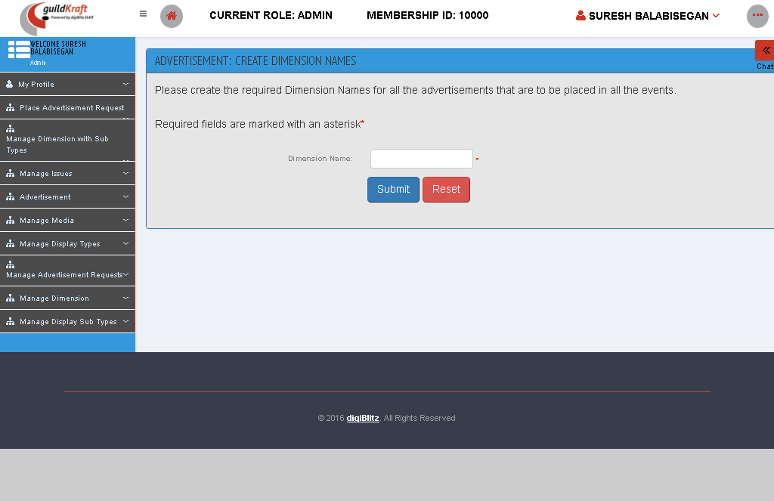

|  |  |  |
| --- | --- | --- |
| **Action** | **DB File** | **Table Name** |
| frmAdvDimensionAdd.jsp file will call GldkftActionAdvertisement**.java** with event name **advDimensionAdd.** | GeneralDBAction.java will pass values and save in database table. | tblAdvDimensionTypeMaster |

### Delete / List / Edit Dimension Type

In this permission we can create the dimension for advertisement that is to be placed in the events.

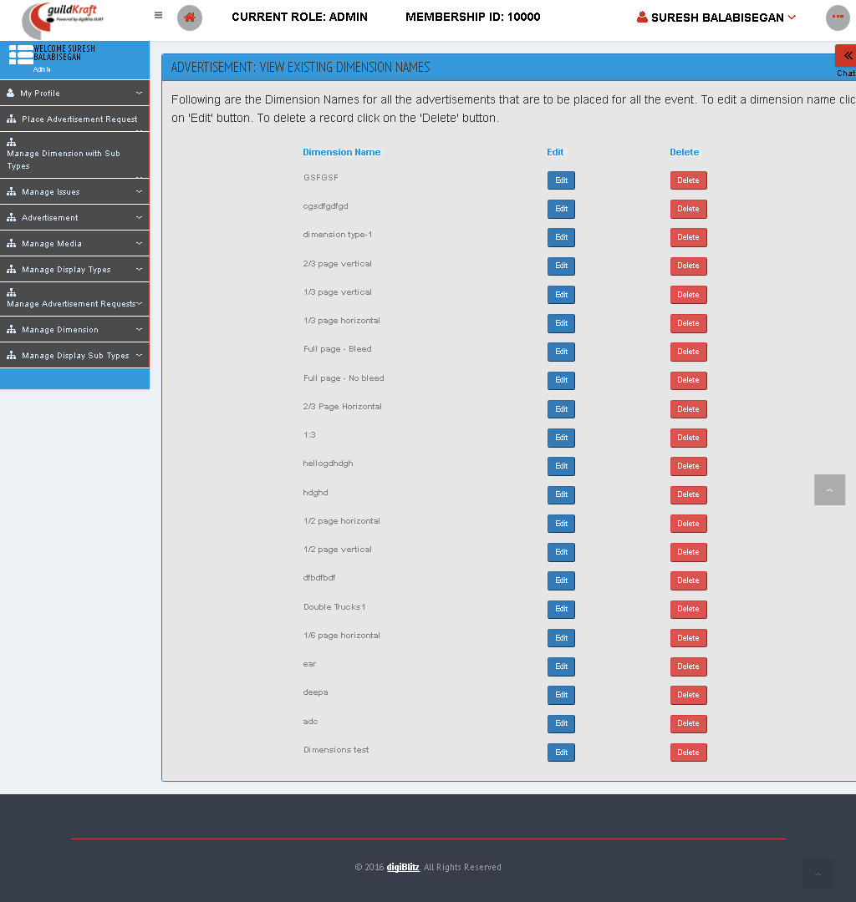

|  |  |  |
| --- | --- | --- |
| **Action** | **DB File** | **Table Name** |
| frmAdvDimensionList.jsp file will call GldkftActionAdvertisement**.java** with event name **advLstDimension.** | GeneralDBAction.java will pass values and save in database table. | tblAdvDimensionTypeMaster |

## Manage Display sub Types

### Create Display Sub Type

In this permission we can create a sub type advertisement for advertisement. As given below select **“Media Type”** and **“Advertisement Type”.** Enter advertisement sub-type name and description and then click **“Create”** button.

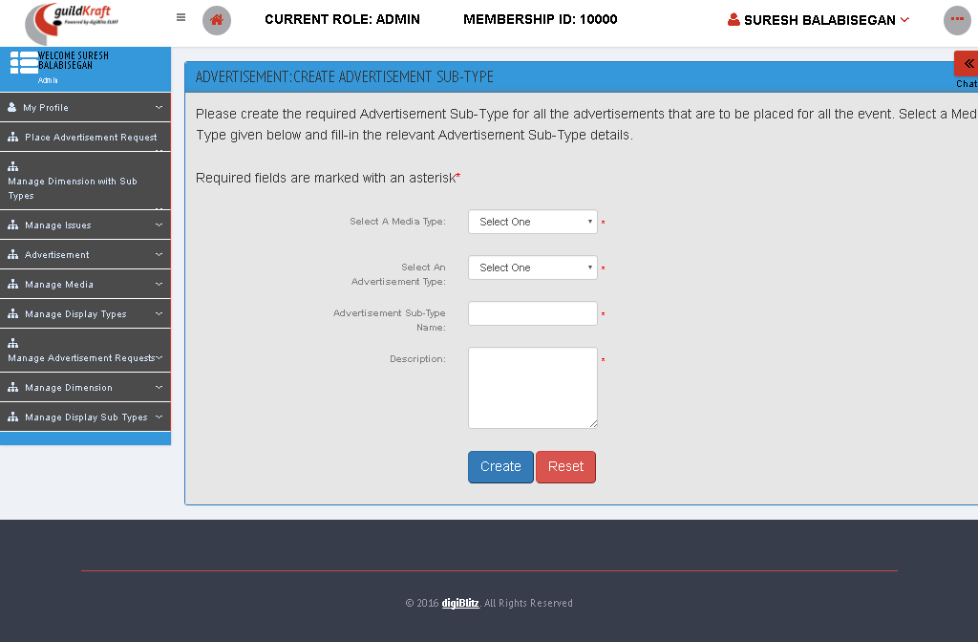

|  |  |  |
| --- | --- | --- |
| **Action** | **DB File** | **Table Name** |
| frmAdvDisplaySubTypeAdd.jsp file will call GldkftActionAdvertisement**.java** with event name **advDispSubTypeAdd.** | GeneralDBAction.java will pass values and save in database table. | tblAdvDisplaySubTypes |

### Delete / List / Edit Display sub Type

In this permission we can delete a sub type advertisement for advertisement. As given below select **“Media Type”** and **“Advertisement Type”.** Enter advertisement sub-type name and description and then click **“Delete”** button.

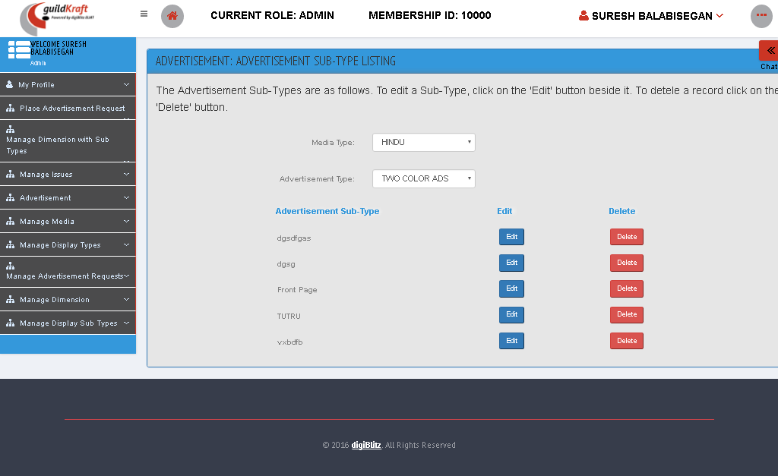

|  |  |  |
| --- | --- | --- |
| **Action** | **DB File** | **Table Name** |
| frmAdvDisplaySubTypeAdd.jsp file will call GldkftActionAdvertisement**.java** with event name **advDispSubTypeLst.** | GeneralDBAction.java will pass values and save in database table. | tblAdvDisplaySubTypes |

# **Artifact** Management

## Manage Framework Level

### Artifact Mappings

Select **“view point”** and select required artifacts and click **“Map artifacts”** to map the artifacts roles.

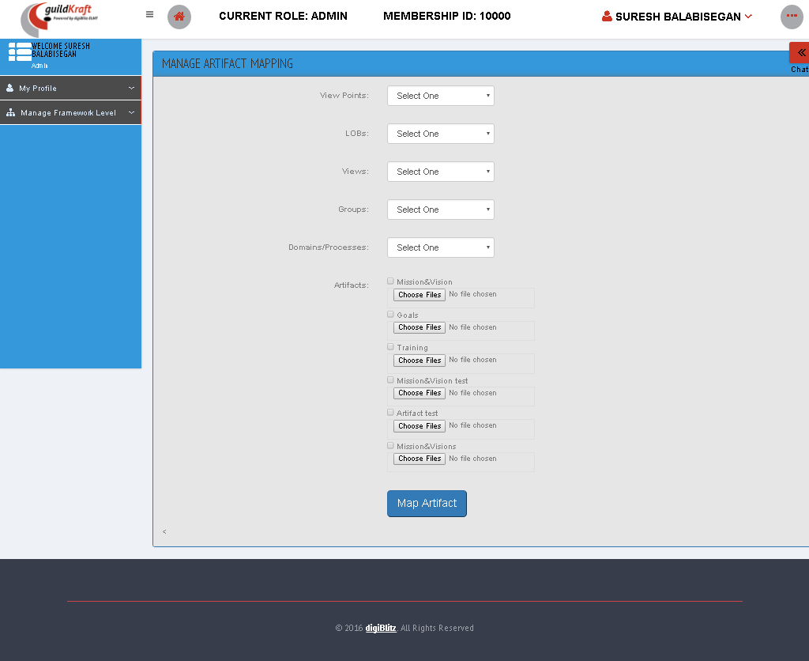

|  |  |  |
| --- | --- | --- |
| **Action** | **DB File** | **Table Name** |
| frmArtifactMapList.jsp file will call KlgArtifactAction**.java** with event name **loadArtifact.** | GeneralDBAction.java will pass values and save in database table. | tblviewpointmaster gets the value of view.  tblMapArtifact stores the mapped values |

### Group Level Master

In this permission we can add and edit the groups which were already created. We can create new groups.

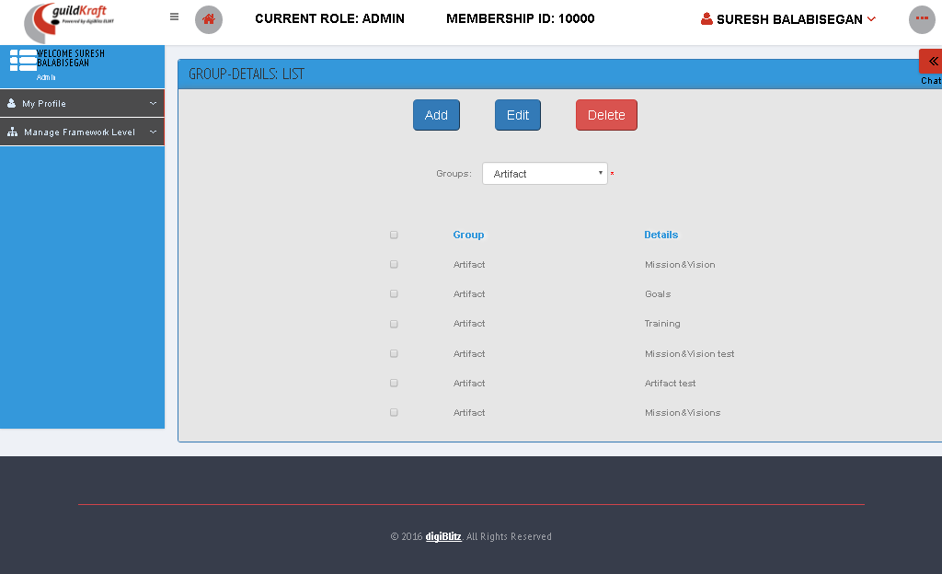

|  |  |  |
| --- | --- | --- |
| **Action** | **DB File** | **Table Name** |
| frmAddListgroups.jsp file will call KlgArtifactAction**.java** with event name **searchList.** | GeneralDBAction.java will pass values and save in database table. | tblviewpointmaster gets the value of view.  tblMapArtifact stores the mapped values |

* On Clicking Add button

|  |  |  |
| --- | --- | --- |
| **Action** | **DB File** | **Table Name** |
| frmAddGroups.jsp file will call KlgArtifactAction**.java** with event name AddGroups**.** | -- | -- |

### Mapping View Point Master

To map with other groups click **“view point”** and then click **“map”**.

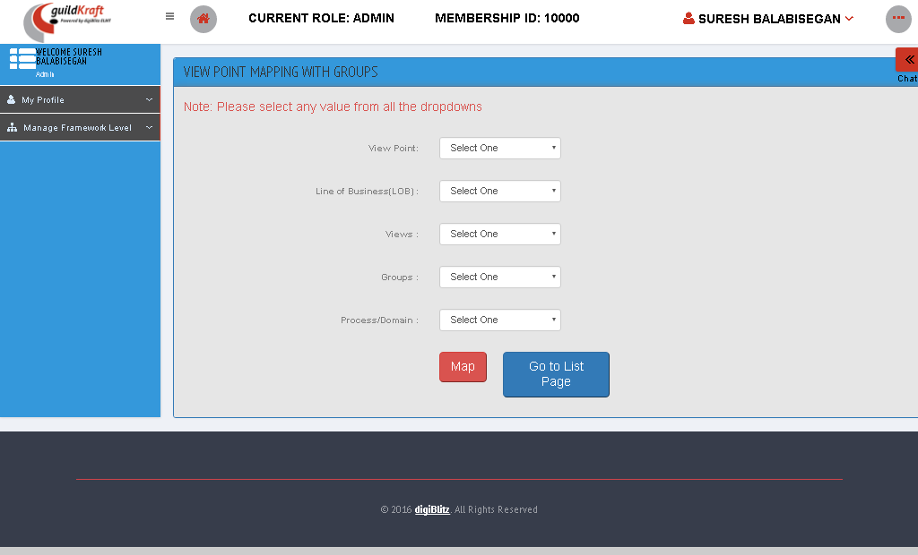

|  |  |  |
| --- | --- | --- |
| **Action** | **DB File** | **Table Name** |
| frmViewPointMapping.jsp file will call KlgArtifactAction**.java** with event name initArtifactMap**.** | GeneralDBAction.java will pass values and save in database table. | tblviewpointmaster – get all views  tblframeworkmaster – get all groups  tblframeworklayermap – get all group details |

* On clicking go to list page

|  |  |  |
| --- | --- | --- |
| **Action** | **DB File** | **Table Name** |
| frmMappedViewPointList.jsp file will call KlgArtifactAction**.java** with event name searchMappedGroup**.** | GeneralDBAction.java will pass values and save in database table. | tblviewpointmaster – get all views  tblframeworkmaster – get all groups  tblframeworklayermap – get all group details |

# Customer Support Management

## Manage Customer

It has a permission that manage the customer details.

### Search

Enter the Customer ID to search for details of that Member.

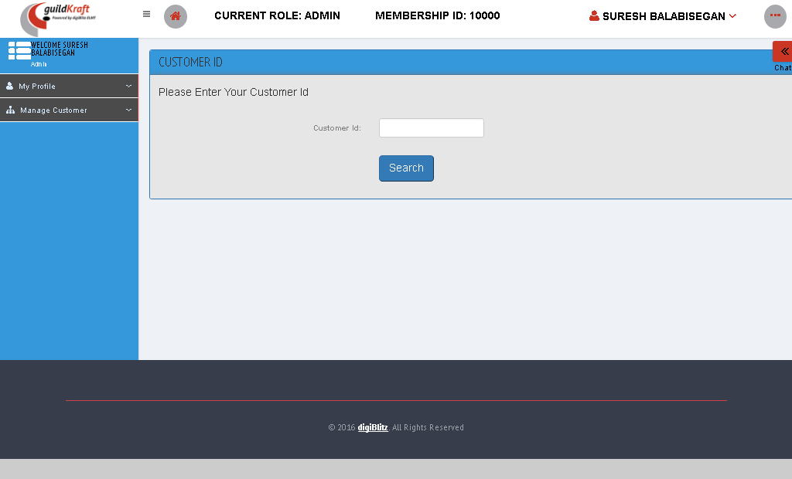

|  |  |  |
| --- | --- | --- |
| **Action** | **DB File** | **Table Name** |
| customersupport.jsp file will call CustomersupportAction**.java** with event name **customer.** | GeneralDBAction.java will pass values and save in database table. | tblSignUpDetails |

# Life Cycle Management

## Life Cycle Process

### Create Life Cycle Process

To create life cycle process fill the form given below and click **“Add/Save Stage**

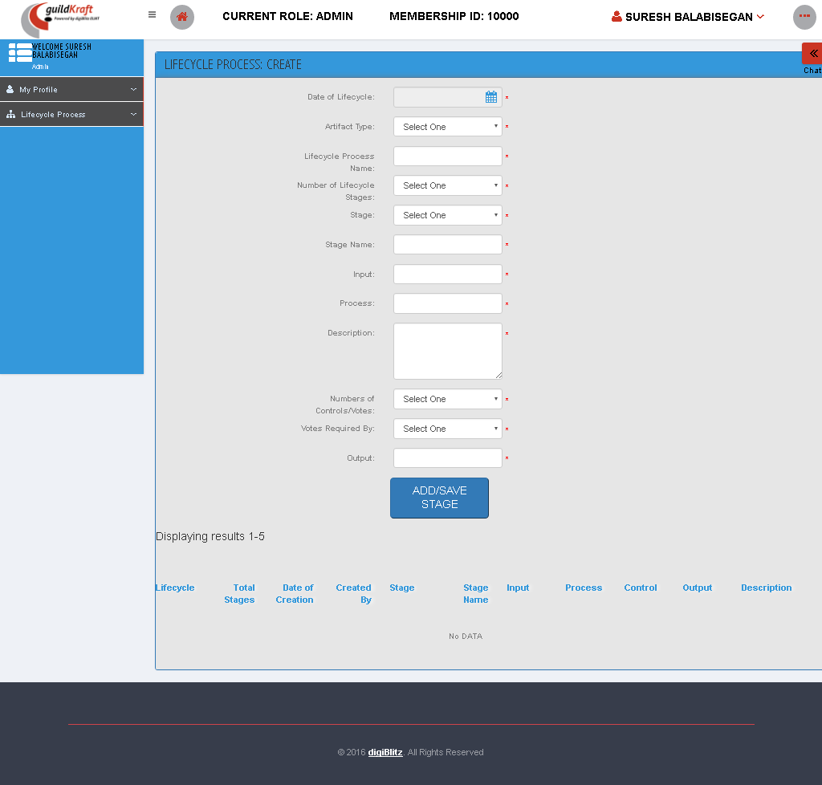

|  |  |  |
| --- | --- | --- |
| **Action** | **DB File** | **Table Name** |
| SystinetArtifactadd.jsp file will call KlgHpSystinetAction**.java** with event name **callArtadd.** | --. | -- |

# Meetings and Events

## Events

### View All Event Report

This show the list of Event report , that displays the pictorial representation of the report.

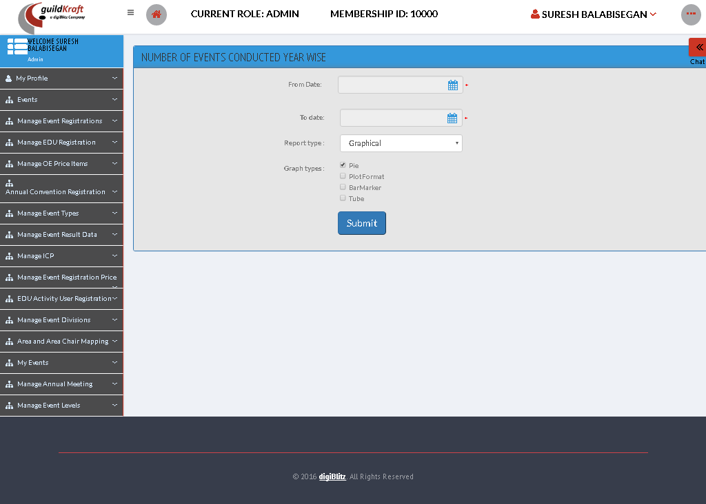

* createEventReports.jsp file will call from GldkfteventReport**.java** with event name eventsYearWise**.**
* On Clicking the submit button, views the pictorial representation.

|  |  |  |
| --- | --- | --- |
| **Action** | **DB File** | **Table Name** |
| generateYearlyEventsReports.jsp file will call from EventReports**.java** with event name eventsYearWise**.** | -- | -- |

## Manage Event Registrations

### Event Requests

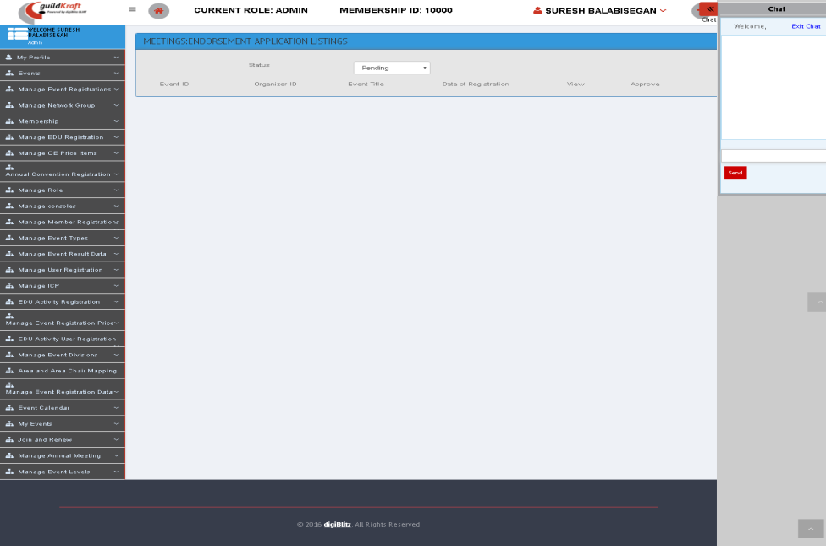Click “Status” button to see the current status of the request whether it is, pending, approved, rejected requests.

|  |  |  |
| --- | --- | --- |
| **Action** | **DB File** | **Table Name** |
| frmMeeAdminEventListings.jsp file will call from ActionEventOrgRenewal**.java** with event name eventViewAdmin**.** | -- | -- |

### List Event Requests

To see the list of event requests click **“year”** and **“Select one”** then click **“submit”** button.

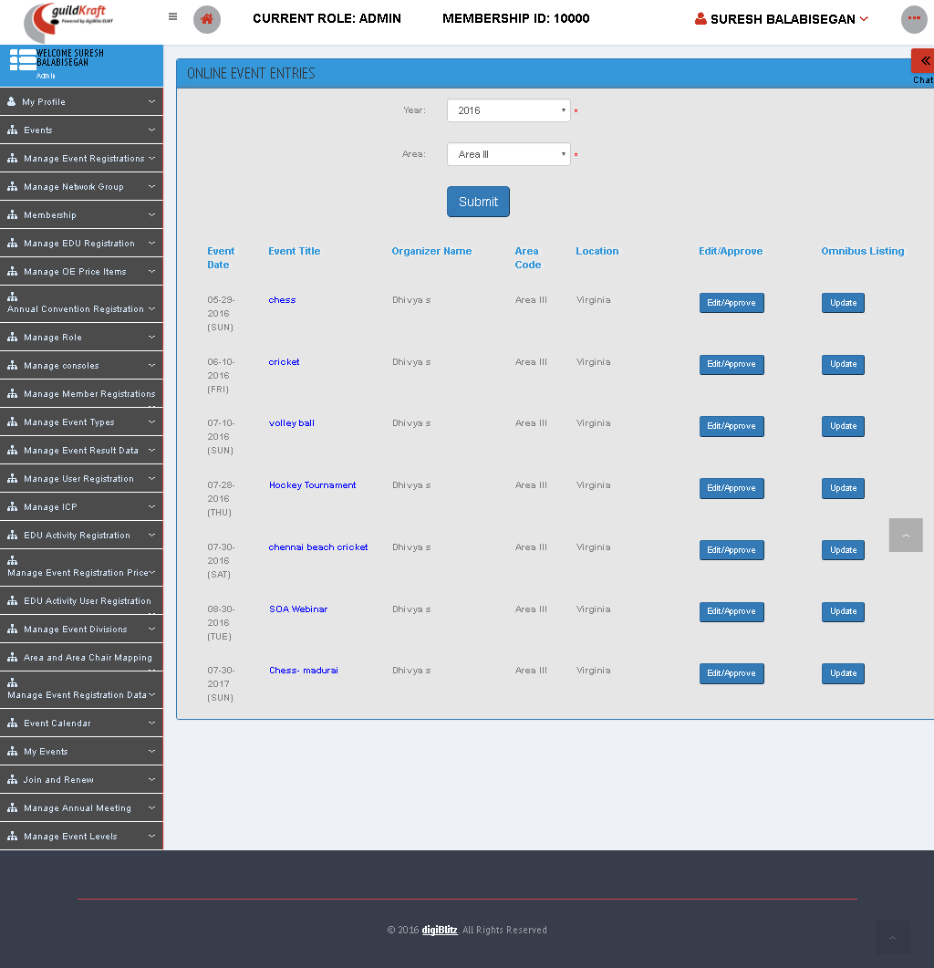

|  |  |  |
| --- | --- | --- |
| **Action** | **DB File** | **Table Name** |
| frmProCalUseaStaffList.jsp file will call OnlineEntriesListAction**.java** with event name initList**.** | -- | -- |

* After selecting the year and area click submit button, it shows the list of event details.

### List Omnibus Requests

In this permission we can see the list of requests.

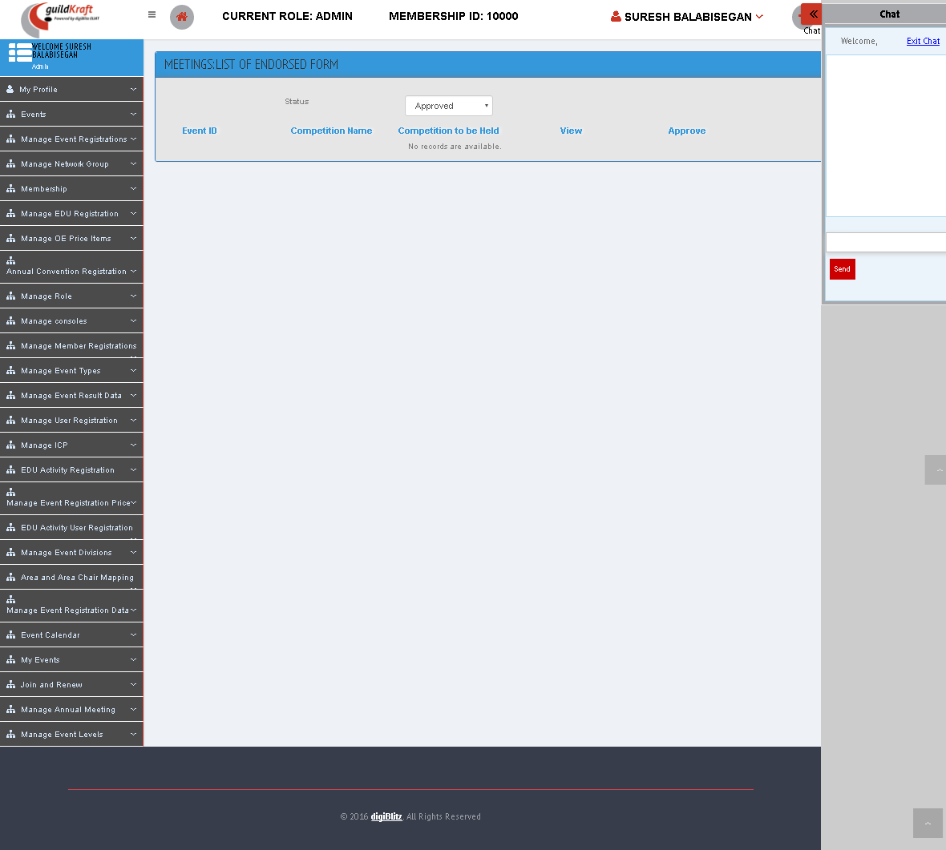

|  |  |  |
| --- | --- | --- |
| **Action** | **DB File** | **Table Name** |
| frmEventOrgRenewalListing.jsp file will call ActionEventOrgRenewal**.java** with event name initShow**.** | -- | -- |

## Membership

### Apply Refund

In this page shows the form to apply for refund.

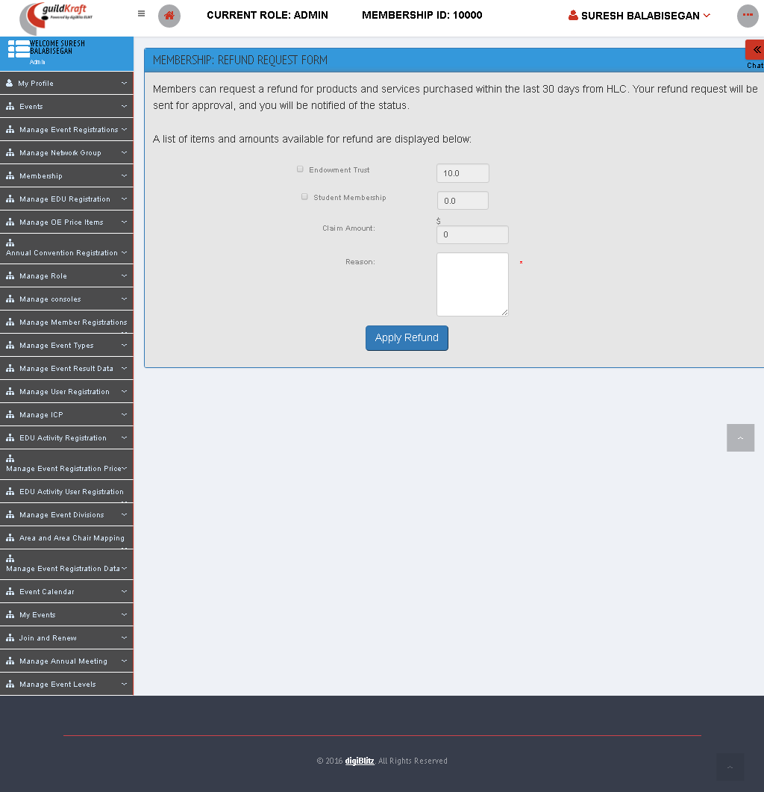

|  |  |  |
| --- | --- | --- |
| **Action** | **DB File** | **Table Name** |
| refund-request.jsp file will call RefundReqDispAction**.java** | -- | -- |

### Refund Request List

It shows the list of refund request and its status whether the refund is approved or in pending.

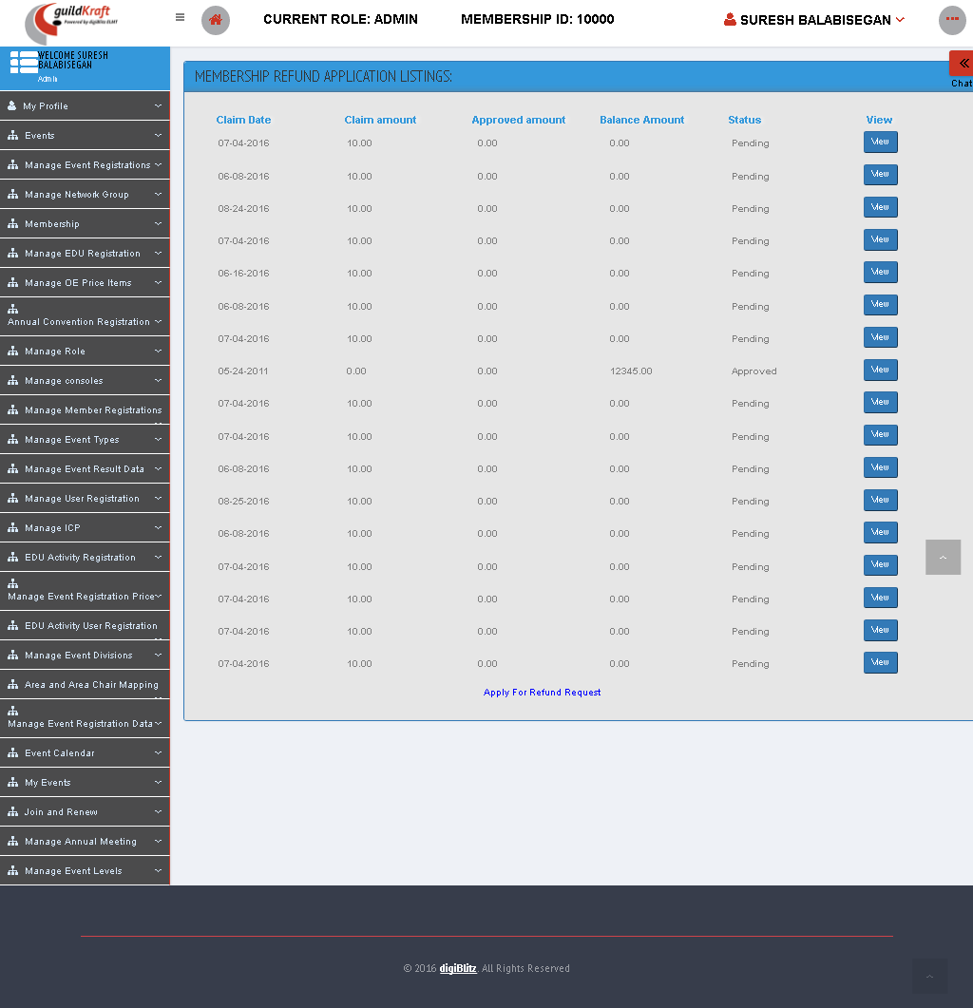

|  |  |  |
| --- | --- | --- |
| **Action** | **DB File** | **Table Name** |
| usr_refund-request-list.jsp file will call UsrRefundReqListAction**.java** | -- | -- |

* View the Details of refund by clicking “VIEW” button, that shows the amount claimed and the amount approved for refund.

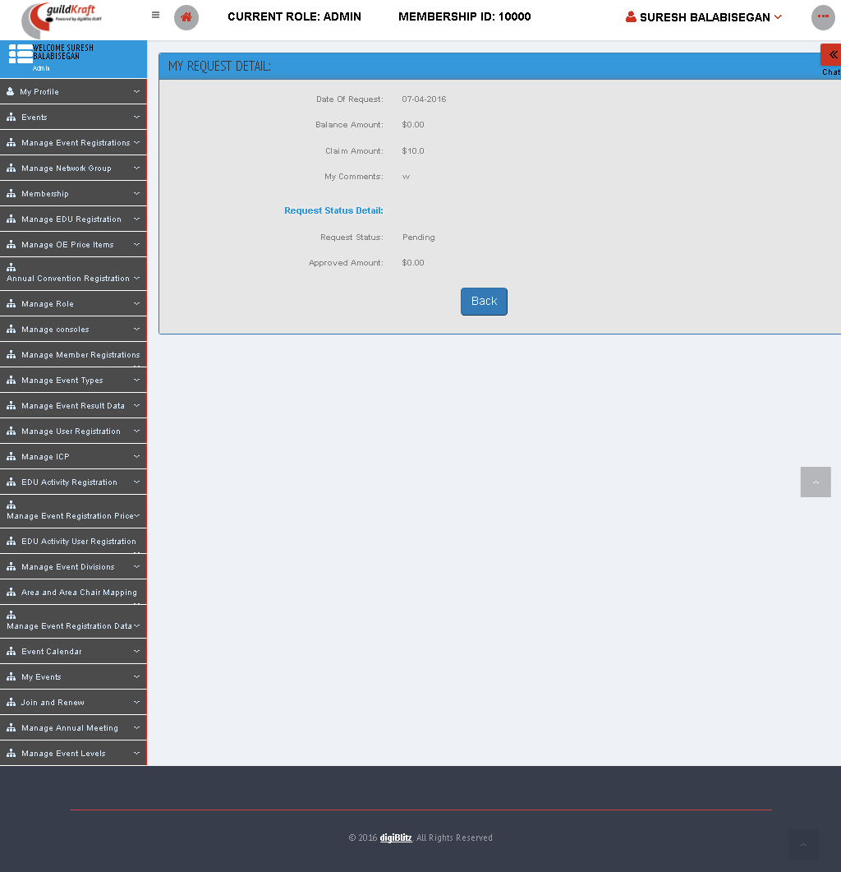

|  |  |  |
| --- | --- | --- |
| **Action** | **DB File** | **Table Name** |
| usr_refund-request-viewstatus.jsp file will call UsrRefundReqListAction**.java** | -- | -- |

## Manage EDU Registration

### Manage EDU Organizer Event List

Educational Activity Registrations placed by organizers are listed below. To view the details, click on the **'View'** button beside each record.

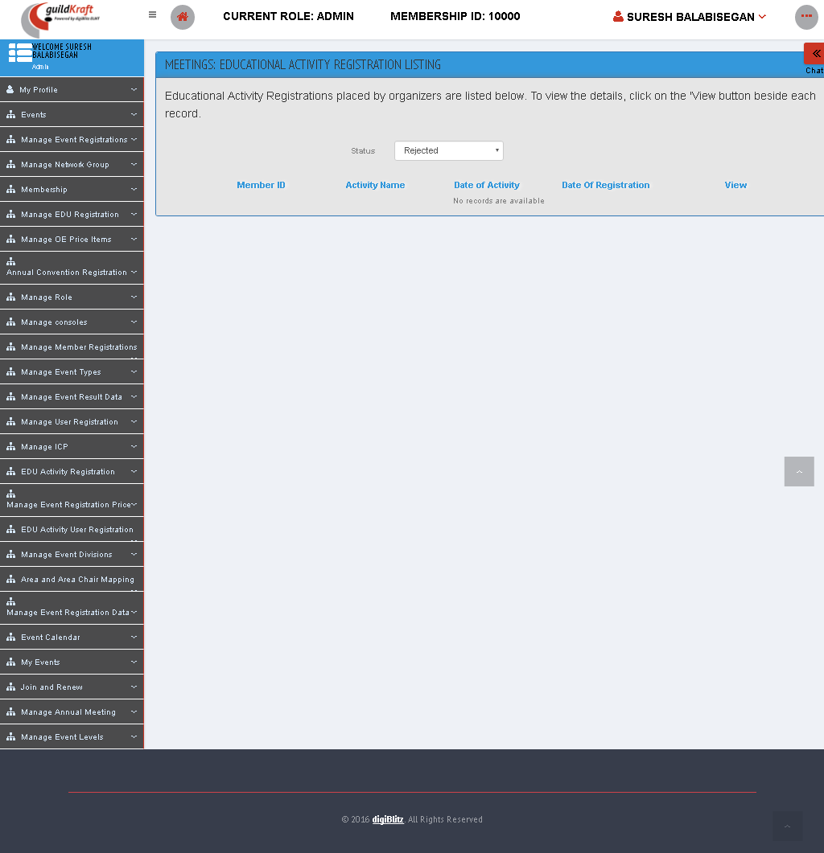

|  |  |  |
| --- | --- | --- |
| **Action** | **DB File** | **Table Name** |
| frmMeeAdminEduActRegiListing.jsp file will call ActionMeeting**.java** with event name newAdmin**.** | -- | -- |

## Manage OE Price Items

### Add New OE Price Item

Enter name in the “Item name” field and then create “Create” button.

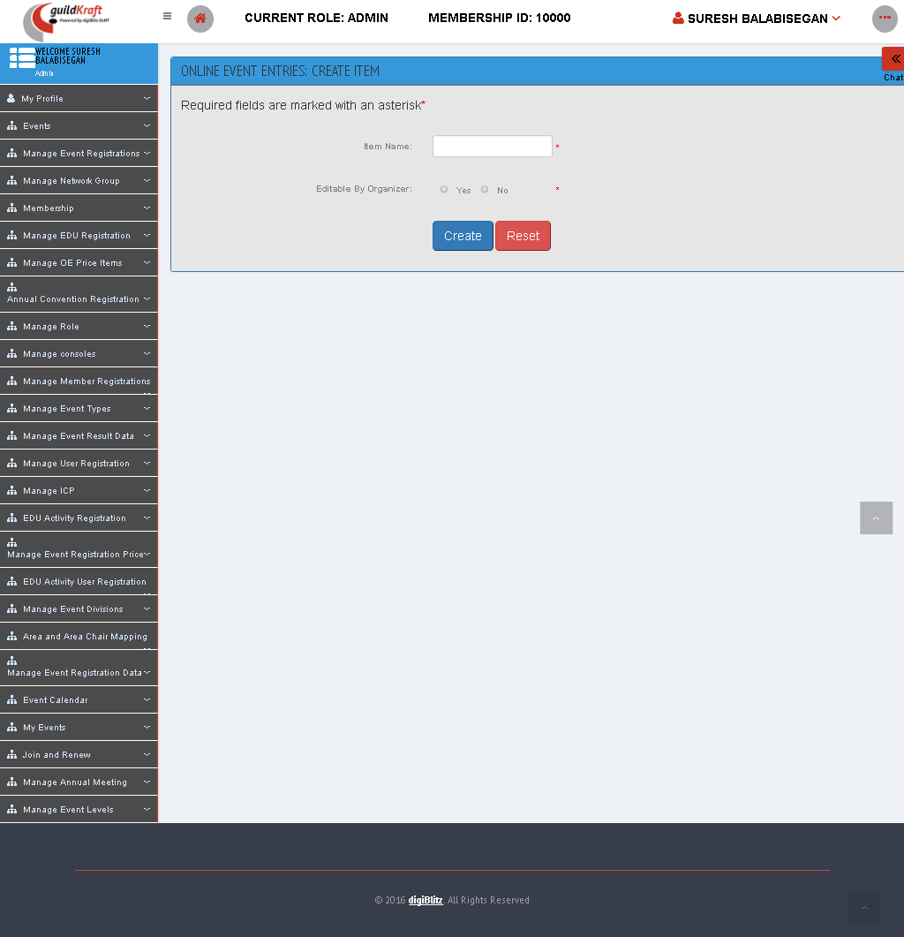

|  |  |  |
| --- | --- | --- |
| **Action** | **DB File** | **Table Name** |
| frmOEEPriceItemCreate.jsp file will call PriceItemAction**.java** with event name initCreateItem**.** | -- | -- |

### List All OE Price Items

Click “Status” to check activate and deactivate list, and then click “submit” button

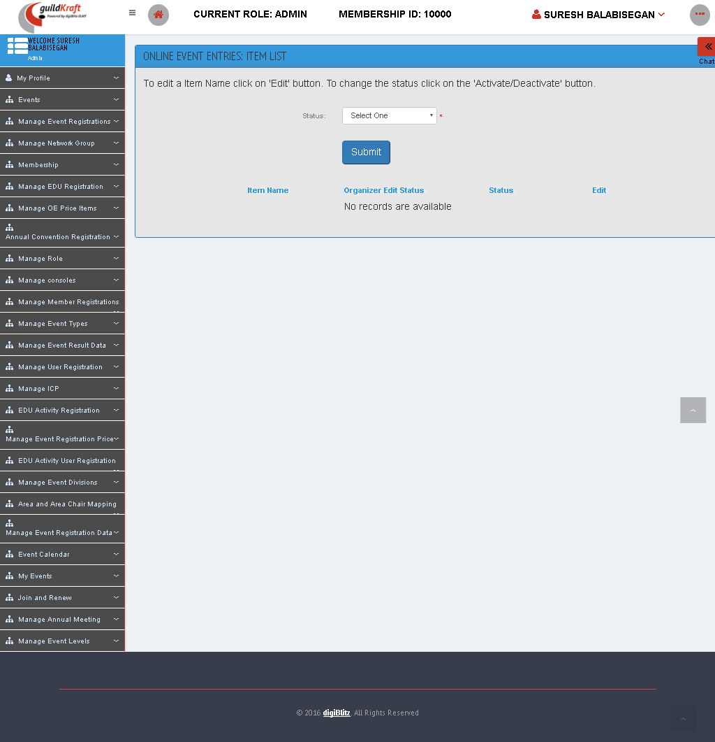

|  |  |  |
| --- | --- | --- |
| **Action** | **DB File** | **Table Name** |
| frmOEEPriceItemList.jsp file will call PriceItemAction**.java** with event name initListItem**.** | .--. | -- |

### List OE Fixed Price Items

Click item name, Event type and area it will display pricing details.

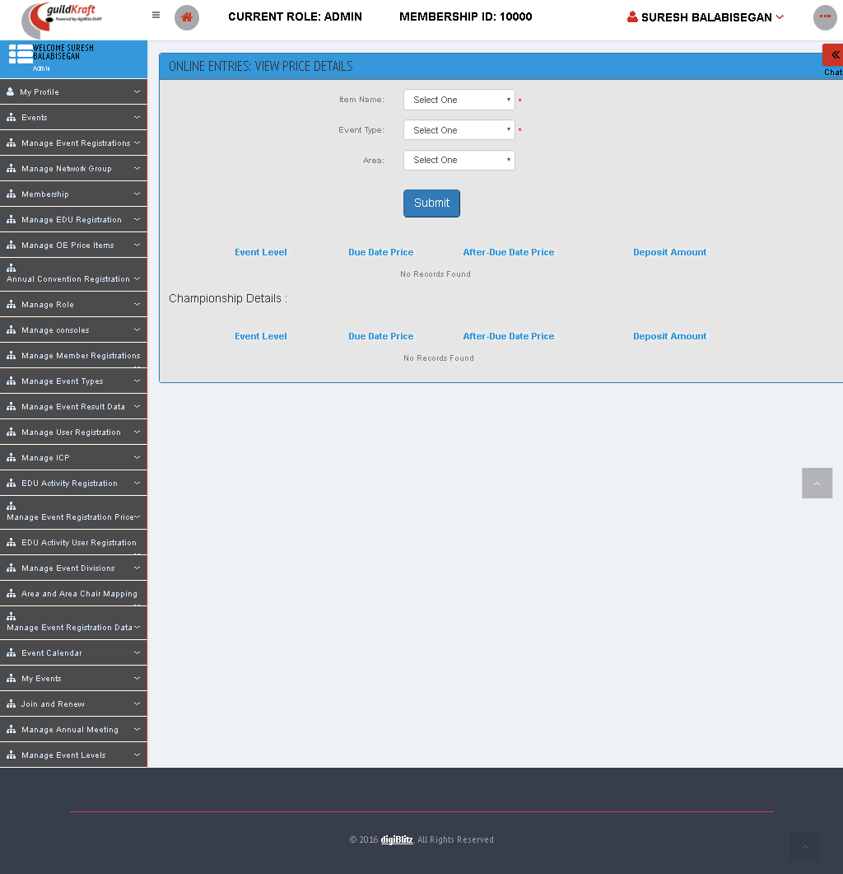

|  |  |  |
| --- | --- | --- |
| **Action** | **DB File** | **Table Name** |
| frmOEEStaffViewPrice.jsp file will call AddFixedPriceAction**.java** with event name initViewPrice**.** | .--. | -- |

### Set OE Fixed Price Items

Here we can insert the price details depending upon the Events and item name.

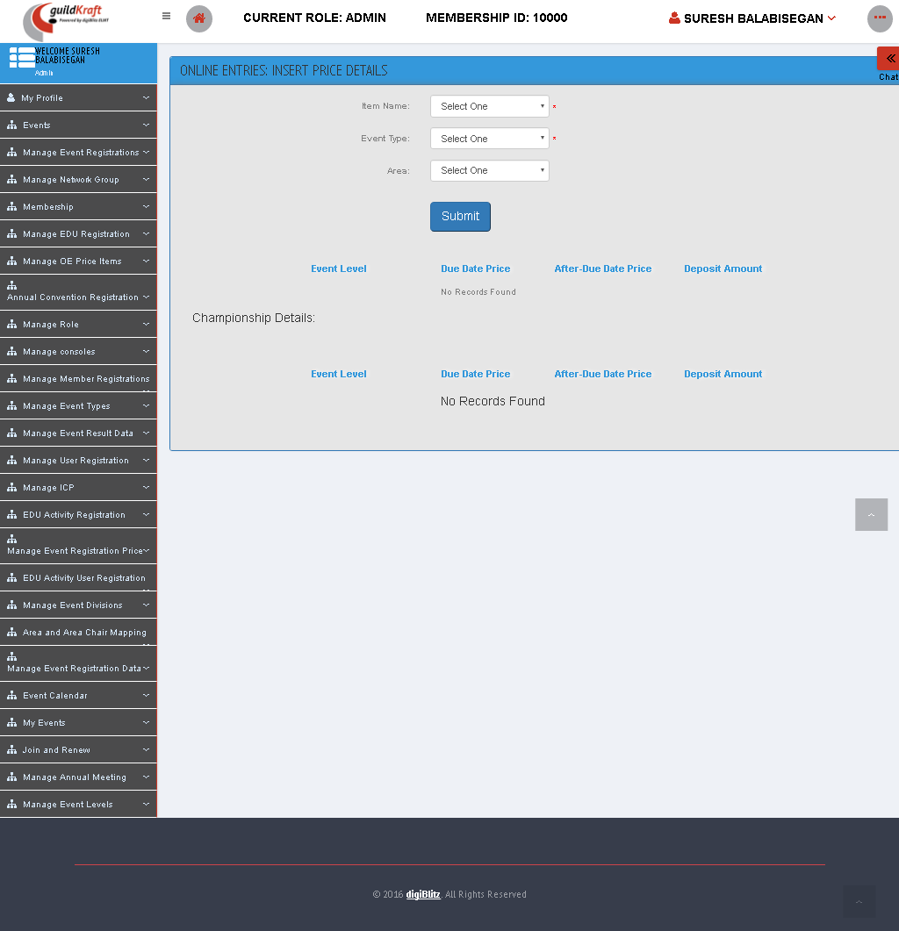

|  |  |  |
| --- | --- | --- |
| **Action** | **DB File** | **Table Name** |
| frmOEEStaffInsertPrice.jsp file will call AddFixedPriceAction**.java** with event name initPrice**.** | -- | -- |

## Annual Convention Registration

### List Annual Meeting Registration

In this permission we can see the list of meetings which were already conducted.

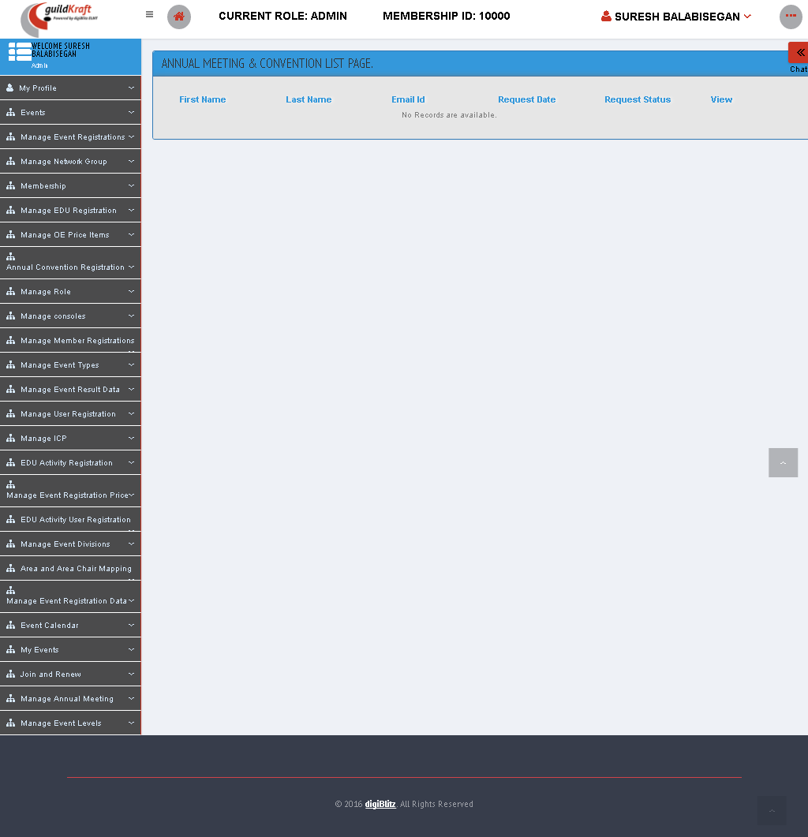

|  |  |  |
| --- | --- | --- |
| **Action** | **DB File** | **Table Name** |
| frmMeeUserAnnConRegiListings.jsp file will call AdminAnnualRegListAction**.java** with event name myListView**.** | DBHelper.java will pass values and save in database table. | tblMeeAnnualDetails  tblUserMaster  tblUserPaymentDetails |

## Manage Role

### Assign Roles Securities

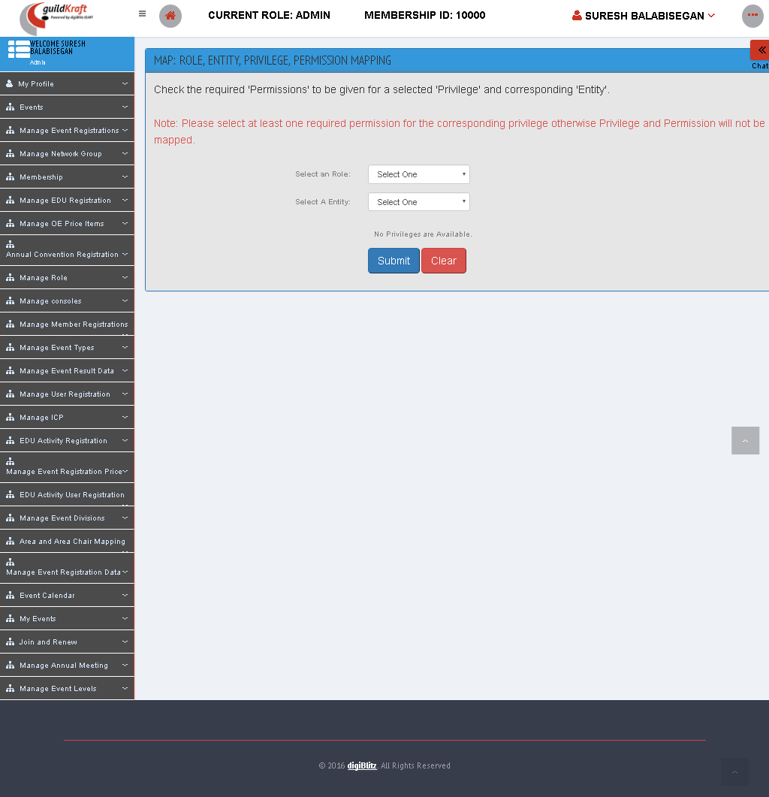 For each member , Certain privilege can be assigned to the corresponding entity and roles.

|  |  |  |
| --- | --- | --- |
| **Action** | **DB File** | **Table Name** |
| frmRolMRoleMapping.jsp file will call KlgRoleAction  .javawith event nameinitRoleEntPriv | GeneralDBAction.java will pass values and save in database table. | tblEntityMaster – get all entity  [tblMapEntity  tblMapUserPrivilege  tblMapRole  tblRoleMaster] – get all roles |

### Assign Roles to user

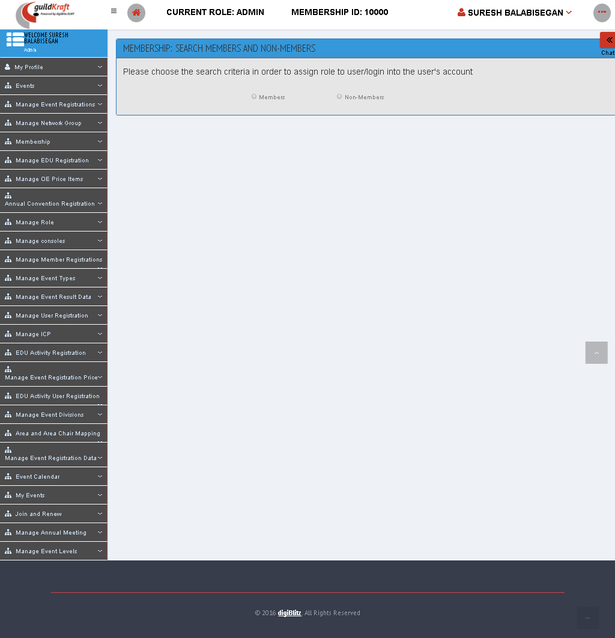Either Member or Nonmember search with Member ID or Username

|  |  |  |
| --- | --- | --- |
| **Action** | **DB File** | **Table Name** |
| frmMemberSearchList.jsp file will call KlgSearchAction  .javawith event nameinitViewDet | GeneralDBAction.java will pass values and save in database table. | [tblMapEntity  tblMapUserPrivilege  tblMapRole  tblRoleMaster] – get all roles with repesct to user ID to search a user |

* Then For each user the Different role will be assigned by the admin. Here clicking signin button it shows the dashboard page of concern user.
* On clicking “ASSIGN” button, the list of roles will be viewed, from the list certain role can be assigned to the concern user.

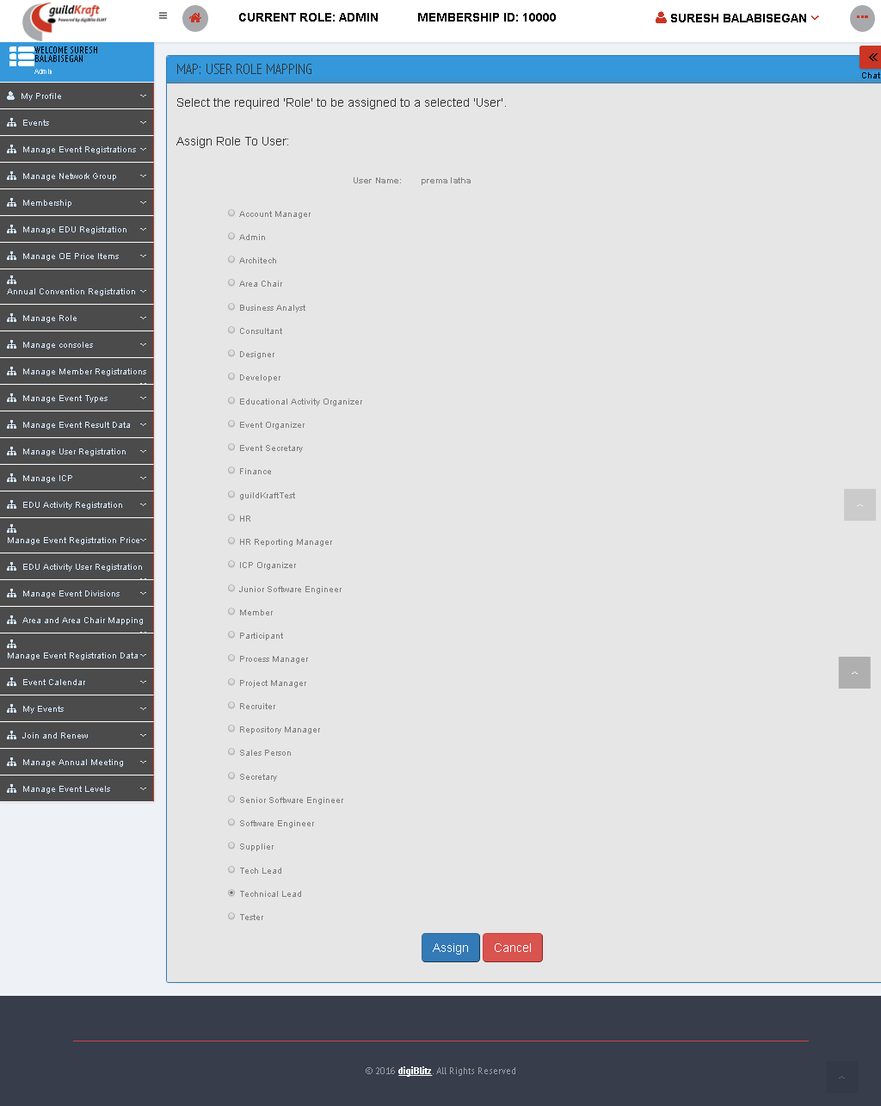

### Maintain Roles

It shows the list of role and its status whether it is active or inactive. Also One can Add/Edit or Delete the role.

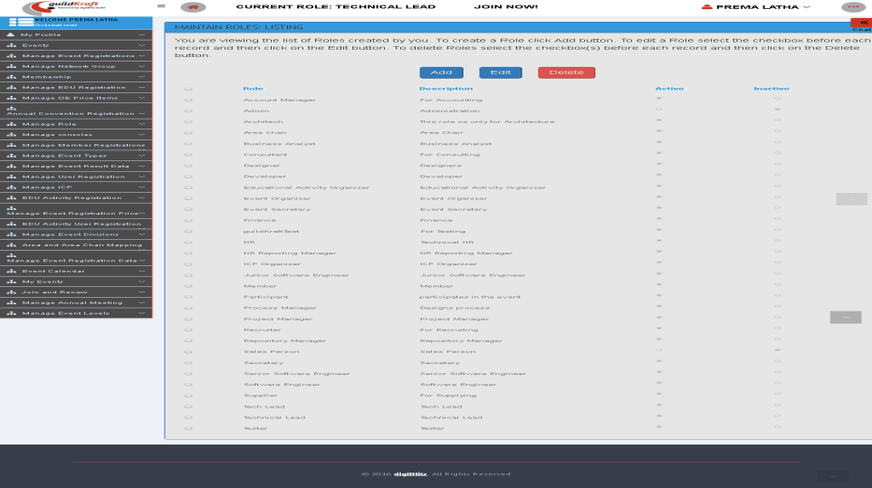

|  |  |  |
| --- | --- | --- |
| **Action** | **DB File** | **Table Name** |
| frmRolMListRoles.jsp file will call KlgRoleAction.javawith event nameroleList | GeneralDBAction.java will pass values and save in database table. | [tblMapEntity  tblMapUserPrivilege  tblMapRole  tblRoleMaster] – get all roles with repesct to user ID to search a user |

* New Role can be created by clicking on the “ADD” button.

|  |  |  |
| --- | --- | --- |
| **Action** | **DB File** | **Table Name** |
| frmRolMCreateRole.jsp file will call KlgRoleAction.javawith event nameinitCreateRole | GeneralDBAction.java will pass values and save in database table. | tblRoleMaster |

* Each Role can be edited by clicking on the “EDIT” button after selecting any one of the roles. “DELETE ” button is used to delete the particular role.

### Mapping Role with Entities

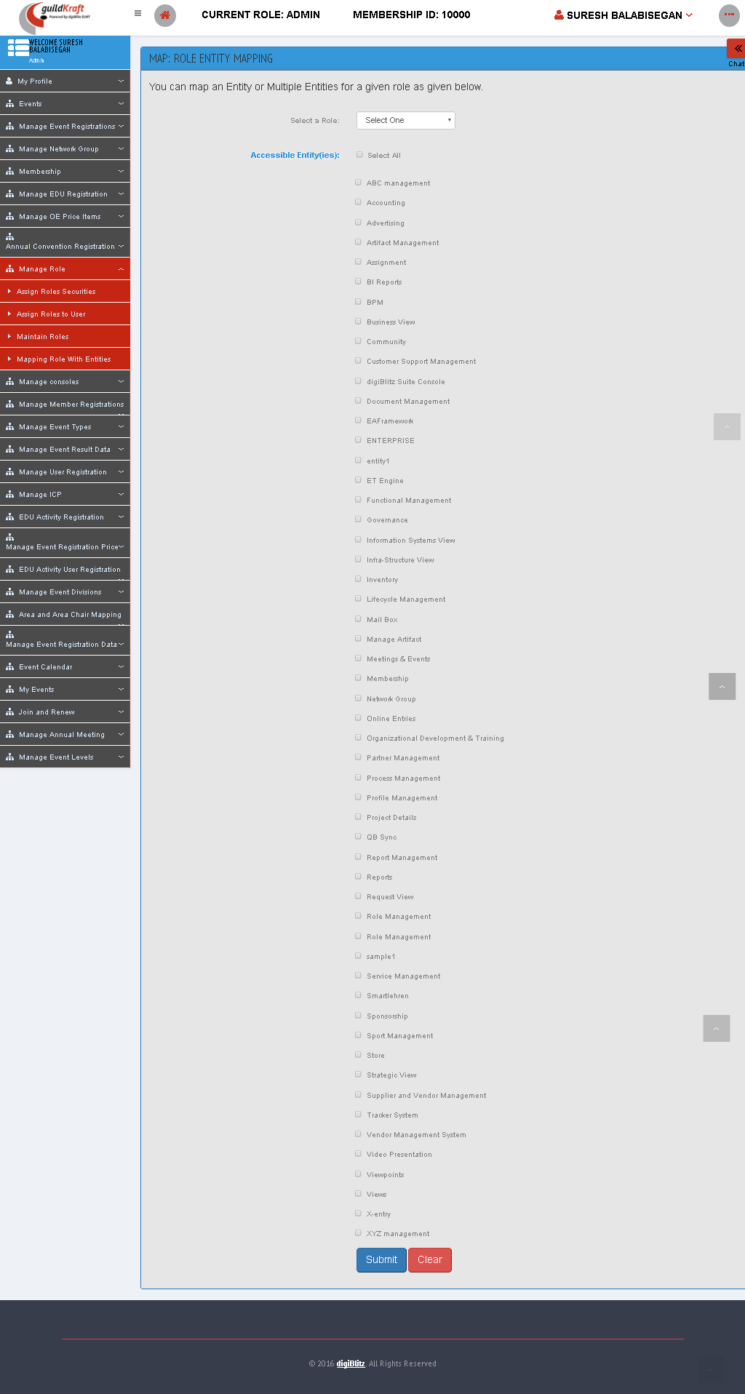 For each role, Admin can map the particular Entities ,that are available for that particular role.

|  |  |  |
| --- | --- | --- |
| **Action** | **DB File** | **Table Name** |
| frmRolMEntityRoleMapping.jsp file will call KlgRoleAction  .javawith event nameinitRoleEnt | GeneralDBAction.java will pass values and save in database table. | tblEntityMaster – get all entity  [tblMapEntity  tblMapUserPrivilege  tblMapRole  tblRoleMaster] – get all roles |

## Manage Member Registration

### List Registered Members

By selecting the membership type, status and year, it sort the list of available users .

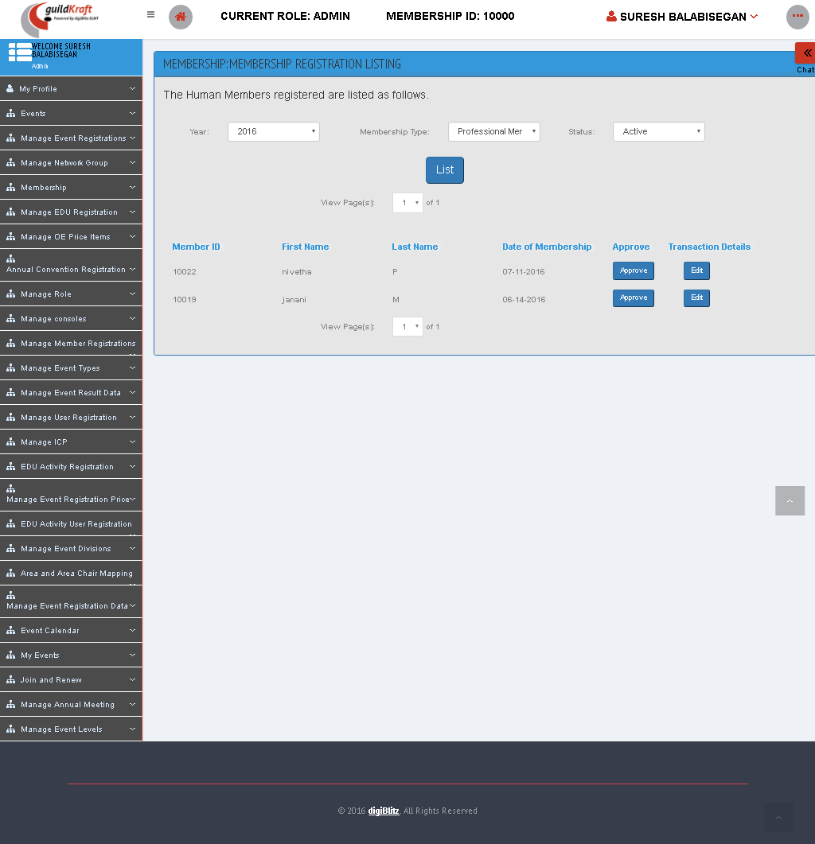

|  |  |  |
| --- | --- | --- |
| **Action** | **DB File** | **Table Name** |
| MemberRegiList.jsp file will call GldkftMembershipAction  .javawith event nameinitFind | -- | -- |

### New Member Registration

In this form, the user can Signup/Register for a new Member.

|  |  |  |
| --- | --- | --- |
| **Action** | **DB File** | **Table Name** |
| frmMemberUserRegistration.jsp file will call KlgUserAction  .javawith event nameinitUsrReg | GeneralDBAction.java will pass values and save in database table. | tblUserTypeMaster  tblContactDetails  tbluserpictures |

### Search members and Users

The Member can be searched with their Member ID or User Login Name.

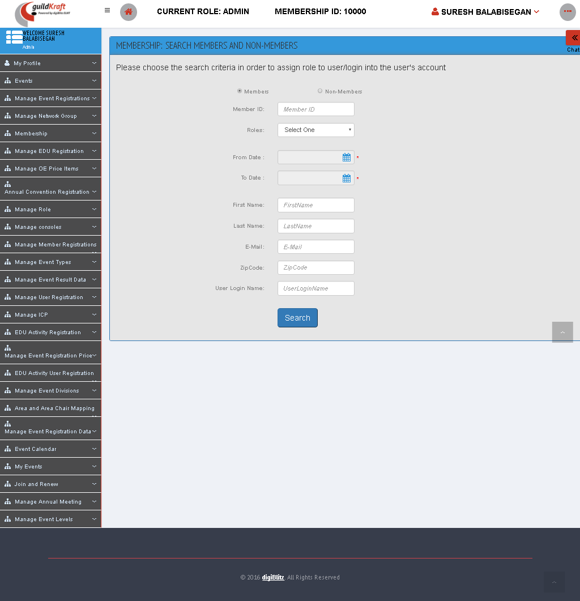

|  |  |  |
| --- | --- | --- |
| **Action** | **DB File** | **Table Name** |
| frmMemberSearchList.jsp file will call KlgSearchAction  .javawith event nameinitViewDet | GeneralDBAction.java will pass values and save in database table. | [tblMapEntity  tblMapUserPrivilege  tblMapRole  tblRoleMaster] – get all roles with repesct to user ID to search a user |

## Manage Event Types

### Add Event Type

Enter name of the events in “create an Event Type” field and then click “create” button.

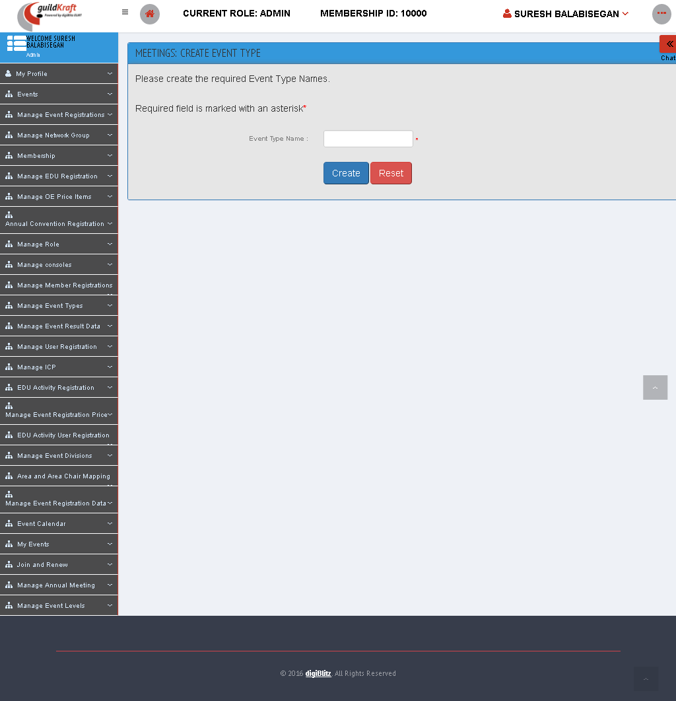

|  |  |  |
| --- | --- | --- |
| **Action** | **DB File** | **Table Name** |
| frmMeeEventTypeAdd.jsp file will call ActionEventType**.java** with event name newEventType**.** | DBHelper.java will pass values and save in database table. | tblMeeEventTypeMaster |

### List Event Type

In this permission we can see the list of events which were already created.

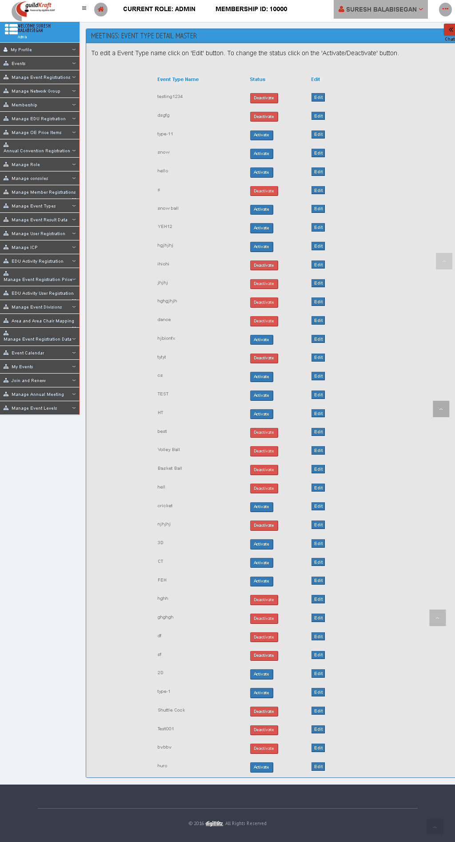

|  |  |  |
| --- | --- | --- |
| **Action** | **DB File** | **Table Name** |
| frmMeeEventTypeList.jsp file will call ActionEventType**.java** with event name initList**.** | DBHelper.java will pass values and save in database table. | tblMeeEventTypeMaster |

## Manage Event Result Data

### Map Event Result Field with Type

You can map an **Event Level** or Multiple **Event Level** for a given “Membership Type Name” as given below.

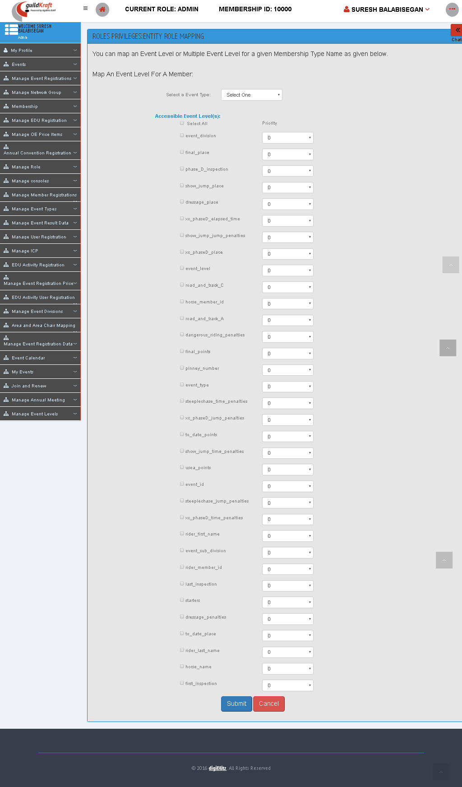

|  |  |  |
| --- | --- | --- |
| **Action** | **DB File** | **Table Name** |
| frmMemPriorityMap.jsp file will call MemEventLevelMapAction**.java** with event name newPriorityMap**.** | DBHelper.java will pass values and save in database table. | tblMeeEventTypeMaster – loads all event type |

### Upload Event Result

Fill the fields accordingly and click “upload” button to upload the Some of the excel sheet or report of that event.

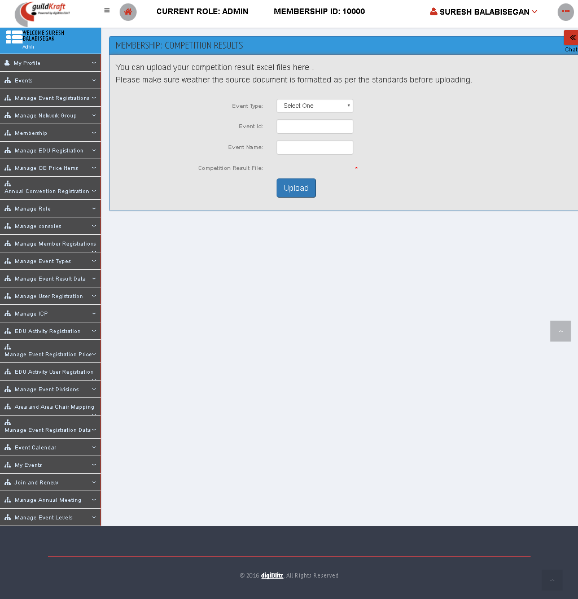

|  |  |  |
| --- | --- | --- |
| **Action** | **DB File** | **Table Name** |
| uploadHorseCompExcel.jsp file will call HorseCompDataMapping**.java** with event name viewUpload**.** | DBHelper.java will pass values and save in database table. | tblMeeCompResultFileDetails |

## EDU Activity Registration

### EDU Activity Registration

This page shows the registration form for the Educational Activity.

|  |  |  |
| --- | --- | --- |
| **Action** | **DB File** | **Table Name** |
| frmMeeEduActivity.jsp file will call ActionMadhurai**.java** with event name initEduOrg**.** | -- | -- |

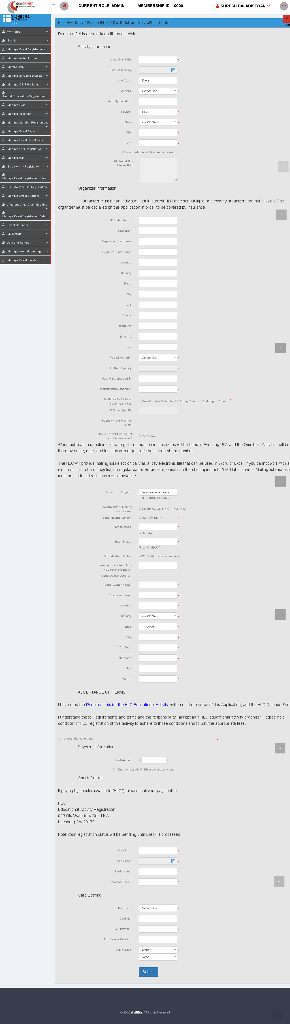

### List Activity Request

It displays the list of Educational Activity meeting with its status.

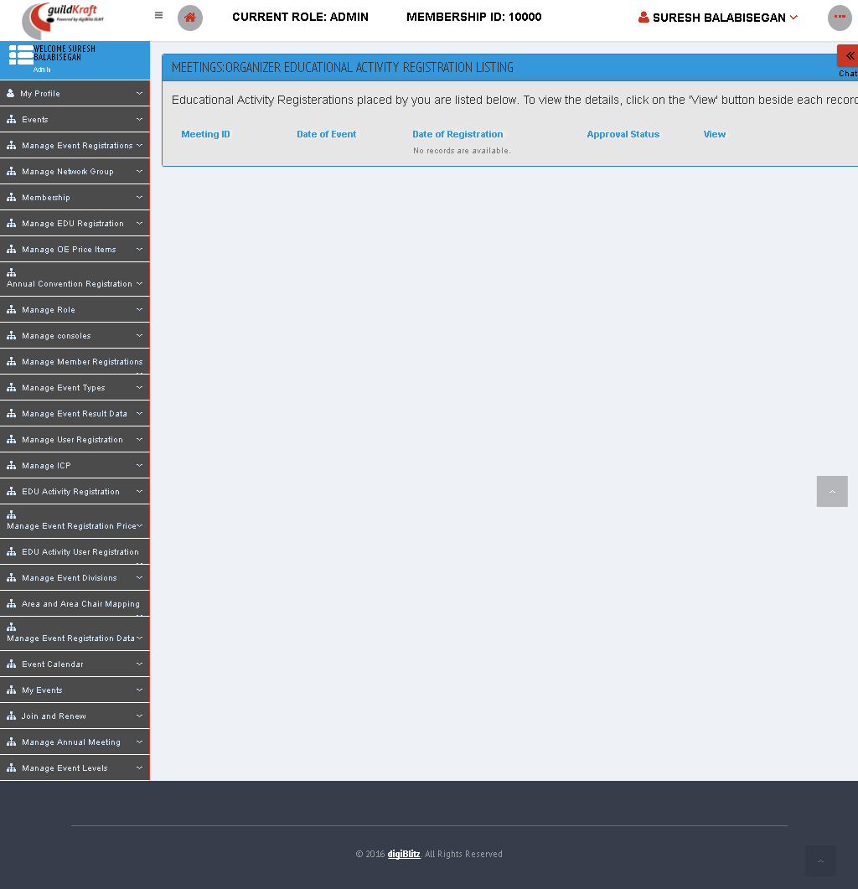

|  |  |  |
| --- | --- | --- |
| **Action** | **DB File** | **Table Name** |
| frmMeeOrgEduActRegiListing.jsp file will call ActionMeeting**.java** with event name orgOwnList**.** | -- | -- |

### List User Request

**==============Add==============**

## Manage Event Registration Price

### List All Event Registration Price

Select “price type” and click “Submit” to view the list of Events.

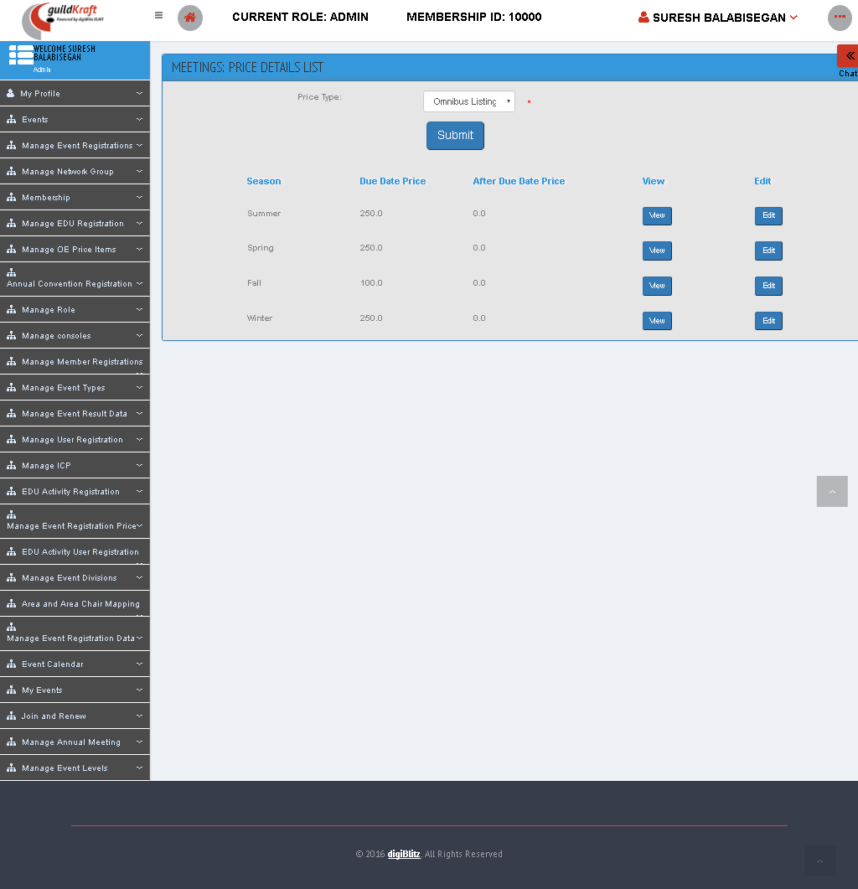

|  |  |  |
| --- | --- | --- |
| **Action** | **DB File** | **Table Name** |
| frmMeeEventRegPriceList.jsp file will call EventRegPriceAction**.java** with event name initListPrice**.** | DBHelper.java will pass values and save in database table. | tblMeeEventRegistrationPriceMaster - displays the price types.  tblAdvIssueMaster  tblMeeEventRegistrationPriceDetails - displays the price details. |

### Set Event Registration Price

Fill the fields accordingly and click “Add” button.

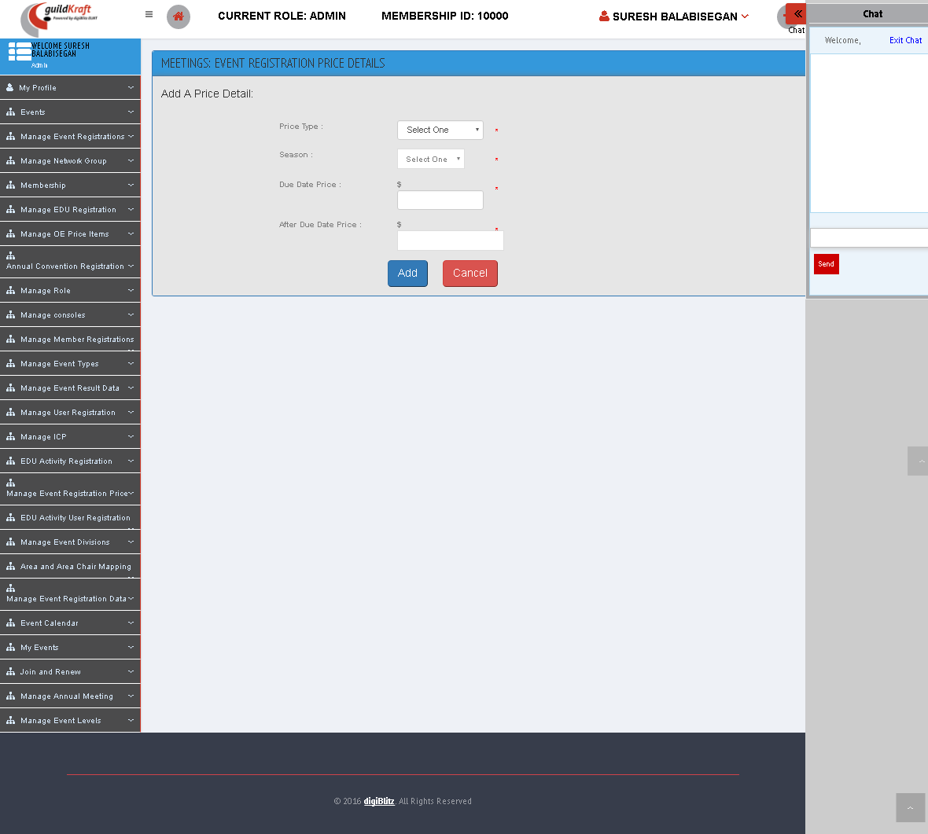

|  |  |  |
| --- | --- | --- |
| **Action** | **DB File** | **Table Name** |
| frmMeeEventRegPriceAdd.jsp file will call EventRegPriceAction**.java** with event name initCreatePrice**.** | DBHelper.java will pass values and save in database table. | tblMeeEventRegistrationPriceDetails - displays the price details. |

## EDU Activity User Registration

### Apply EDU Activity

It shows the list of activity requests. To Apply this click “Apply” button.

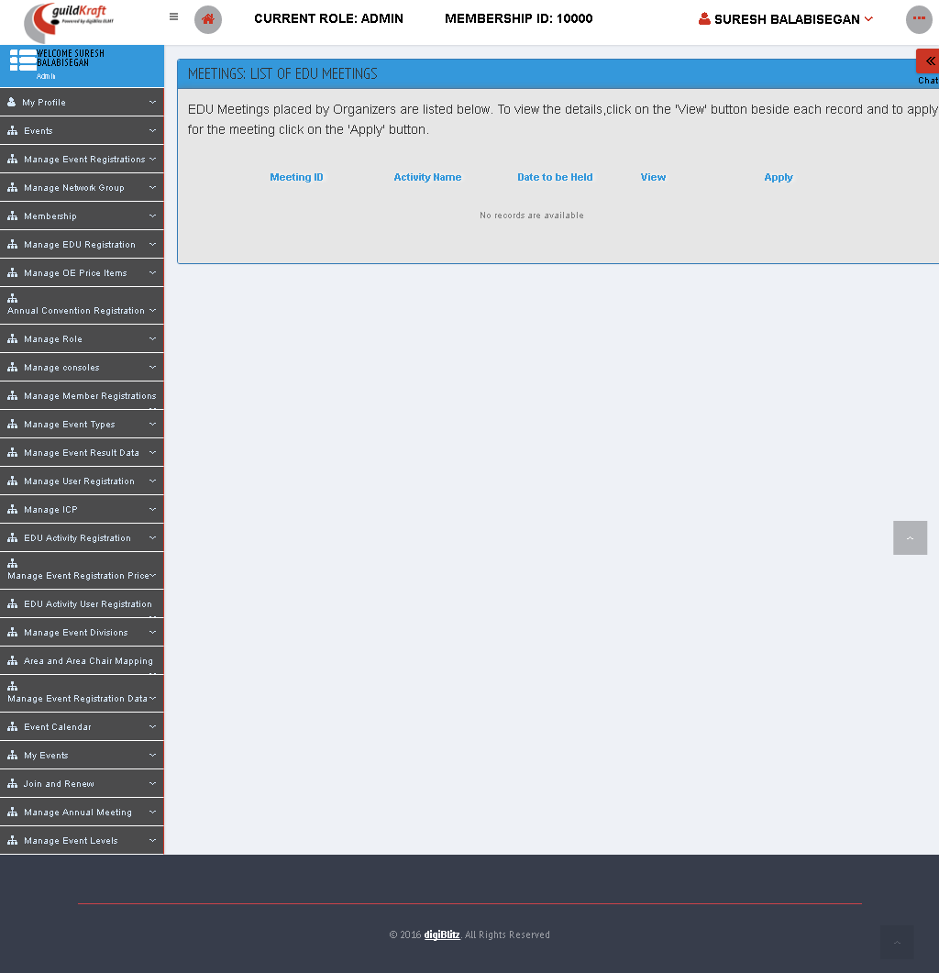

|  |  |  |
| --- | --- | --- |
| **Action** | **DB File** | **Table Name** |
| frmMeeUserEduMeeListing.jsp file will call ActionMeeting**.java** with event name statusApproved**.** | -- | -- |

### List EDU Activity Requests

It shows the list of activity requests. To view this click “View” button.

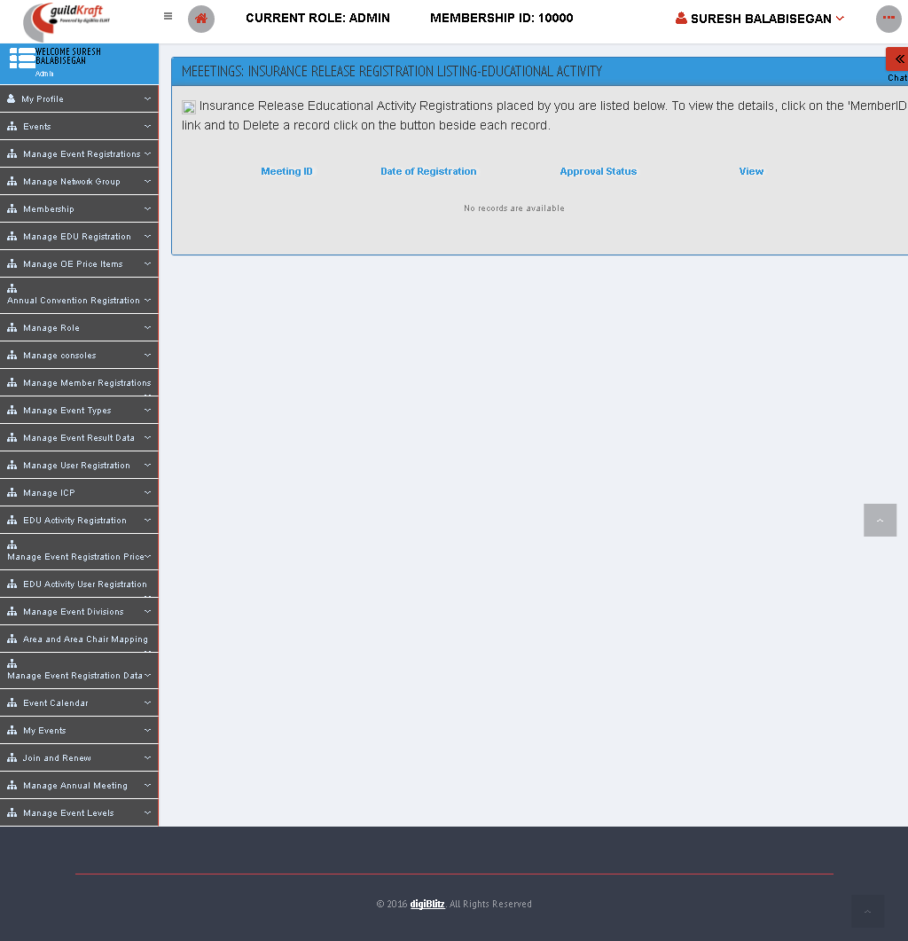

|  |  |  |
| --- | --- | --- |
| **Action** | **DB File** | **Table Name** |
| frmMeeUserEduActInsureRegiListing.jsp file will call ActionMeeting**.java** with event name userStatus**.** | DBHelper.java will pass values and save in database table. | tblMeeEduActivityUserDetails |

## Manage Event Divisions

### Add Event Divisions

Fill the fields accordingly and click “Create” button.

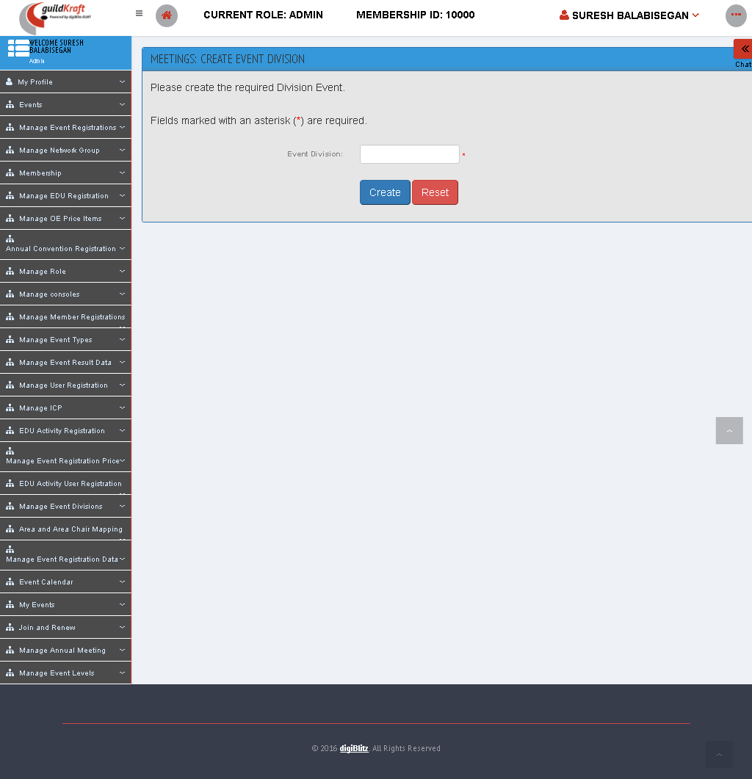

|  |  |  |
| --- | --- | --- |
| **Action** | **DB File** | **Table Name** |
| frmMeeDivisionEventTypeCreate.jsp file will call DivisionEventTypeMasterAction**.java** with event name add**.** | DBHelper.java will pass values and save in database table. | tblMeeEventDivisionMaster |

### List Event Divisions

To edit an Event Type name click on **'Edit'** button. To change the status click on the **'Activate/Deactivate'** button.

|  |  |  |
| --- | --- | --- |
| **Action** | **DB File** | **Table Name** |
| frmMeeDivisionEventList.jsp file will call DivisionEventTypeMasterAction**.java** with event name list**.** | DBHelper.java will pass values and save in database table. | tblMeeEventDivisionMaster |

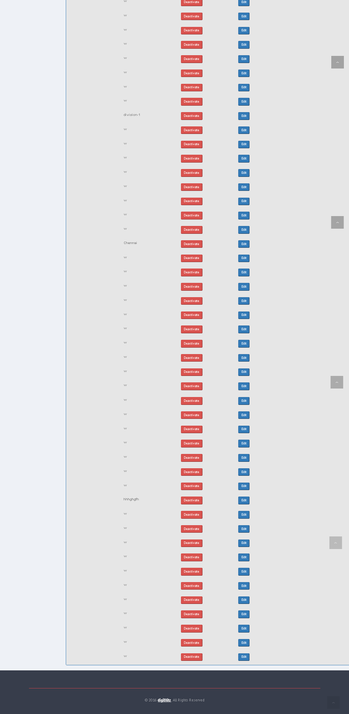

## Area and Area Chair Mapping

### Listing Area Chair and Area Person

To edit Area chair id and area click on **'Edit'** button.

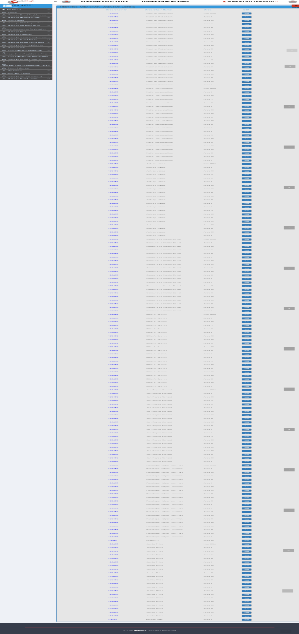

|  |  |  |
| --- | --- | --- |
| **Action** | **DB File** | **Table Name** |
| frmMeeACAreaMapListing.jsp file will call ActionEventOrgRenewal**.java** with event name mapAreaAndAreaChairListing**.** | DBHelper.java will pass values and save in database table. | tblMeeMapAreaChair  tblMeeAreaMaster  tblUserMaster |

### Mapping Area Chair and Area Person

To map the area, to Area person fill the following fields and click “Assign” button.

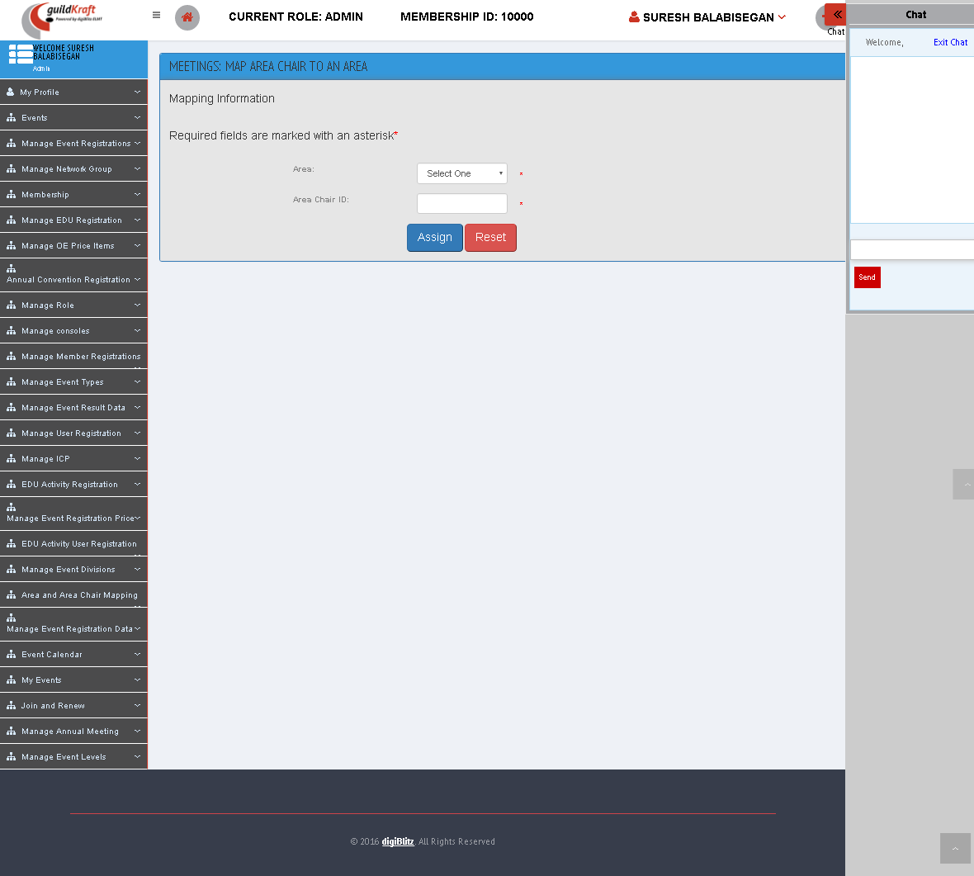

|  |  |  |
| --- | --- | --- |
| **Action** | **DB File** | **Table Name** |
| frmMeeMapACAreaMaster.jsp file will call ActionEventOrgRenewal**.java** with event name initMapAreaAndAreaChair**.** | DBHelper.java will pass values and save in database table. | tblMeeMapAreaChair  tblMeeAreaMaster  tblUserMaster |

### Mapping Area State Zip

Mapping area according to state and zip code, fill the following fields and click “Submit” button.

|  |  |  |
| --- | --- | --- |
| **Action** | **DB File** | **Table Name** |
| frmMeeMapAreaZip.jsp file will call ActionEventOrgRenewal**.java** with event name initMapStateZip**.** | DBHelper.java will pass values and save in database table. | tblMeeMapAreaChair  tblMeeAreaMaster  tblUserMaster |

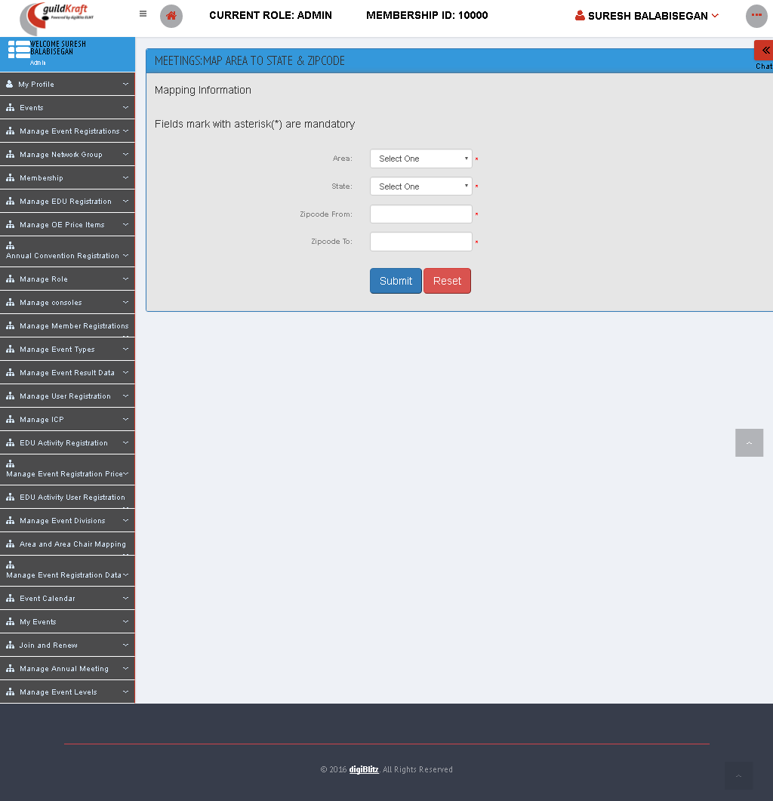

## Manage Event Registration Data

### List Uploaded Event Registration Data

Shows the list of uploaded files, Click “MAP” button to map with the registered details. Click “VALIDATE” button to validate for qualification. Click “DELETE” button to the uploaded details.

|  |  |  |
| --- | --- | --- |
| **Action** | **DB File** | **Table Name** |
| frmMemLstUploadReg.jsp file will call UploadRegDataAction**.java** with event name listUploadDetails**.** | -- | -- |

### Map Event Level with Membership type

Here map the different Event Level for Each Membership Type.

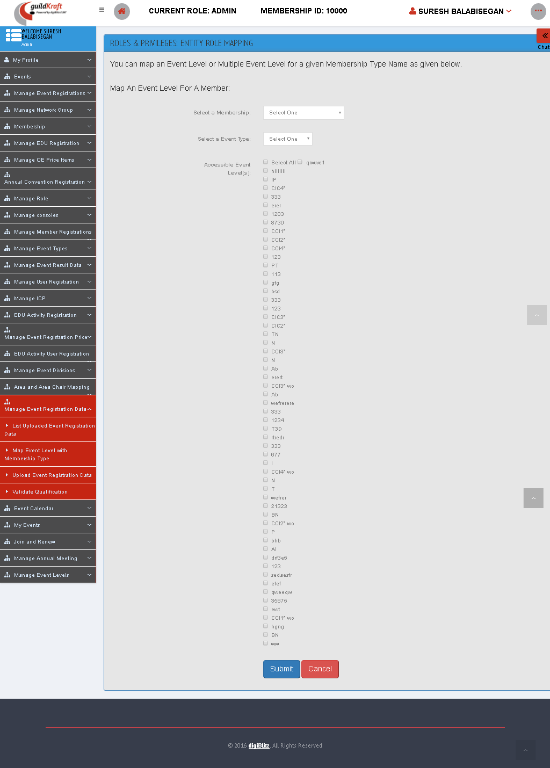

|  |  |  |
| --- | --- | --- |
| **Action** | **DB File** | **Table Name** |
| frmMemEventLevelMap.jsp file will call MemEventLevelMapAction**.java** with event name newMap**.** | -- | -- |

### Upload Event Registration Data

Upload the Competition Excel sheet here.

|  |  |  |
| --- | --- | --- |
| **Action** | **DB File** | **Table Name** |
| frmMemUploadHorseReg.jsp file will call UploadRegDataAction**.java** with event name viewUpload**.** | -- | -- |

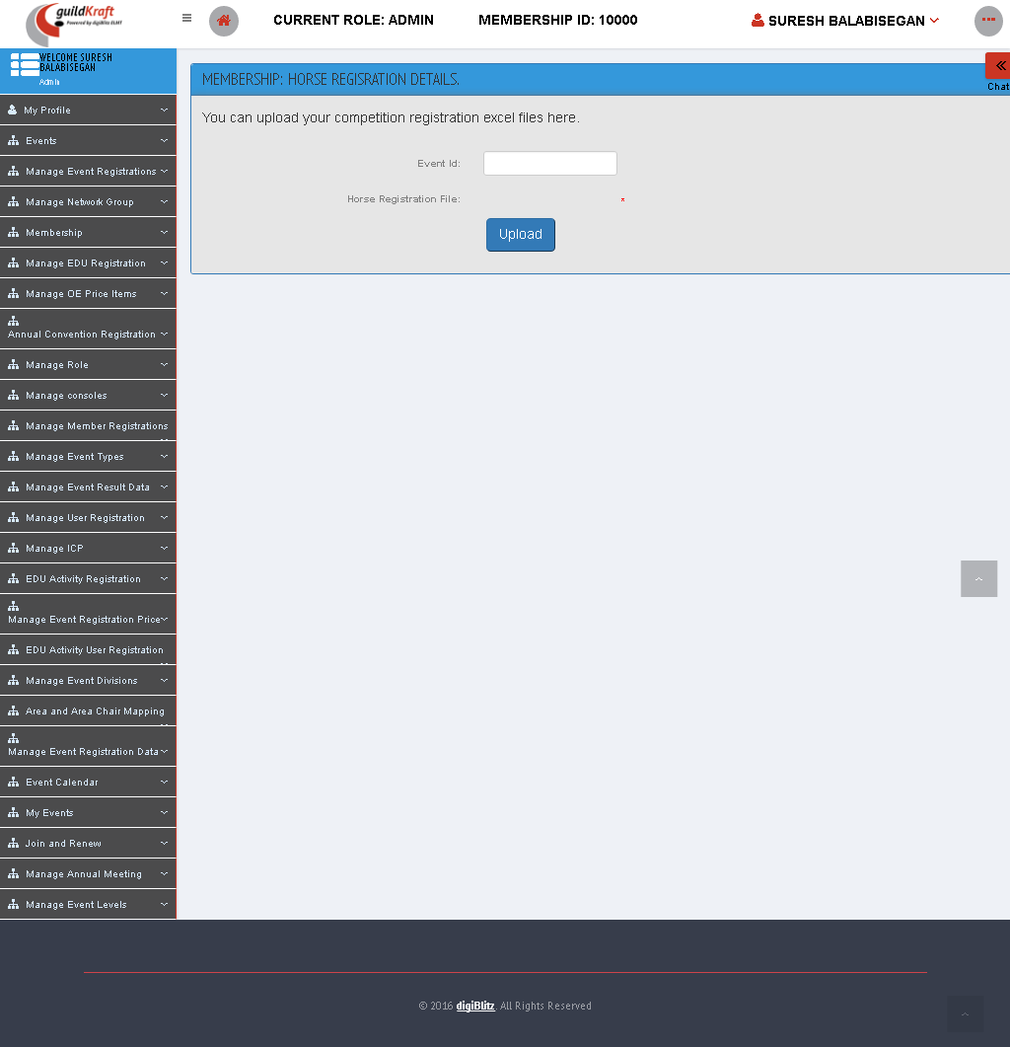

### Validate Qualification

Here map the qualification detail for each Event Level with corresponding Event Type.

|  |  |  |
| --- | --- | --- |
| **Action** | **DB File** | **Table Name** |
| frmMapValidation.jsp file will call MapValidationAction**.java** with event name newMapValidate**.** | -- | -- |

## Event Calendar

### Search Event

Search for an Event to know the details of that Event like location, Status, Event date.

|  |  |  |
| --- | --- | --- |
| **Action** | **DB File** | **Table Name** |
| frmOECSearchEvents.jsp file will call calendarAction**.java** with event name initSearch**.** | -- | -- |

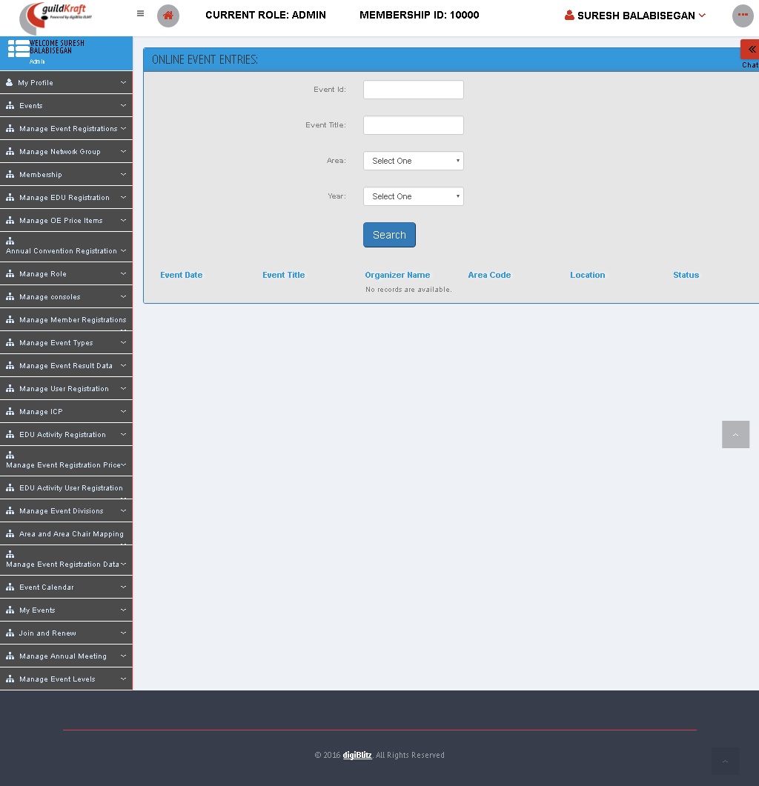

### View Event Calendars

Shows the list of Events with complete details.

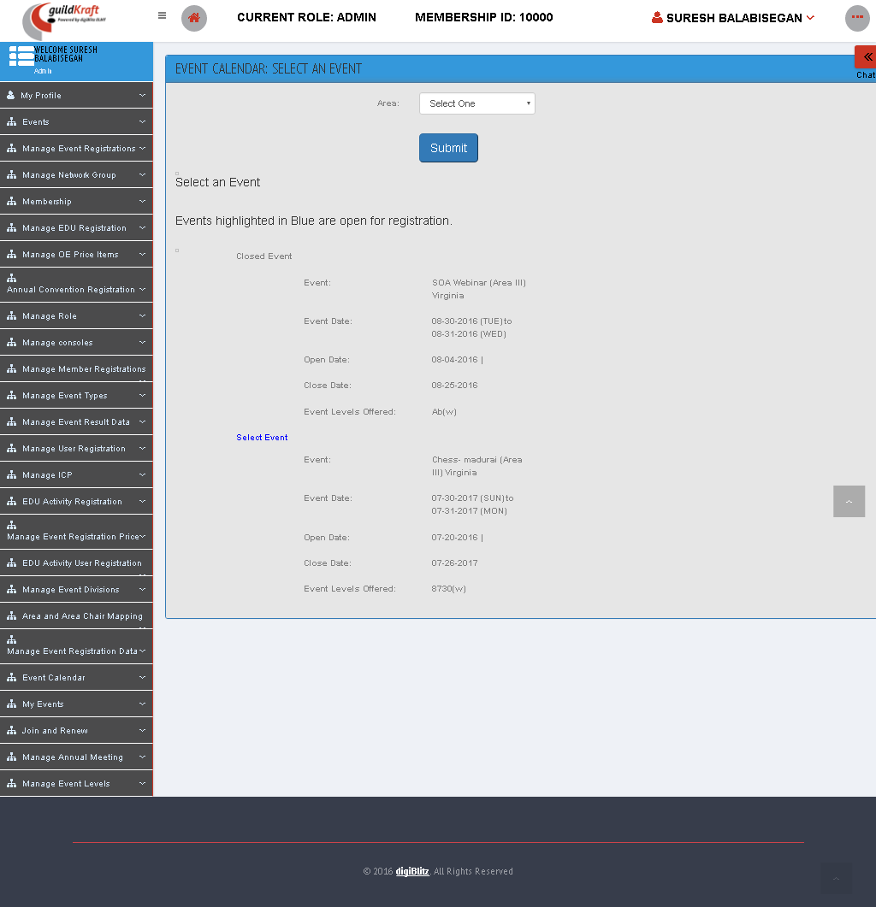

|  |  |  |
| --- | --- | --- |
| **Action** | **DB File** | **Table Name** |
| frmFinalizedEventCalendar.jsp file will call OnlineEntriesListAction**.java** with event name intEveCalList**.** | -- | -- |

### View My Event Registrations

By Selecting the Year, sort the Event that shows with detail like Event ID, Type, Level.

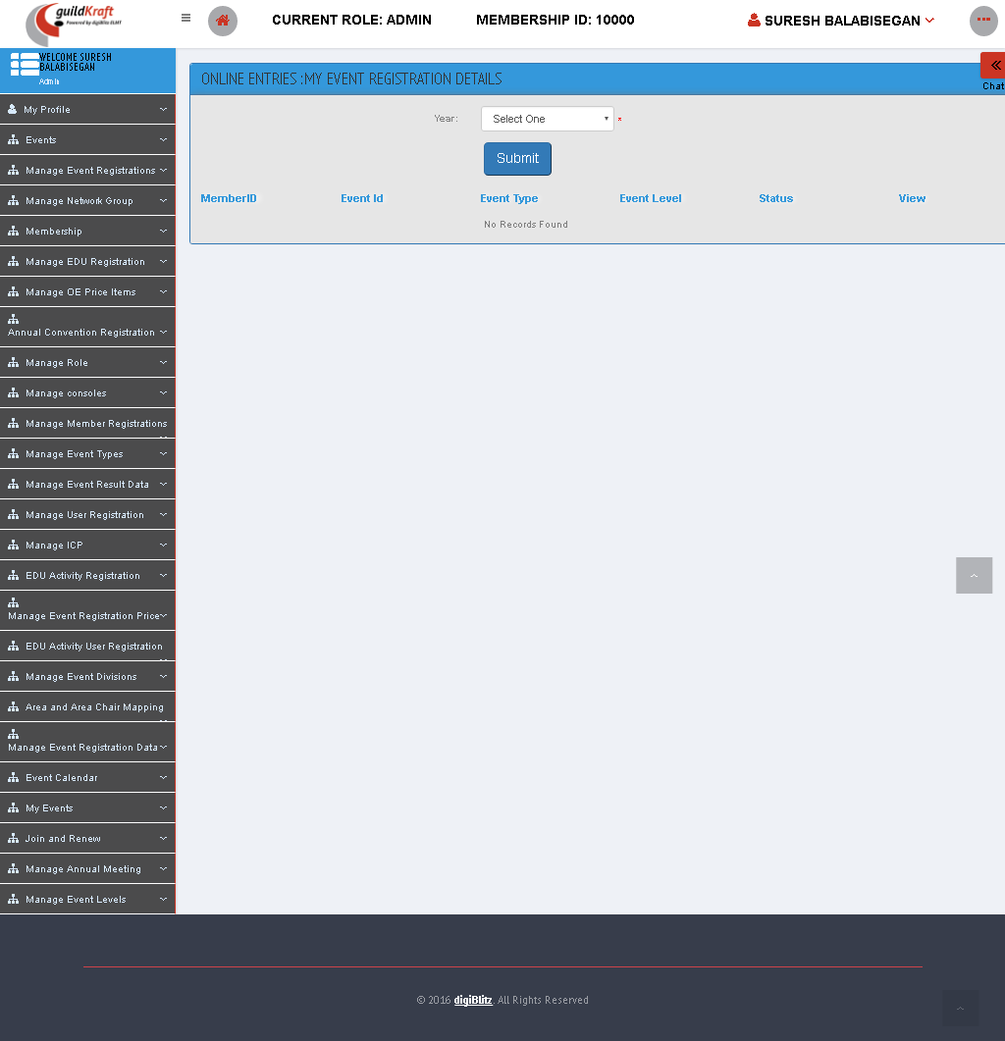

|  |  |  |
| --- | --- | --- |
| **Action** | **DB File** | **Table Name** |
| frmOEMParticipantList.jsp file will call ParticipantCompRegListAction**.java** with event name initPartiList**.** | -- | -- |

## My Events

### Approve Event Registrations

To see the list of status select “Status” and “Completion Year” and click “Submit” button.

|  |  |  |
| --- | --- | --- |
| **Action** | **DB File** | **Table Name** |
| frmListEventRegistration.jsp file will call EventRegListing**.java** with event name eventReg**.** | ELMTdbaction.java will pass values and save in database table. | tblMeeEventDetails  tblMeeMapAreaChair |

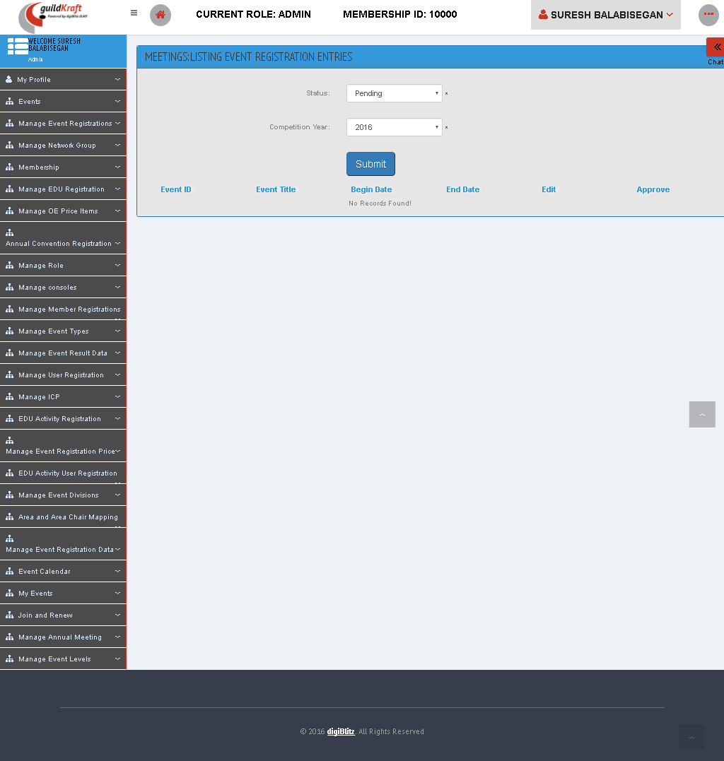

### List Posted Events

To see the list of event registered list click “**Status**” and click “**Submit**” button.

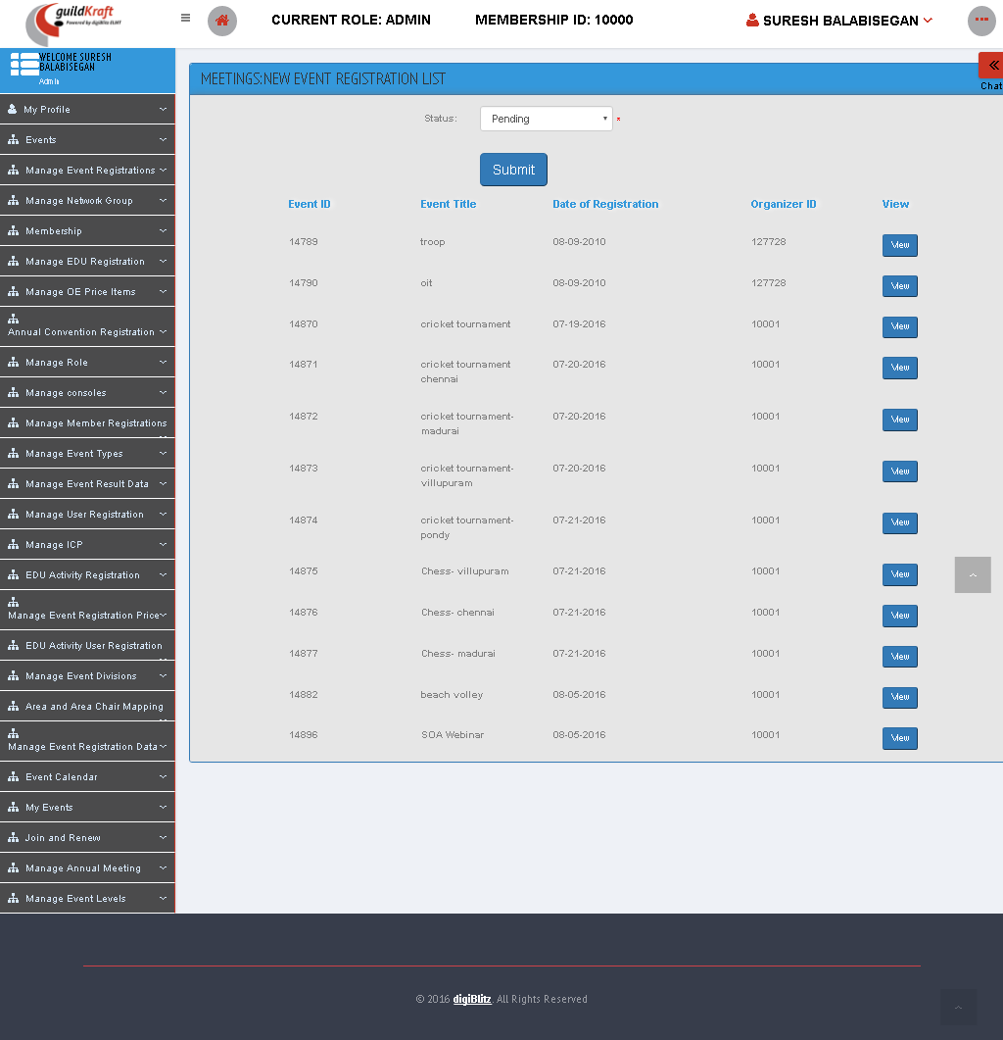

|  |  |  |
| --- | --- | --- |
| **Action** | **DB File** | **Table Name** |
| frmMeeUserNewEveRegListing.jsp file will call EventRegListing**.java** with event name initUserList**.** | -- | -- |

### Register New Events

Fill the registration page as given below and click **“Submit”** button.

|  |  |  |
| --- | --- | --- |
| **Action** | **DB File** | **Table Name** |
| frmEventRequestReg.jsp file will call OrganizerHLCEventRegAction**.java** with event name reqreg**.** | ELMTdbaction.java will pass values and save in database table. | tblMeeEventDetails |

### View Event Details

To review the Event details, click on the **Event ID**. To edit event divisions, click the **Edit** button Once payment is made, click **Update** button to create/update the Omnibus Listing.

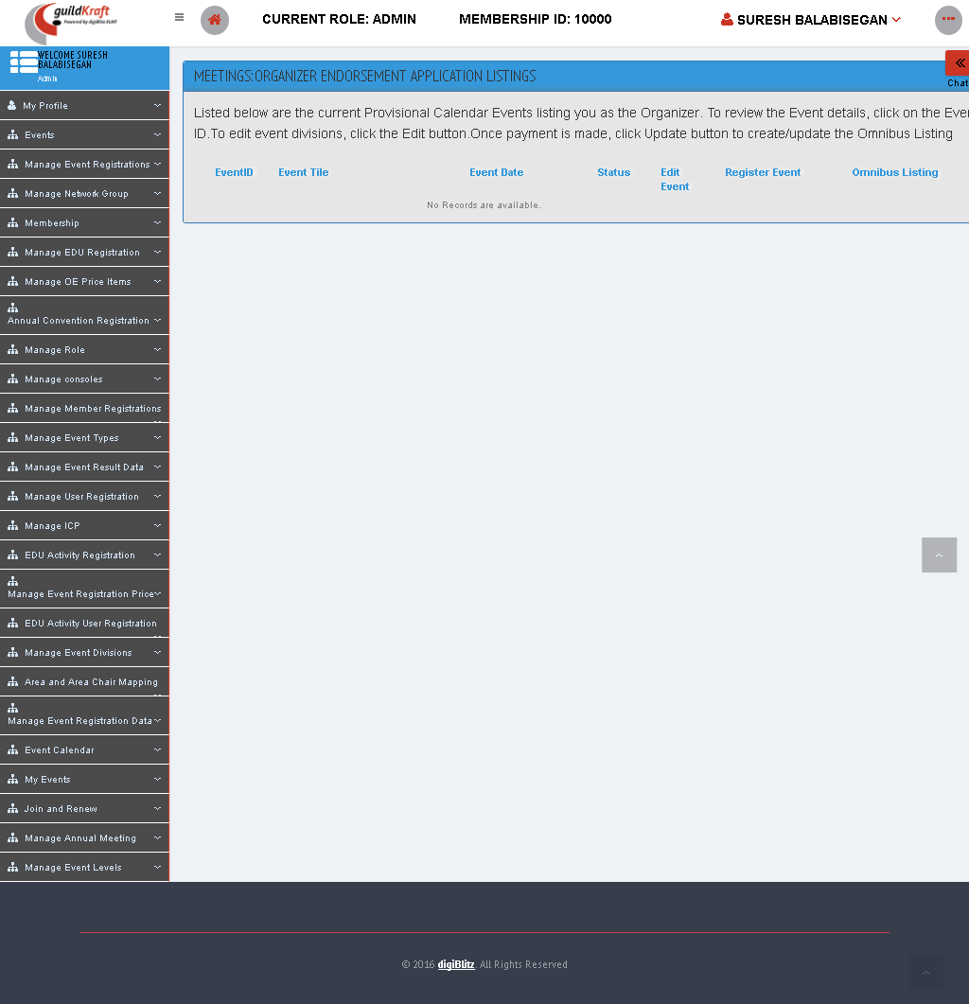

|  |  |  |
| --- | --- | --- |
| **Action** | **DB File** | **Table Name** |
| frmMeeOrgEventListings.jsp file will call ActionEventOrgRenewal**.java** with event name eventViewOrg**.** | -- | -- |

## Join and Renew

### Join as Member

Here the User can become a Member by selecting the membership type and Continue with further processing.

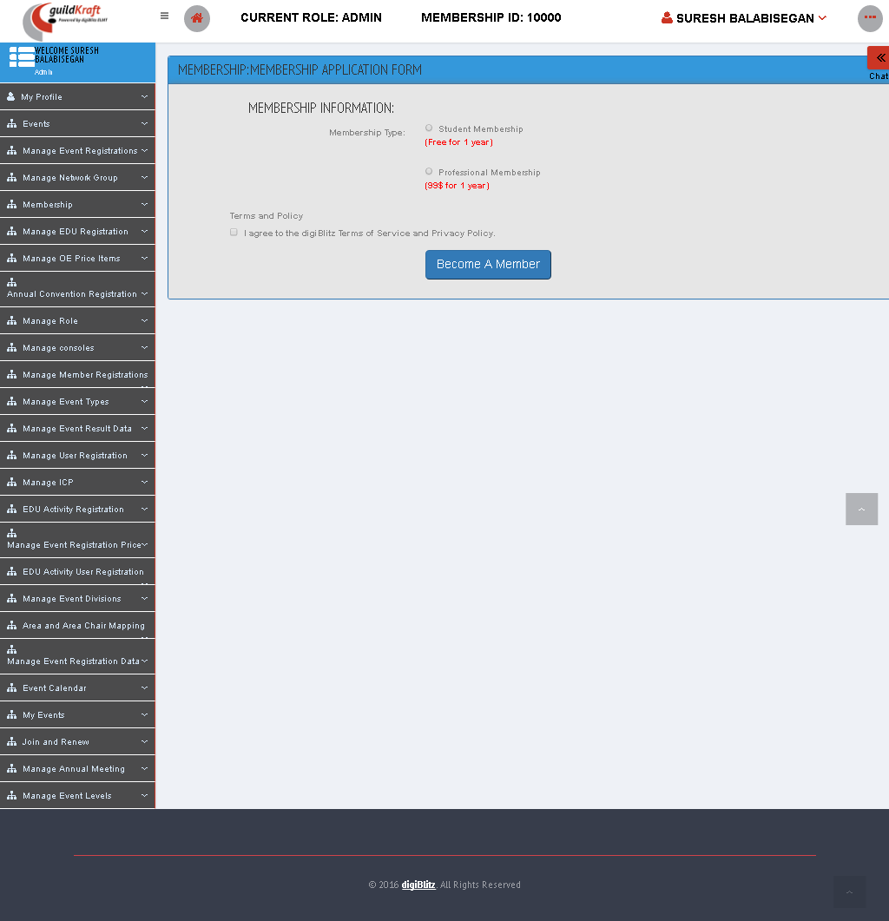

|  |  |  |
| --- | --- | --- |
| **Action** | **DB File** | **Table Name** |
| preMemberShip.jsp file will call GldkftMembershipRegistrationAction**.java** with event name preMemReg**.** | GeneralDBAction.java will pass values and save in database table. | tblMemberSubscription – displays all publication name |

### Renew/Upgrade My Membership

This page shows the Membership renewal and also payment information.

|  |  |  |
| --- | --- | --- |
| **Action** | **DB File** | **Table Name** |
| memb-reg-ren-eligibility.jsp file will call GldkftMembershipRegistrationAction**.java** with event name renew**.** | -- | -- |

## Manage Annual Meetings

### List Annual Convention Registrations

Select the “Status” to see user requests.

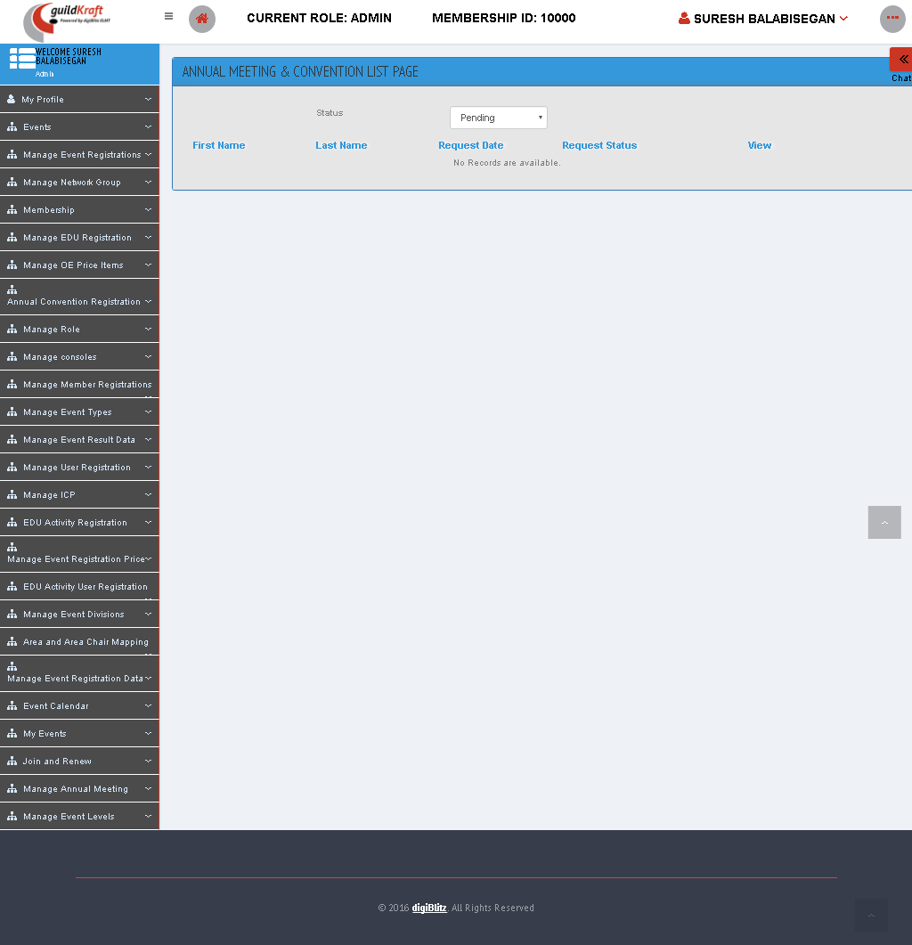

|  |  |  |
| --- | --- | --- |
| **Action** | **DB File** | **Table Name** |
| frmMeeAdminAnnConRegiListings.jsp file will call AdminAnnualRegListAction**.java** with event name initAdminView**.** | -- | -- |

### List Annual Meeting price

Select event type and specifications to view the list of “price detail master”.

|  |  |  |
| --- | --- | --- |
| **Action** | **DB File** | **Table Name** |
| frmMeeAdminAnnConPriceDetailListings.jsp file will call AddMeePriceDetailMasterAction**.java** with event name initPriceList**.** | -- | -- |

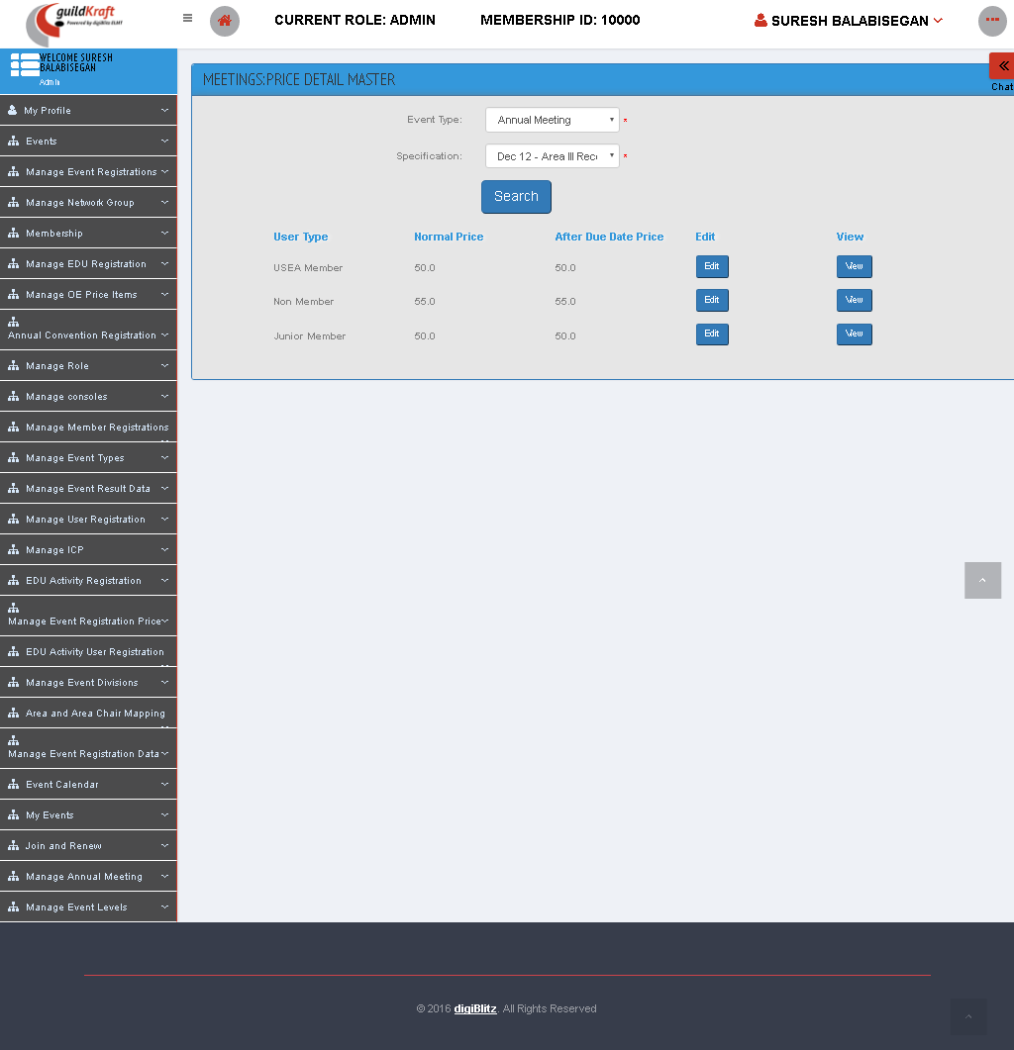

* To Edit the price details Click “EDIT” button and update with the new information.

|  |  |  |
| --- | --- | --- |
| **Action** | **DB File** | **Table Name** |
| frmMeeAdminAnnConPriceDetailEdit.jsp file will call AddMeePriceDetailMasterAction**.java** with event name viewEditPriceList**.** | -- | -- |

* To view the price details of that Event click “VIEW” Button.

|  |  |  |
| --- | --- | --- |
| **Action** | **DB File** | **Table Name** |
| frmMeeAdminAnnConPriceDetailView. jsp file will call AddMeePriceDetailMasterAction**.java** with event name viewEditPriceList**.** | -- | -- |

### Set Annual Meeting price

Fill the details given below and we can set meeting price for an event.

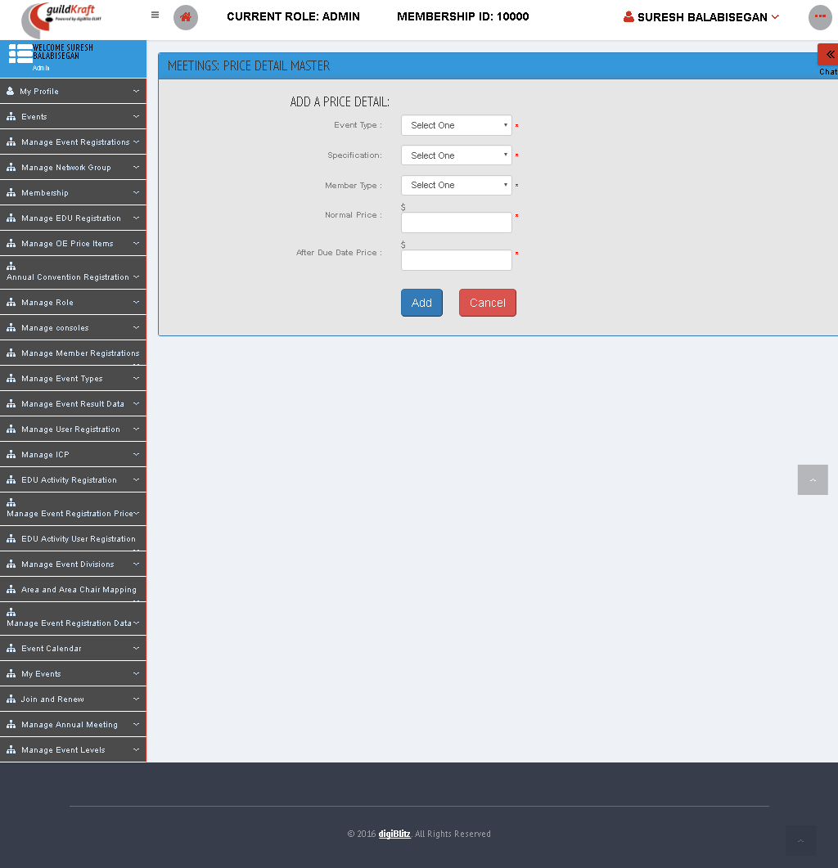

|  |  |  |
| --- | --- | --- |
| **Action** | **DB File** | **Table Name** |
| mee-price-detail-master-Ajax. jsp file will call AddMeePriceDetailMasterAction**.java** with event name addPriceMaster**.** | -- | -- |

### Set Annual Meeting Registration Date

To create a meeting, fill the start date, end date and no of days then click “Set Date” to create a meeting.

|  |  |  |
| --- | --- | --- |
| **Action** | **DB File** | **Table Name** |
| frmMeeAdminSetDateMaster. jsp file will call AdminSetDateMasterAction**.java** with event name adminSetDateProcess**.** | -- | -- |

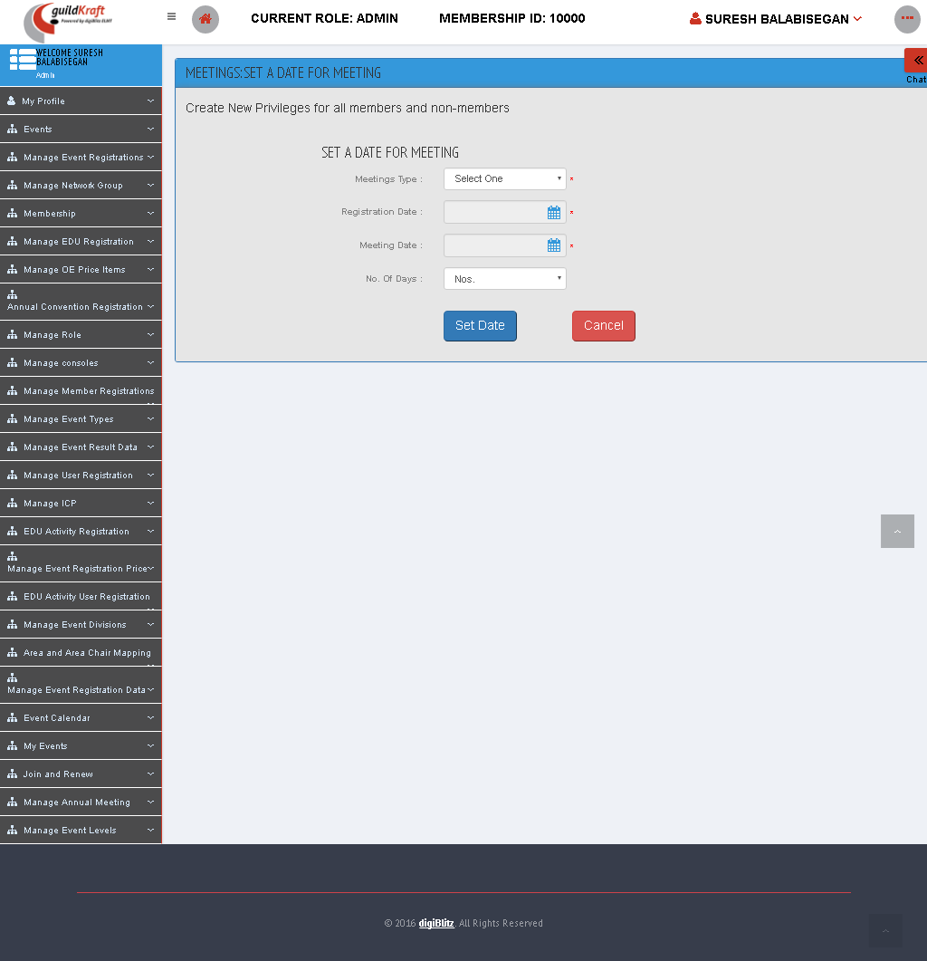

## Manage Event Levels

### Add Event Level

To create event level enter event name and event code and then click **“Create”** button.

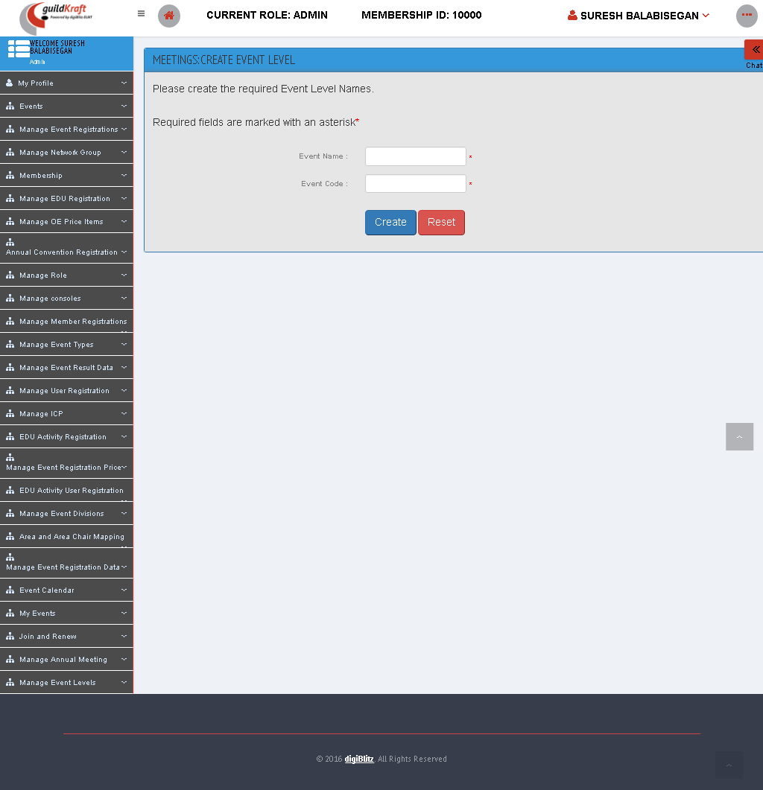

|  |  |  |
| --- | --- | --- |
| **Action** | **DB File** | **Table Name** |
| frmMeeEventLevelCreate. jsp file will call EventLevelMasterAction**.java** with event name add**.** | -- | -- |

### List Event Level

To edit an Event Level Name click on **'Edit'** button. To change the status click on the **'Activate/Deactivate'** button.

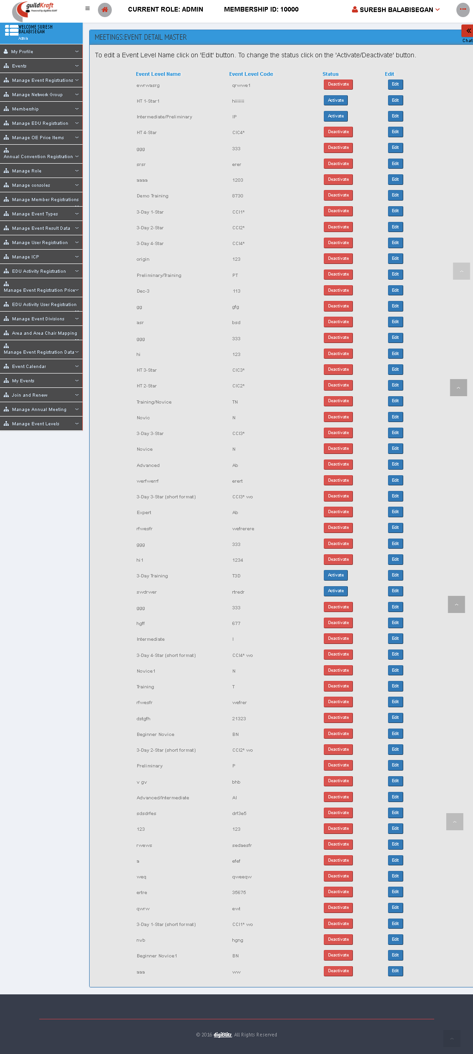

|  |  |  |
| --- | --- | --- |
| **Action** | **DB File** | **Table Name** |
| frmMeeEventLevelList. jsp file will call EventLevelMasterAction**.java** with event name initList**.** | -- | -- |

* On Clicking the “EDIT” Button the page displays as:

|  |  |  |
| --- | --- | --- |
| **Action** | **DB File** | **Table Name** |
| frmMeeEventLevelEdit. jsp file will call EventLevelMasterAction**.java** with event name Edit**.** | -- | -- |

### Map Event Level

We can map Multiple Event Level for an Event Type.

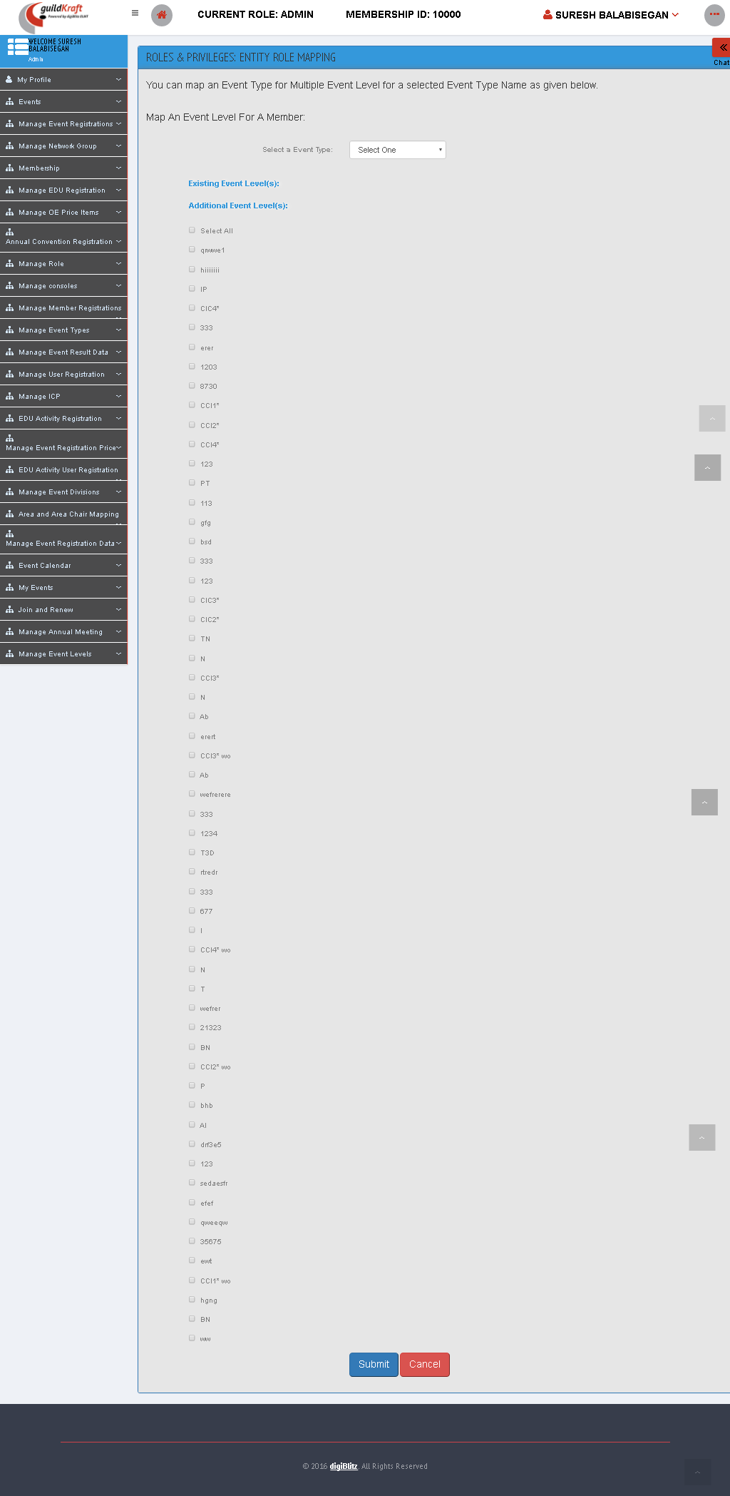

|  |  |  |
| --- | --- | --- |
| **Action** | **DB File** | **Table Name** |
| frmMemEventTypeMap. jsp file will call EventLvlTypMapAction**.java** with event name ListEvntLevel**.** | -- | -- |

# Membership Management

## My Refund

### Apply Refund

It shows the form to apply for refund to particular product and services.

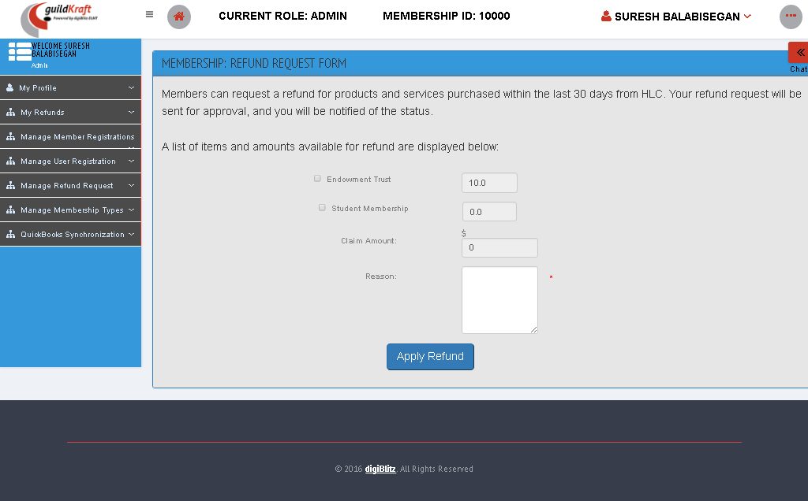

|  |  |  |
| --- | --- | --- |
| **Action** | **DB File** | **Table Name** |
| refund-request.jsp file will call RefundReqDispAction**.java.** | .java will pass values and save in database table. |  |

### List refunds

**====================Add====================**

### My Refunds

Shows the list of refund with the amount claimed and the amount approved.

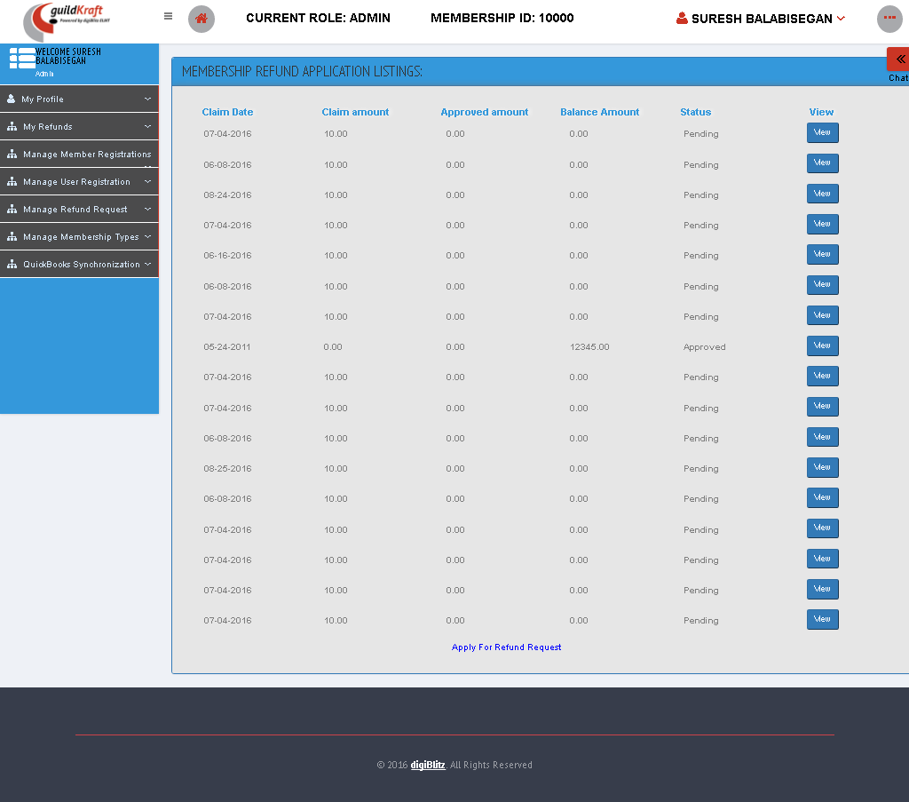

|  |  |  |
| --- | --- | --- |
| **Action** | **DB File** | **Table Name** |
| usr_refund-request-list.jsp file will call UsrRefundReqListAction**.java** | -- | -- |

## Manage Member Registration

### List Registered Members

Fill the given fields and click “list” button to list out the membership registration listing.

|  |  |  |
| --- | --- | --- |
| **Action** | **DB File** | **Table Name** |
| MemberRegiList.jsp file will call GldkftMembershipAction**.java** with event name **initFind.** | -- | -- |

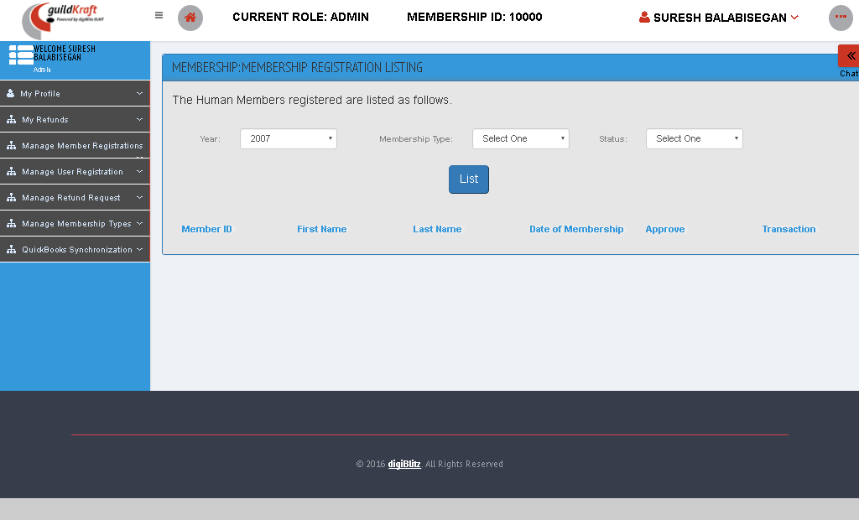

### New Member Registration

It shows the registration form to become a Member.

|  |  |  |
| --- | --- | --- |
| **Action** | **DB File** | **Table Name** |
| frmMemberUserRegistration.jsp file will call KlgUserAction**.java** with event name **initUsrReg.** | GeneralDBAction.java will pass values and save in database table. | tblContactDetails  tblusermaster |

### Search Members and Users

**Choose the search criteria, in order to assign role to user, into the user's account. click member or non-member to search the users.**



|  |  |  |
| --- | --- | --- |
| **Action** | **DB File** | **Table Name** |
| frmMemberSearchList.jsp file will call KlgSearchAction**.java** with event name **initViewDet.** | GeneralDBAction.java will pass values and save in database table. | tblMapEntity tblMapUserPrivilege  tblRoleMaster from these tables shows the list of roles |

* After entering the Member ID , Click “SEARCH” Button.

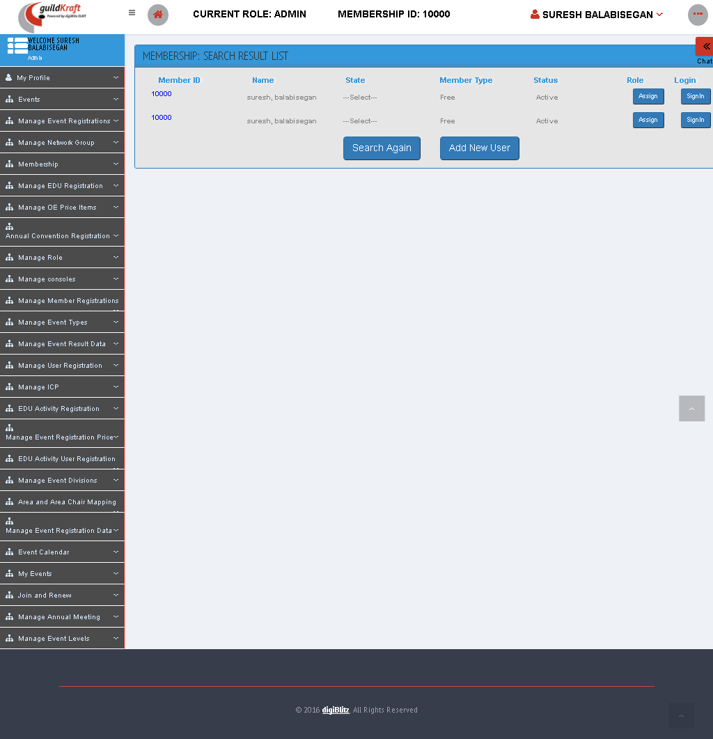

|  |  |  |
| --- | --- | --- |
| **Action** | **DB File** | **Table Name** |
| frmMemberSearchResultList.jsp file will call KlgSearchAction**.java** with event name **humanSearch.** | HLCMemberUpdateDAO.java will pass values and save in database table. | tblUserMaster tblMemberDetails  tblContactDetails  tblMembershipStatusMaster  tblMembershipTypeMaster |

## Manage User Registration

### List Registered Users

All Registered Users are listed as given below. To deactivate/activate a user, click on the **“ACTIVATE/DEACTIVATE** button beside it. To assign a role click on the **'ASSIGN'** button.

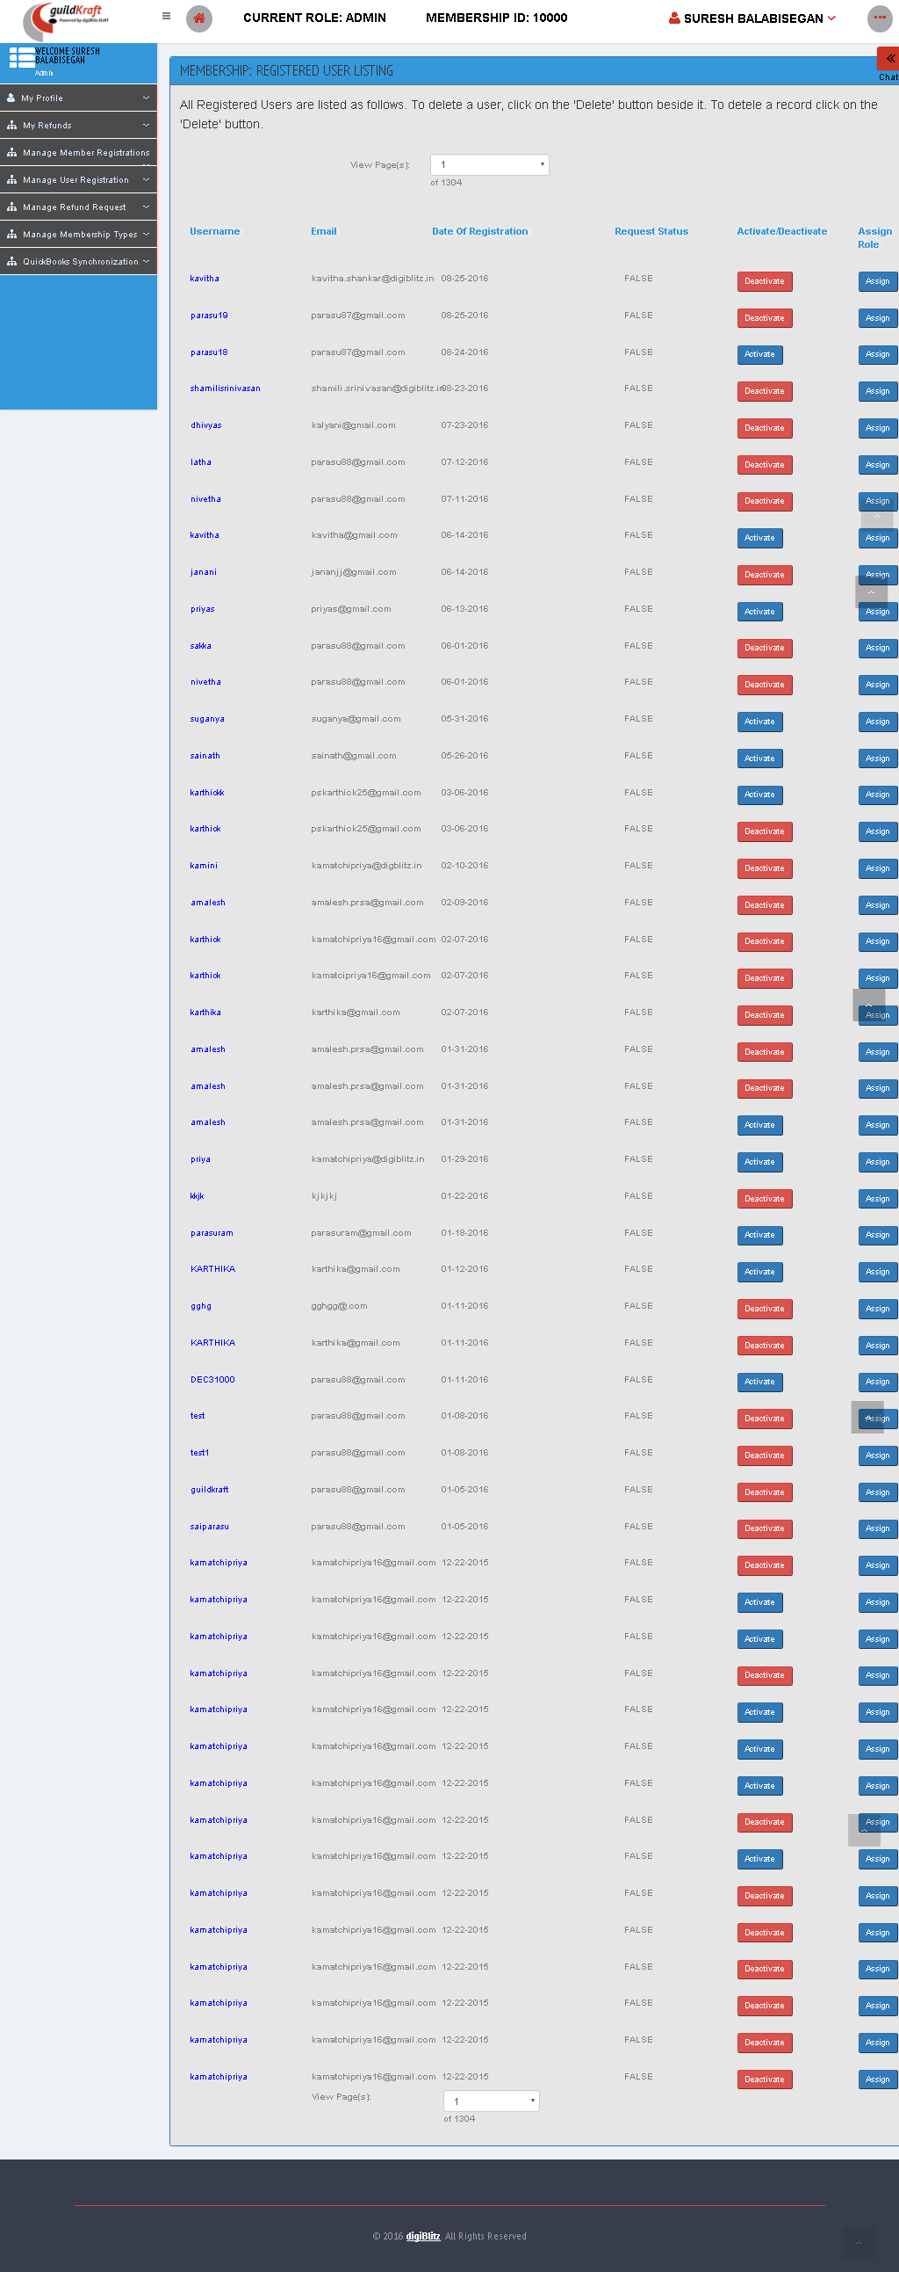

|  |  |  |
| --- | --- | --- |
| **Action** | **DB File** | **Table Name** |
| membership-user-list.jsp file will call  GldkftMemberUserListAction**.java** | -- | -- |

## Manage Refund Request

### Approved Refund Request

It view the list of refund request that are approved. To view the details of refund form click “VIEW REFUND” button

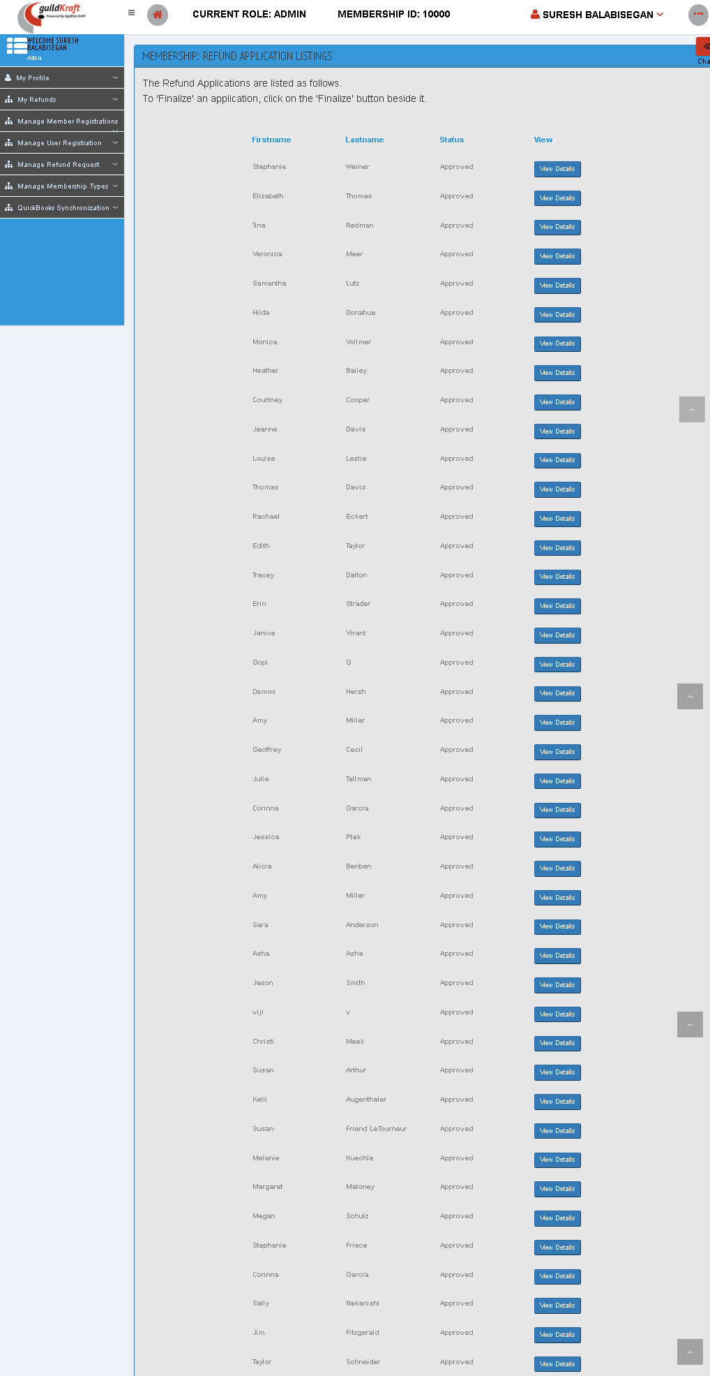

|  |  |  |
| --- | --- | --- |
| **Action** | **DB File** | **Table Name** |
| admin_refund-approve.jsp file will call  AdminRefundStatusDispAction**.java** with event name **Approved** | DBHandler.java will pass values and save in database table. | tblMembershipRefundTypeDetails  tblMembershipRefundTypeMaster |

### List All Over Payments

It displays the over refund payment list.

|  |  |  |
| --- | --- | --- |
| **Action** | **DB File** | **Table Name** |
| admin_refund-approve.jsp file will call  AdminRefundStatusDispAction**.java** with event name **Approved** | DBHandler.java will pass values and save in database table. | tblMembershipRefundTypeDetails  tblMembershipRefundTypeMaster |

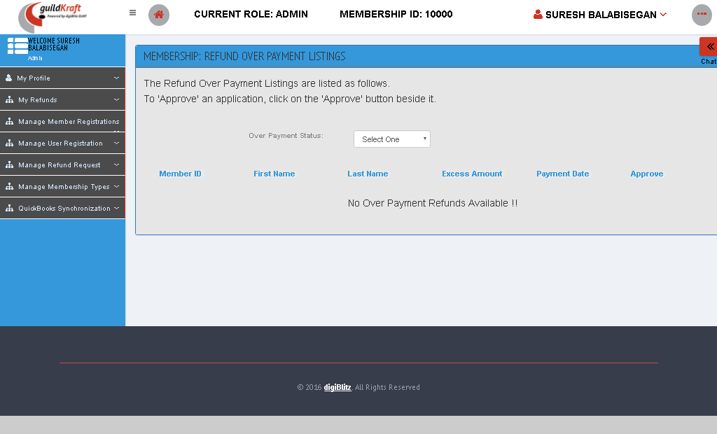

### Pending Refund Requests

List of Pending refund requests displayed here.

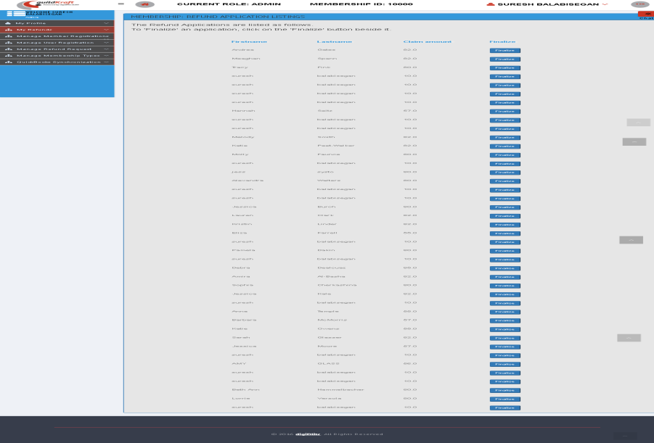

|  |  |  |
| --- | --- | --- |
| **Action** | **DB File** | **Table Name** |
| refund-application-listing .jsp file will call  RefundListAction**.java** | DBHandler.java will pass values and save in database table. | -- |

## Manage Membership Types

### List of Human Members

You are viewing the list of Membership Types - Human created by you. To create a Membership Type - Human click **Add** button. To edit a Membership Type - Human select the checkbox before each record and then click on the **Edit** button. To delete Membership Types - Human select the checkbox(s) before each record and then click on the **Delete** button.

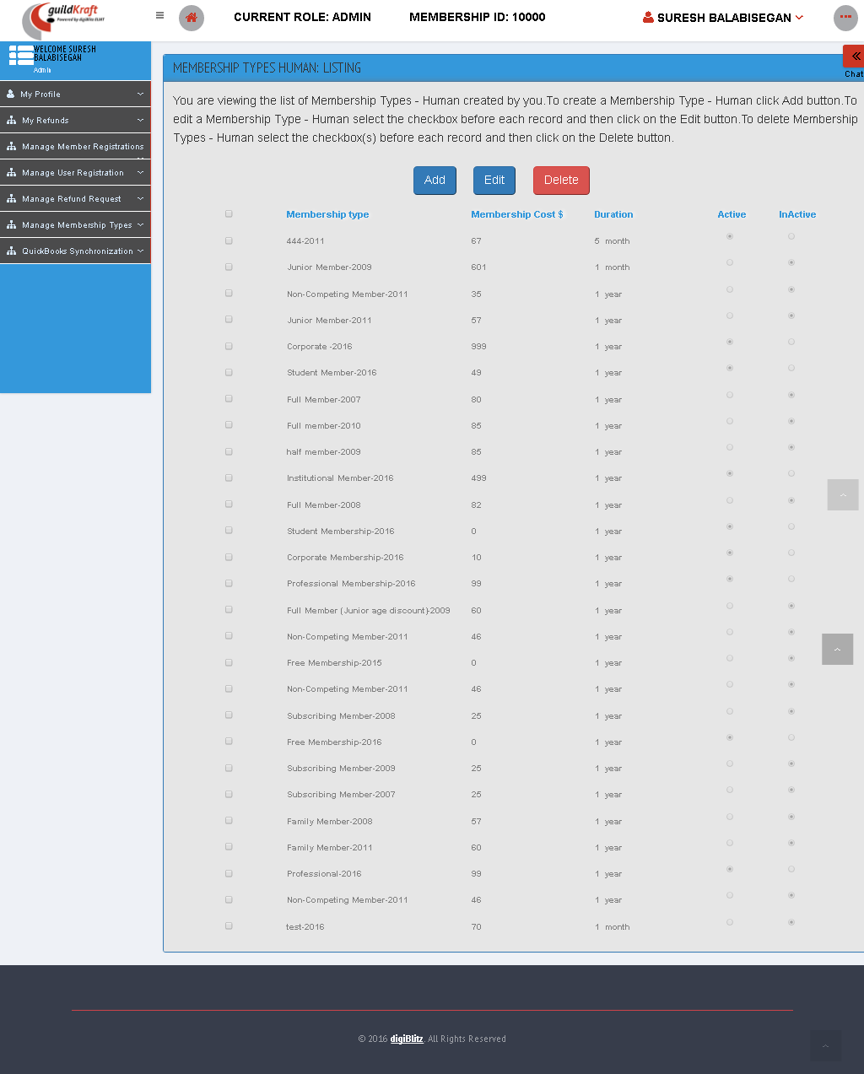

|  |  |  |
| --- | --- | --- |
| **Action** | **DB File** | **Table Name** |
| membership-view-membership-list.jsp file will call  GldkftMembershipListAction**.java with event name initList** | -- | -- |

# Online Entries

## OE Result

### List OE Result

To see the result list, select **year** and **event** **title** and then click **“submit”** button.

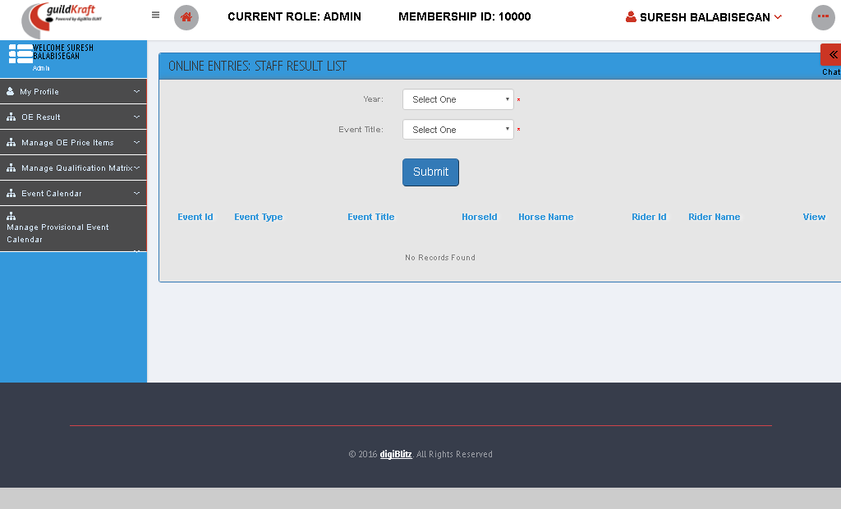

|  |  |  |
| --- | --- | --- |
| **Action** | **DB File** | **Table Name** |
| frmOERStaffCompResList.jsp file will call  OrgStaffCompResultAction**.java** with event name **initStaffResultList** | -- | -- |

## Manage OE Price Items

### Add New OE Price Items

To create an online event entries, fill the item name and click “Create” button.

|  |  |  |
| --- | --- | --- |
| **Action** | **DB File** | **Table Name** |
| frmOEEPriceItemCreate.jsp file will call  PriceItemAction**.java** with event name **initCreateItem** | -- | -- |

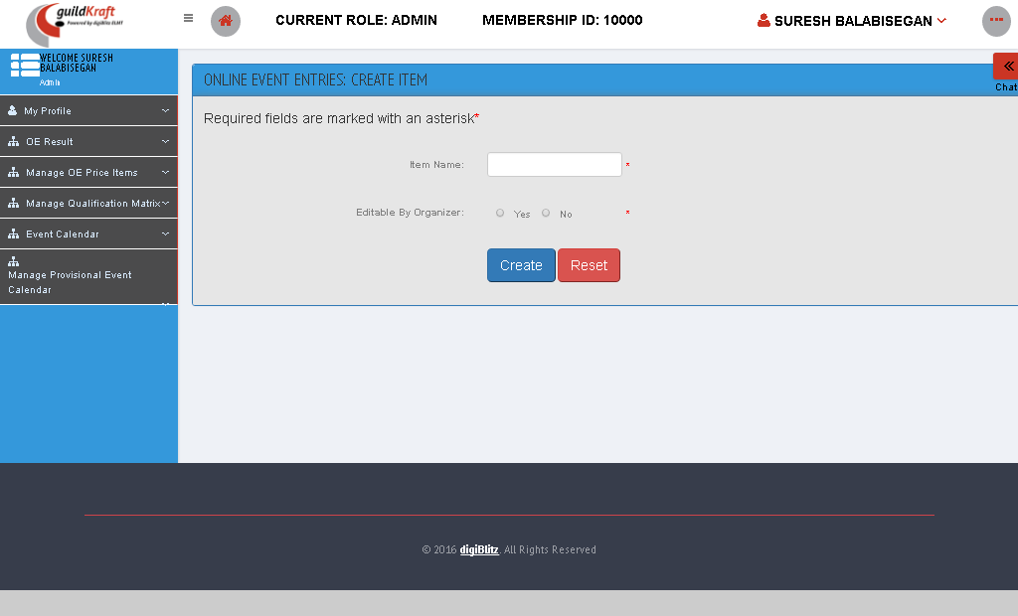

### List All OE Price Items

To edit an Item Name click on **'Edit'** button. To change the status click on the **'Activate/Deactivate'** button.

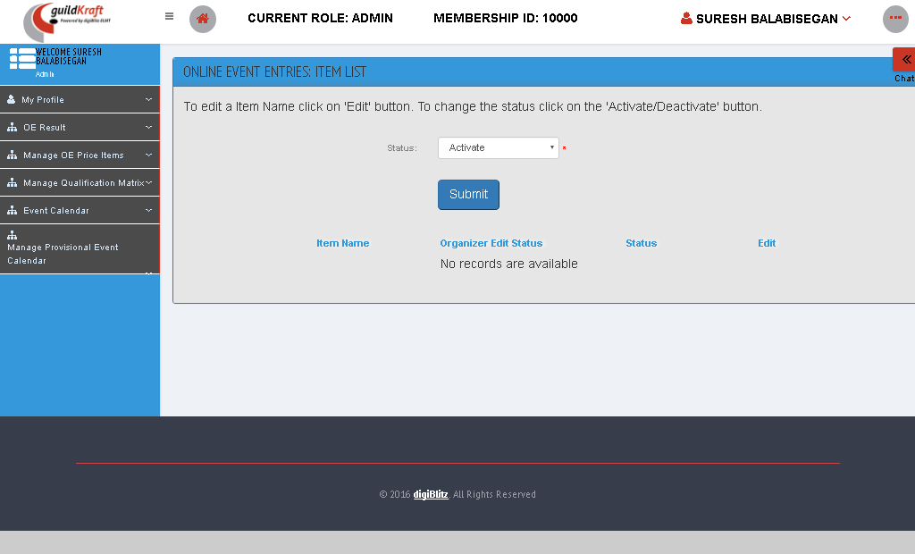

|  |  |  |
| --- | --- | --- |
| **Action** | **DB File** | **Table Name** |
| frmOEEPriceItemList.jsp file will call PriceItemAction**.java** with event name **initListItem** | -- | -- |

### List OE Fixed Price Details

Fill the following fields and click “submit” button to list the fixed price details.

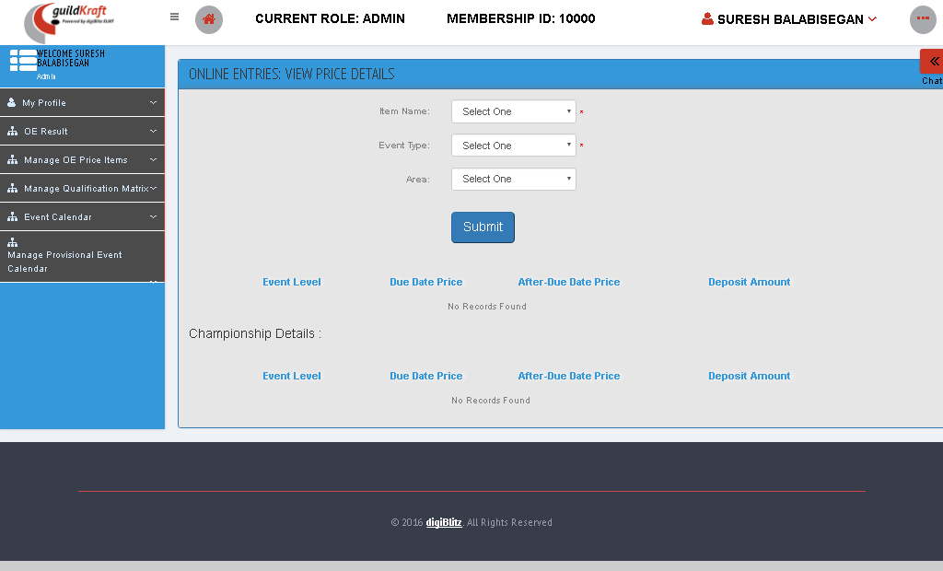

|  |  |  |
| --- | --- | --- |
| **Action** | **DB File** | **Table Name** |
| frmOEEStaffViewPrice.jsp file will call AddFixedPriceAction  .javawith event name **initViewPrice** | -- | -- |

### Set OE Fixed Price Details

To set the OE fixed price enter all the fields and click “Submit” button.

|  |  |  |
| --- | --- | --- |
| **Action** | **DB File** | **Table Name** |
| frmOEEStaffInsertPrice.jsp file will call AddFixedPriceAction  .javawith event name **initPrice** | -- | -- |

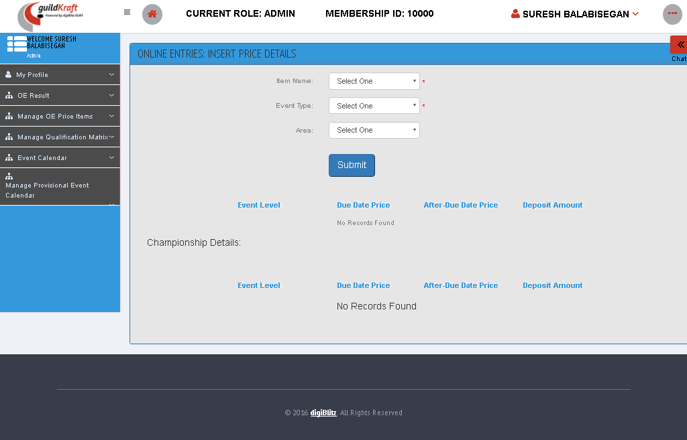

## Manage Qualification Matrix

### Create Qualification Validation

To create qualification details enter the details given below and then click **“Submit”** button.

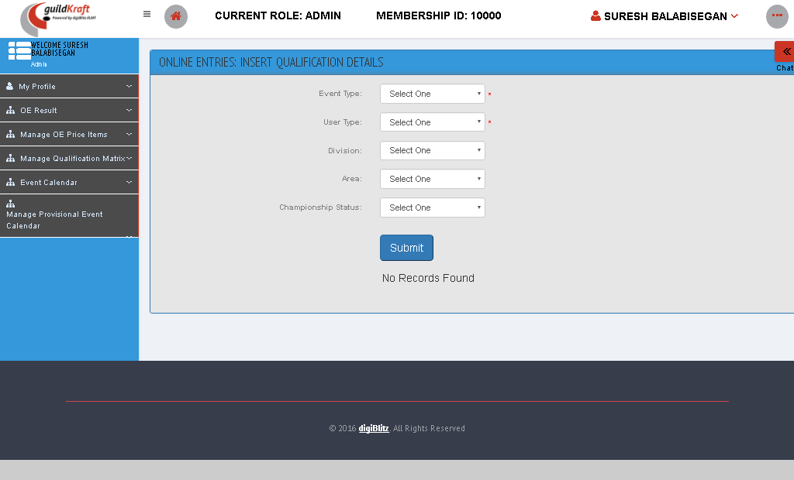

|  |  |  |
| --- | --- | --- |
| **Action** | **DB File** | **Table Name** |
| frmInsertQualificationDetails .jsp file will call OEEValidationAction  .javawith event nameinitValidate | -- | -- |

### Map Championship Levels

You can map an Area for an EventLevel. Select area and click “Submit” button.

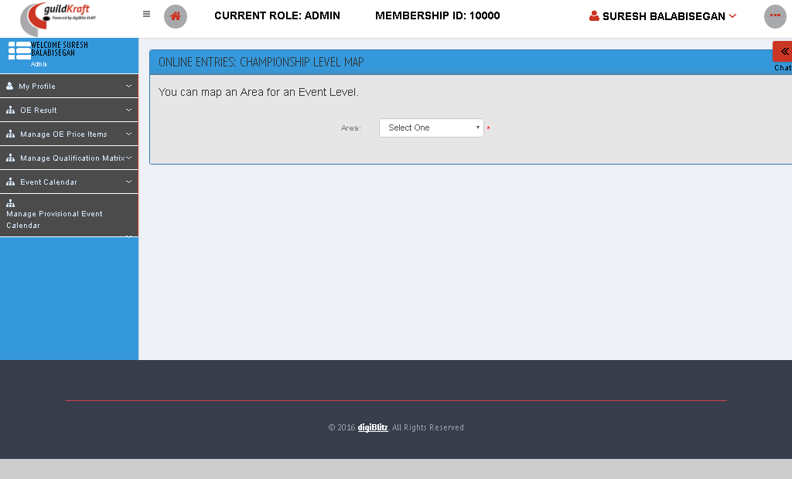

|  |  |  |
| --- | --- | --- |
| **Action** | **DB File** | **Table Name** |
| frmChampLevelMap.jsp file will call OEEMapChampionshipLevel  .javawith event nameintChmpLevel | -- | -- |

### View Qualification Matrix

To view qualifications details fill the fields given below and then click submit button.

|  |  |  |
| --- | --- | --- |
| **Action** | **DB File** | **Table Name** |
| frmViewQualificationDetails.jsp file will call OEEValidationViewAction  .javawith event nameinitView | -- | -- |

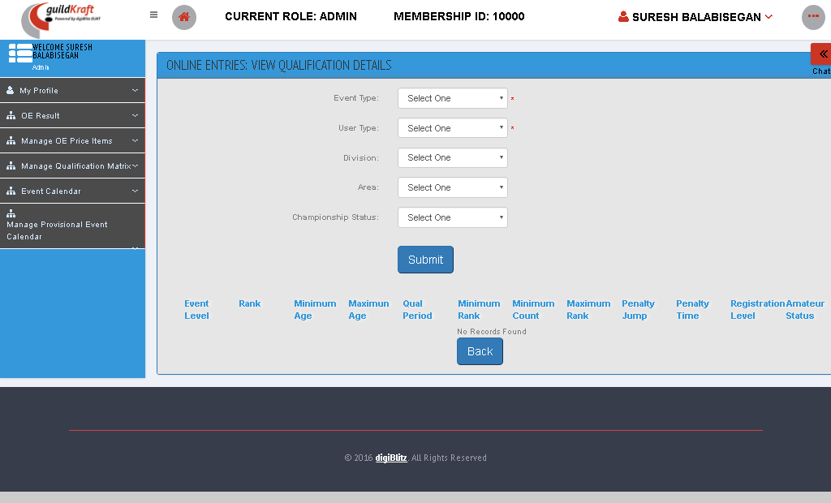

## Event Calendar

### Search Events

Fill the following fields to search the online events and then click “submit” button.

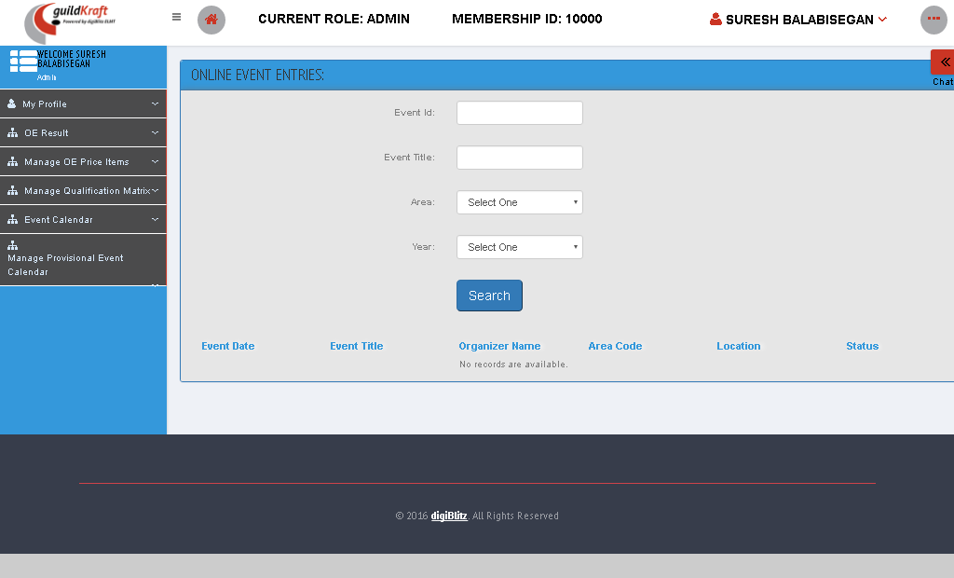

|  |  |  |
| --- | --- | --- |
| **Action** | **DB File** | **Table Name** |
| frmOECSearchEvents.jsp file will call calendarAction  .javawith event nameinitSearch | -- | -- |

### View Event Calendar

Select the area and click “submit” to view the event calendar.

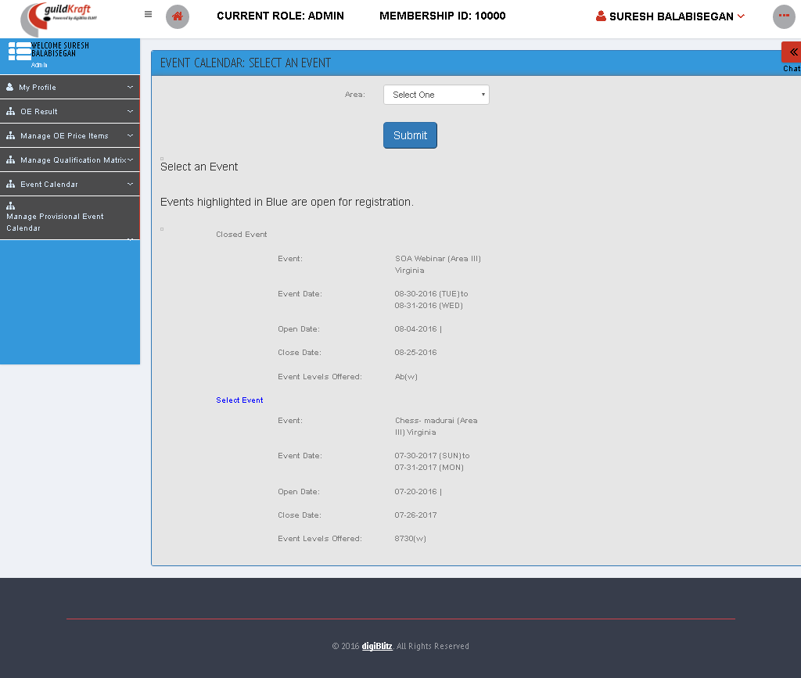

|  |  |  |
| --- | --- | --- |
| **Action** | **DB File** | **Table Name** |
| frmFinalizedEventCalendar.jsp file will call OnlineEntriesListAction  .javawith event nameintEveCalList | -- | -- |

## Manage Provisional Event Calendar

### Approve Provisional Calendar

Select year and area and click “submit” button to approve the provisional calendar.

|  |  |  |
| --- | --- | --- |
| **Action** | **DB File** | **Table Name** |
| frmProCalUseaStaffList.jsp file will call OnlineEntriesListAction  .javawith event nameinitList | -- | -- |

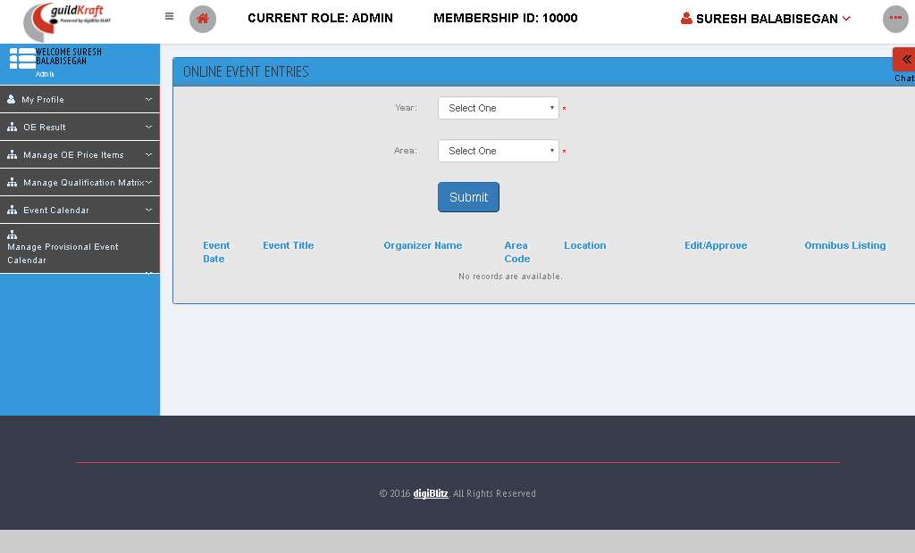

* Click “EDIT/APPROVE” Button to update the details of the Event.

|  |  |  |
| --- | --- | --- |
| **Action** | **DB File** | **Table Name** |
| frmOECStaffEdit.jsp file will call calendarAction  .javawith event nameinitStaffUpdate | -- | -- |

### Create Provisional Calendar

To create a calendar, enter the year and click “create” button.

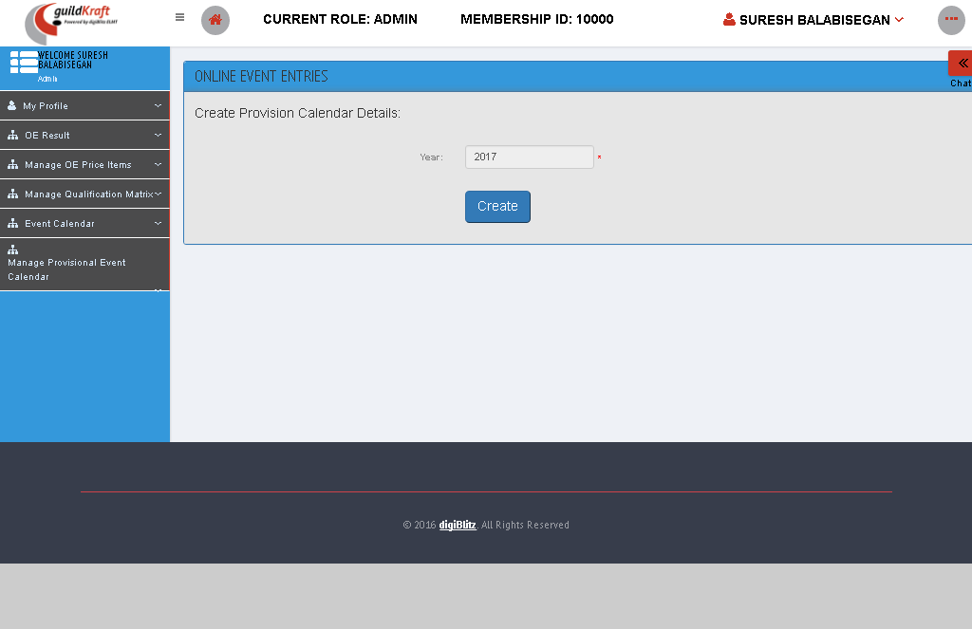

|  |  |  |
| --- | --- | --- |
| **Action** | **DB File** | **Table Name** |
| frmAddCalDetails.jsp file will call calendarAction  .javawith event nameinitCreate | -- | -- |

# Process Management

## Business Process

### Business Process Voting List

Here we can see the business process voting list.

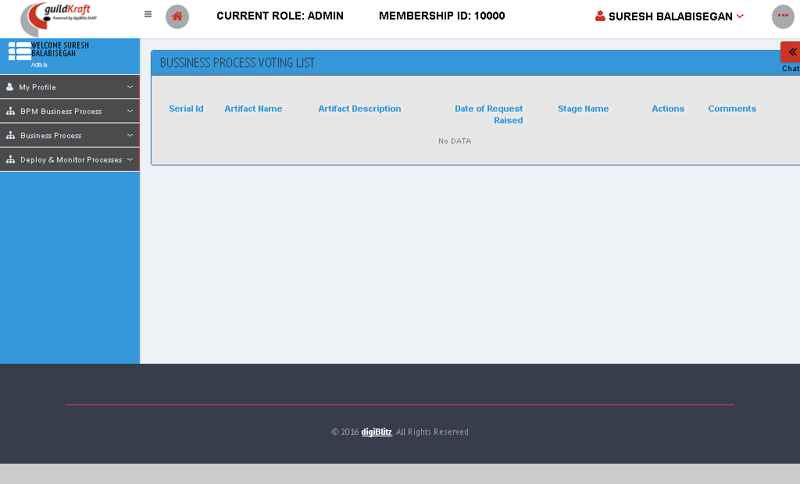

|  |  |  |
| --- | --- | --- |
| **Action** | **DB File** | **Table Name** |
| SystinetBPVotingList.jsp file will call KlgHpSystinetAction  .javawith event nameBPVotingList | -- | -- |

### List of Business Processes

Here we can see the list of business process and start governance.

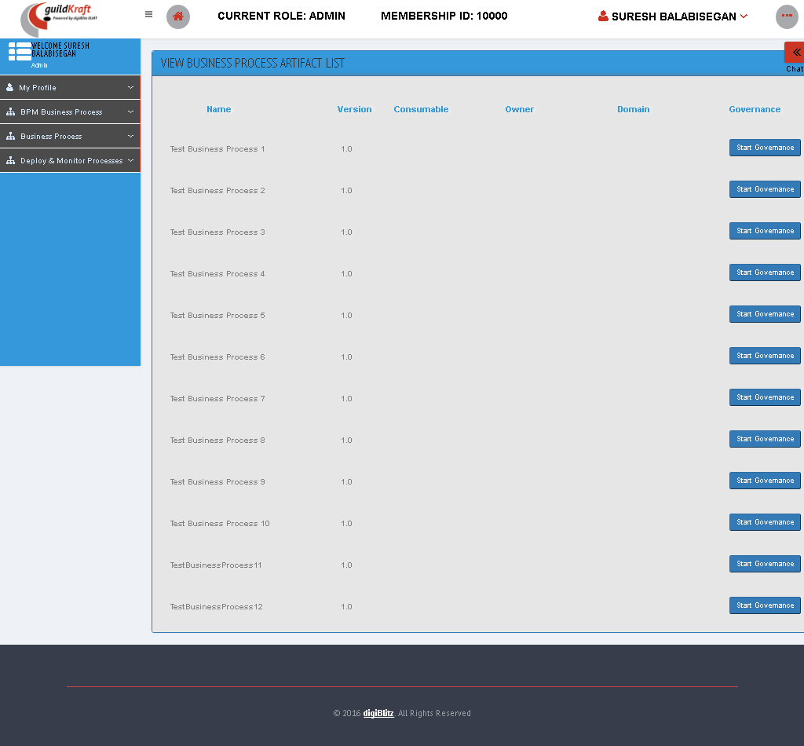

|  |  |  |
| --- | --- | --- |
| **Action** | **DB File** | **Table Name** |
| frmViewArtifacts.jsp file will call KlgHpSystinetAction  .javawith event namecallArtifactBPList | -- | -- |

* On Clicking “START GOVERNANCE” Button , the following page displays.

|  |  |  |
| --- | --- | --- |
| **Action** | **DB File** | **Table Name** |
| Systinetbusinessprocess.jsp file will call KlgHpSystinetAction  .javawith event namebusineessProce | -- | -- |

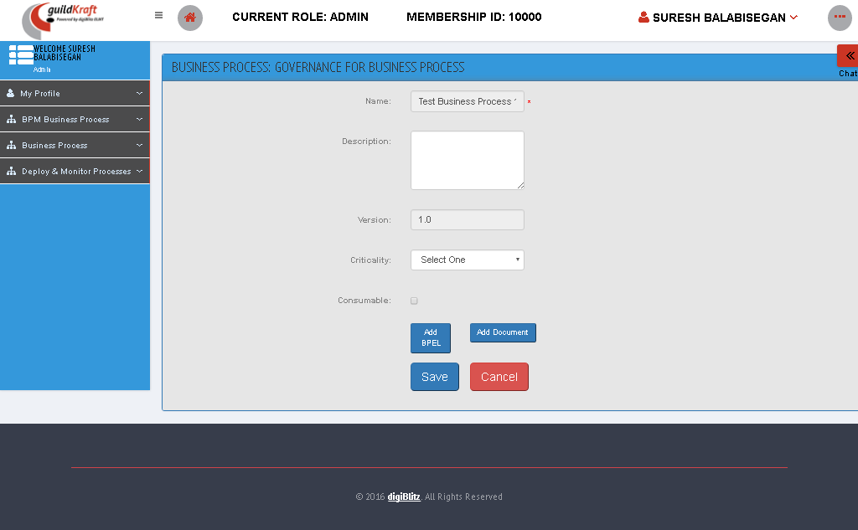

### Move BP Life Cycle Stage

Here we can view the BP life cycle process.

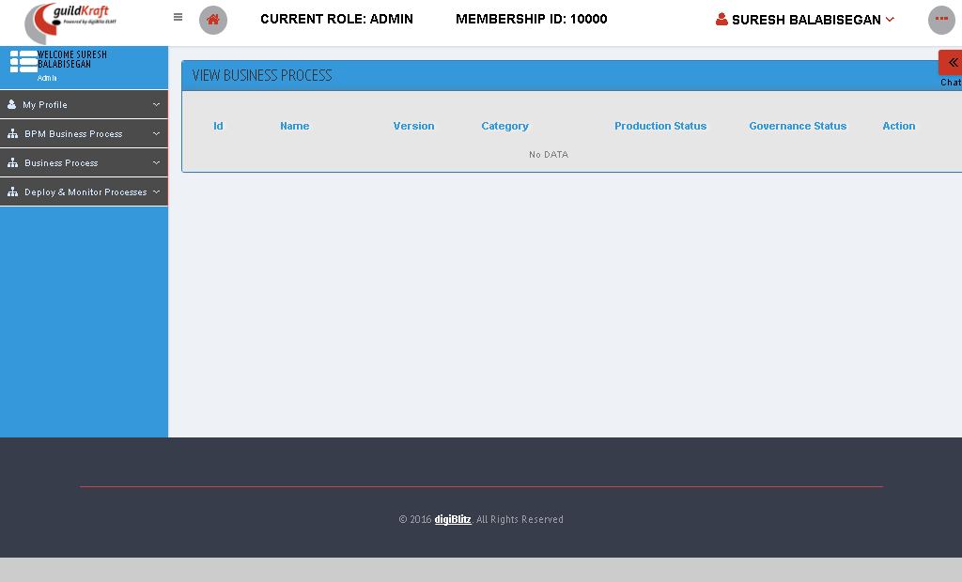

|  |  |  |
| --- | --- | --- |
| **Action** | **DB File** | **Table Name** |
| frmViewBPM.jsp file will call KlgHpSystinetAction  .javawith event namecallBPMList | -- | -- |

# Report Management

## Events

### View All Report Events

It displays the list of report types. On clicking Each link of the report type its displays the different graphs.

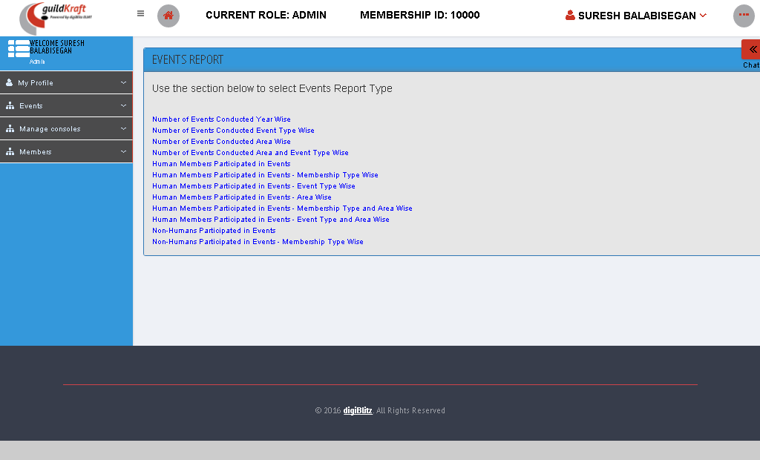

|  |  |  |
| --- | --- | --- |
| **Action** | **DB File** | **Table Name** |
| showEventReportList.jsp file will call GldkftshowEventReportList  .javawith event nameinitShEventRept | -- | -- |

* Select any of the event type to display the graph for particular period

|  |  |  |
| --- | --- | --- |
| **Action** | **DB File** | **Table Name** |
| createEventReports.jsp file will call GldkfteventReport  .javawith event nameeventsYearWise | -- | -- |

## Members

### View All Membership Report

List of Members report type displays here.

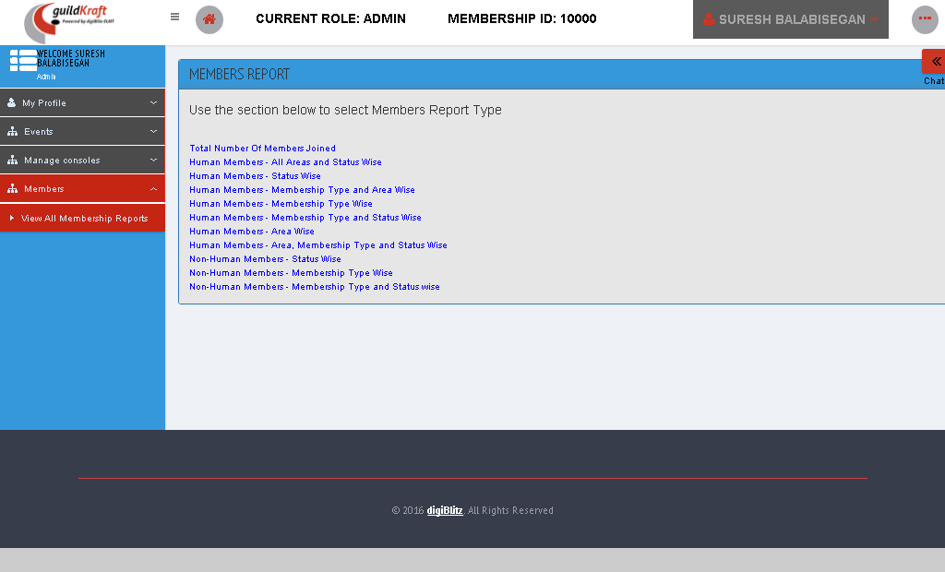

|  |  |  |
| --- | --- | --- |
| **Action** | **DB File** | **Table Name** |
| showMemberReportList.jsp file will call GldkftshowMemberReportList  .javawith event nameinitShMembRpt | -- | -- |

# Reports

Enterprise report management is a methodology that involves providing substantial information to the managers in an organization to help them make business decisions. The main goal of enterprise reporting or management reporting is to supply important timely information to managers in an effective way.

## Manage Additional Reports

### Report List

Report list is generated depending upon the daily/monthly/yearly basis.

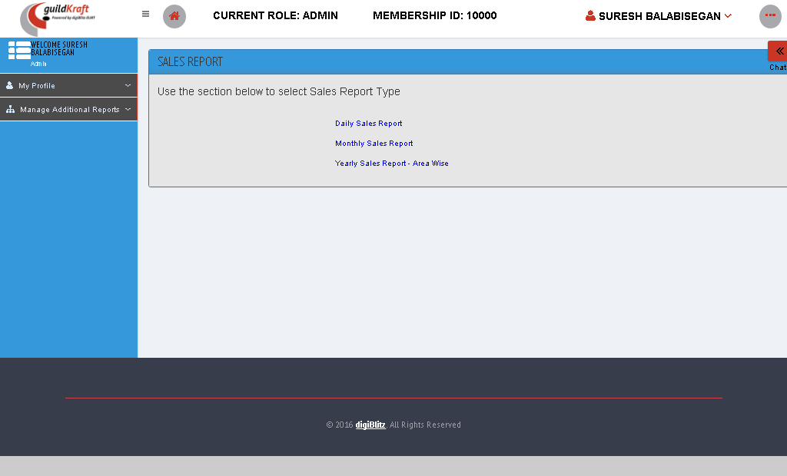

|  |  |  |
| --- | --- | --- |
| **Action** | **DB File** | **Table Name** |
| showReportList.jsp file will call GldkftReportList  .javawith event nameshReportlst | -- | -- |

#### Daily sales Report

In daily sales report, fill the details given below and then click “submit” button. It will generate the graph given below

|  |  |  |
| --- | --- | --- |
| **Action** | **DB File** | **Table Name** |
| createSalesGraph.jsp file will call GldkftcreateSalesGraph  .javawith event namedaily | -- | -- |

.

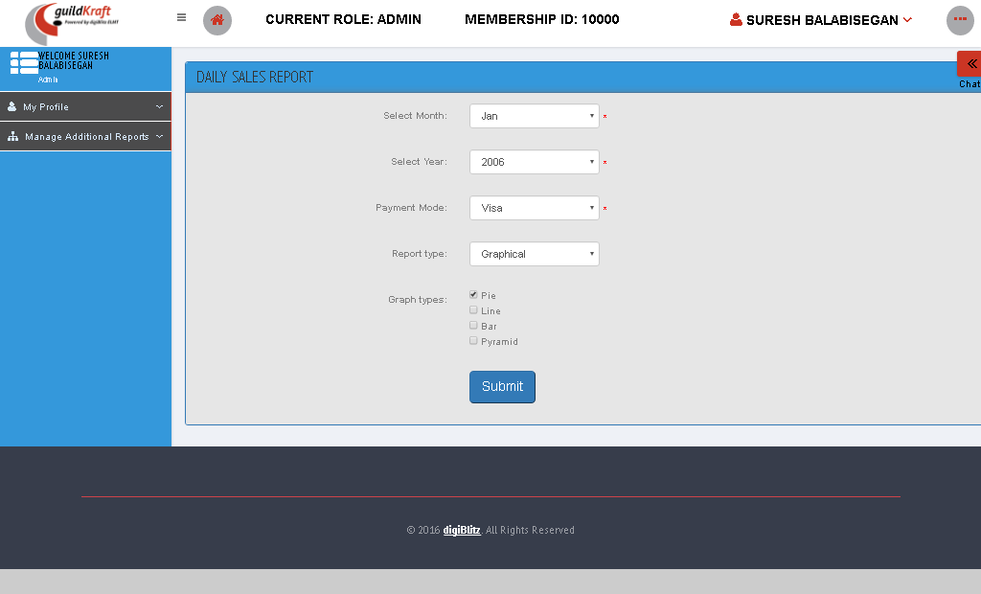

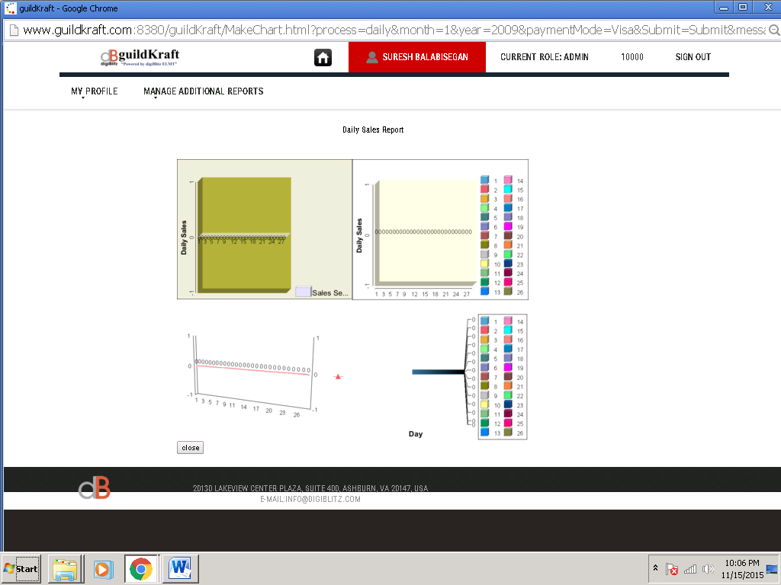

|  |  |  |
| --- | --- | --- |
| **Action** | **DB File** | **Table Name** |
| generateBarFromDB.jsp file will call AccTransAction  .javawith event namedaily | -- | -- |

#### Monthly Sales Report

In monthly sales report, fill the details given below and then click “submit” button. It will generate the graph given below.



|  |  |  |
| --- | --- | --- |
| **Action** | **DB File** | **Table Name** |
| createSalesGraph.jsp file will call GldkftcreateSalesGraph  .javawith event namemonthly | -- | -- |

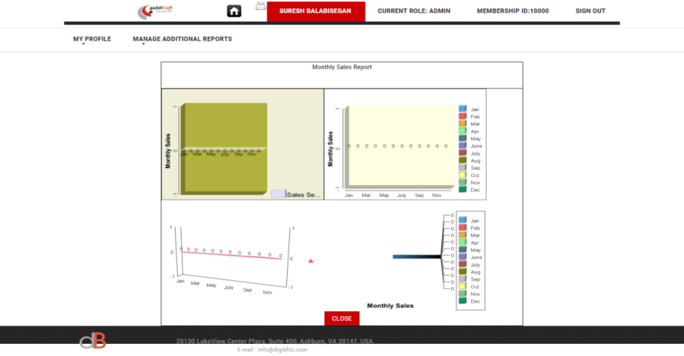

|  |  |  |
| --- | --- | --- |
| **Action** | **DB File** | **Table Name** |
| generateMonthlyBarFromDB.jsp file will call AccTransAction  .javawith event namemonthly | -- | -- |

#### Yearly Sales Report – Area Wise

In Yearly sales report, fill the details given below and then click “submit” button. It will generate the graph given below.

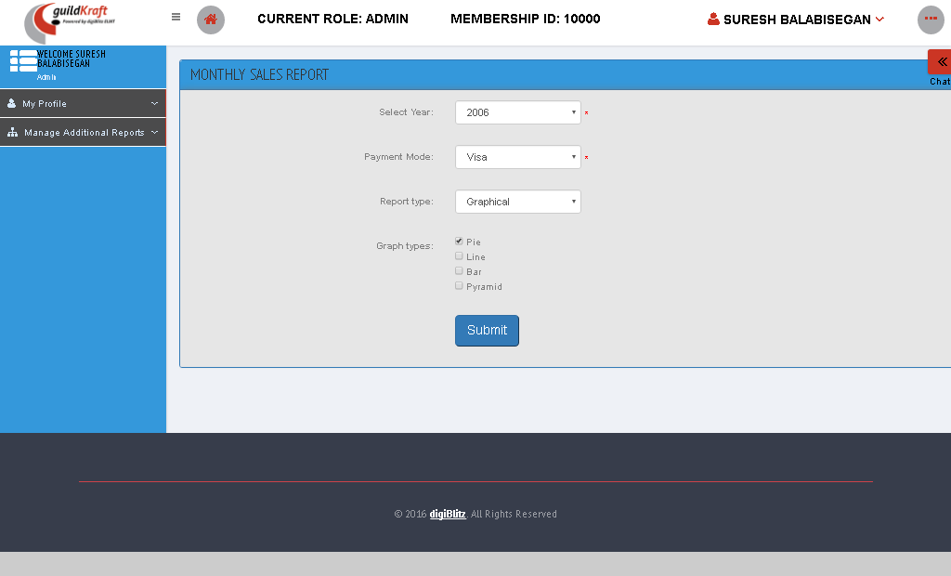

|  |  |  |
| --- | --- | --- |
| **Action** | **DB File** | **Table Name** |
| createAreaGraph.jsp file will call GldkftareaGraph  .javawith event namearea_yearly | -- | -- |

# Role Management

Role management helps you manage authorization, which enables you to specify the resources that users in your application are allowed to access. Role management lets you treat groups of users as a unit by assigning users to roles such as manager, sales, member, and so on. (In Windows, you create roles by assigning users to groups such as Administrators, Power Users, and so on.).

## Manage Mapping

### Mapping Entity with Privileges

  You can map a **Privilege** or Multiple Privileges for a given Entity as shown below.

|  |  |  |
| --- | --- | --- |
| **Action** | **DB File** | **Table Name** |
| frmRolMRoleMapping.jsp file will call KlgRoleAction  .javawith event nameinitEntPriv | GeneralDBAction.java will pass values and save in database table. | tblMapEntity  tblMapUserPrivilege  tblMapRole  tblRoleMaster |

### Mapping Privileges with Permission

Fill the required **Menu Name** for the link to be shown and it's relevant **Link URL** too and then click submit button.

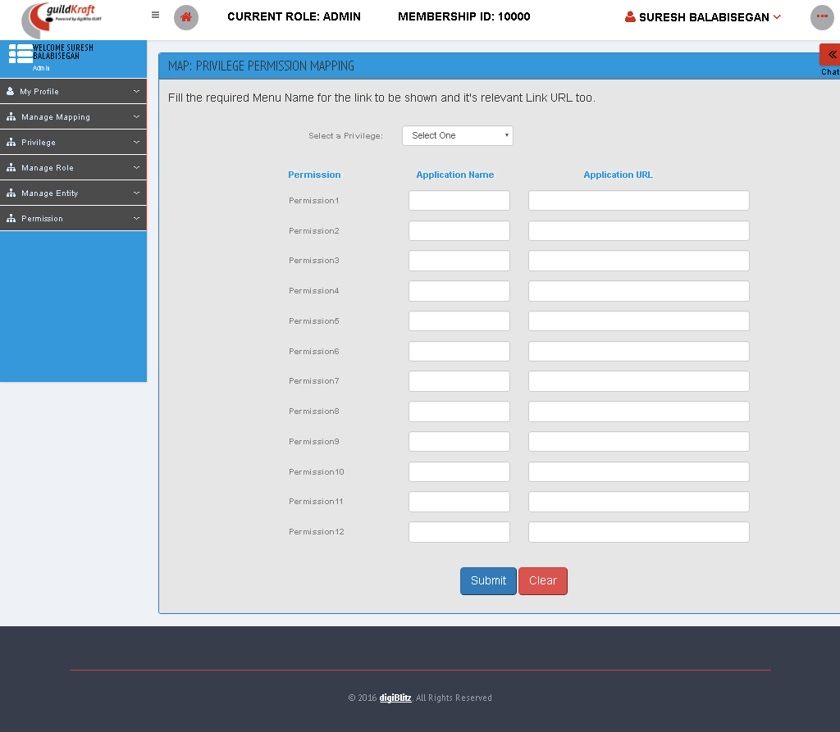

|  |  |  |
| --- | --- | --- |
| **Action** | **DB File** | **Table Name** |
| frmRolMpriviPermissionMapping.jsp file will call KlgRoleAction  .javawith event nameinitPrivPermission | GeneralDBAction.java will pass values and save in database table. | tblPrivilegeMaster – get all privilege name  tblPermissionMaster – stores all permission name  tblMapPermission |

### Mapping Role with Entities

You can map an**Entity** or Multiple Entities for a given role as given below.

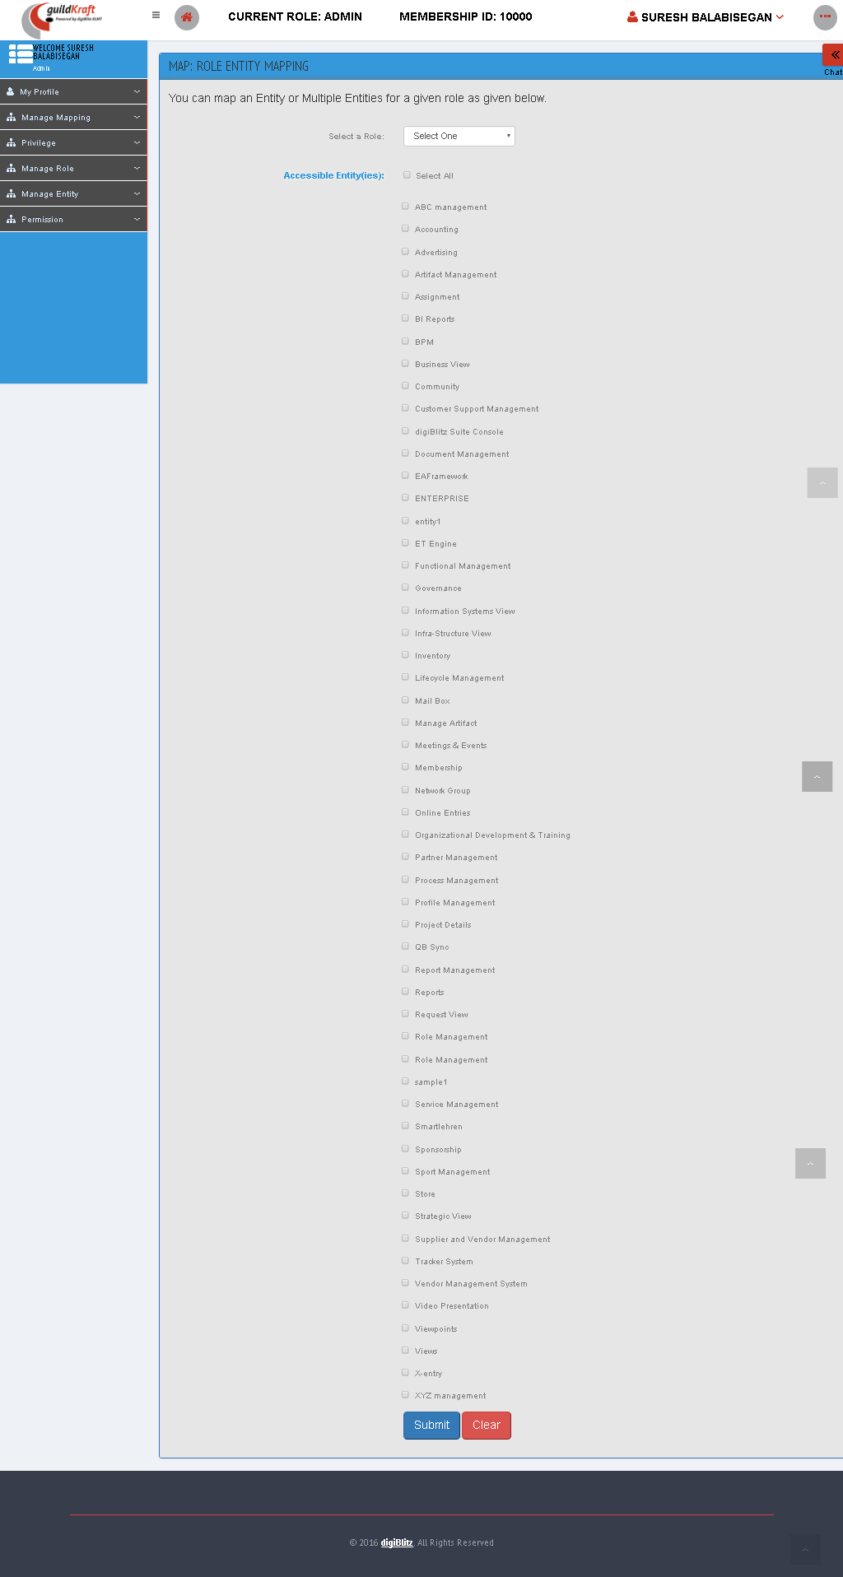

|  |  |  |
| --- | --- | --- |
| **Action** | **DB File** | **Table Name** |
| frmRolMEntityRoleMapping.jsp file will call KlgRoleAction  .javawith event nameinitRoleEnt | GeneralDBAction.java will pass values and save in database table. | tblEntityMaster – get all entity  [tblMapEntity  tblMapUserPrivilege  tblMapRole  tblRoleMaster] – get all roles |

### Mapping Role with entities and Privileges

Check the required **'Permissions'** to be given for a selected **'Privilege'** and corresponding **'Entity'**.

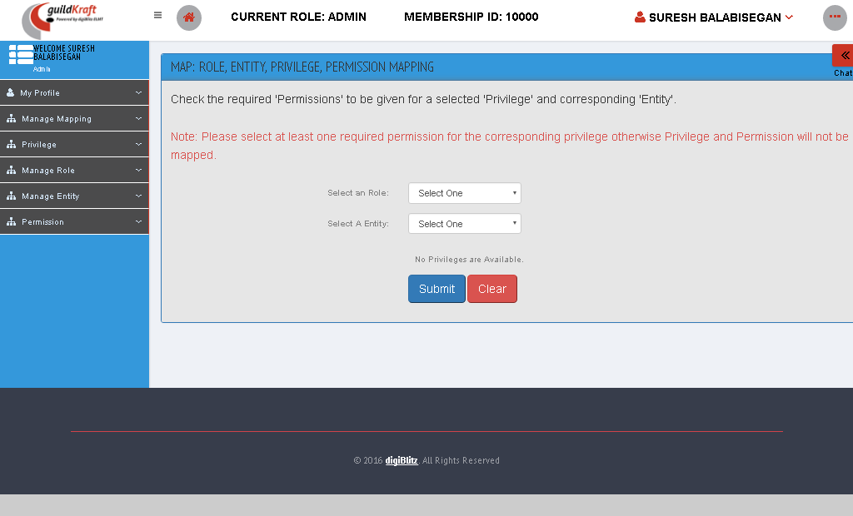

|  |  |  |
| --- | --- | --- |
| **Action** | **DB File** | **Table Name** |
| frmRolMRoleMapping.jsp file will call KlgRoleAction  .javawith event nameinitRoleEntPriv | GeneralDBAction.java will pass values and save in database table. | tblEntityMaster – get all entity  [tblMapEntity  tblMapUserPrivilege  tblMapRole  tblRoleMaster] – get all roles |

## Privileges

### Create privileges

Enter privileges and then click “create” button to create privileges.

|  |  |  |
| --- | --- | --- |
| **Action** | **DB File** | **Table Name** |
| frmRolMCreatePrivileges.jsp file will call KlgRoleAction  .javawith event nameinitCreatePriv | GeneralDBAction.java will pass values and save in database table. | tblPrivilegeMaster |

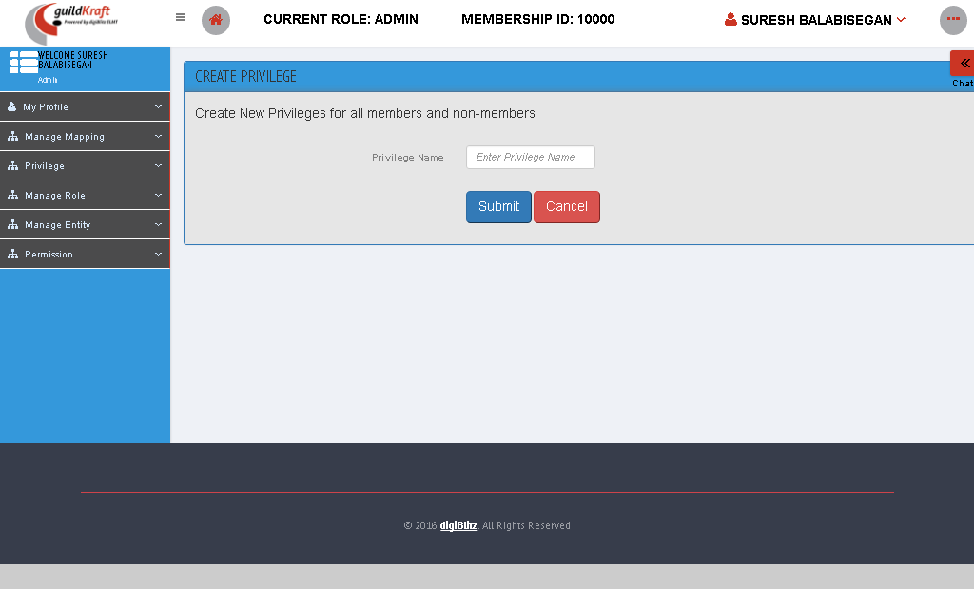

### Edit List of Privileges

You are viewing the list of **Privileges** created by you. To edit a privilege click on the **Edit** button beside each record.

|  |  |  |
| --- | --- | --- |
| **Action** | **DB File** | **Table Name** |
| frmRolMListPrivileges.jsp file will call KlgRoleAction  .javawith event nameprivList | GeneralDBAction.java will pass values and save in database table. | tblPrivilegeMaster – get all privilege name |

## Manage Role

### Assign Roles Securities

To assign role and entities select the role and entity and then click submit button.



|  |  |  |
| --- | --- | --- |
| **Action** | **DB File** | **Table Name** |
| frmRolMRoleMapping.jsp file will call KlgRoleAction  .javawith event nameinitRoleEntPriv | GeneralDBAction.java will pass values and save in database table. | tblEntityMaster – get all entity  [tblMapEntity  tblMapUserPrivilege  tblMapRole  tblRoleMaster] – get all roles |

### Assign Roles To User

**Choose the search criteria in order to assign role to user/login into the user's account.**

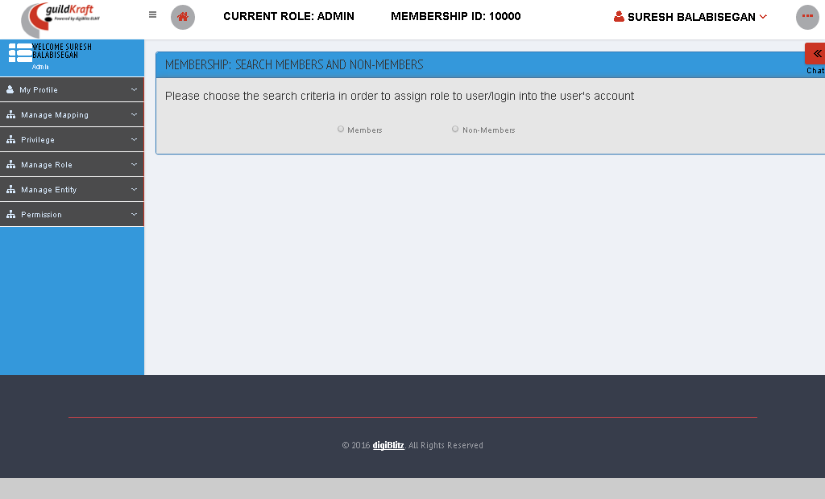

|  |  |  |
| --- | --- | --- |
| **Action** | **DB File** | **Table Name** |
| frmMemberSearchList.jsp file will call KlgSearchAction  .javawith event nameinitViewDet | GeneralDBAction.java will pass values and save in database table. | [tblMapEntity  tblMapUserPrivilege  tblMapRole  tblRoleMaster] – get all roles with repesct to user ID to search a user |

### Maintain Roles

You are viewing the list of Roles created by you. To create a Role click **Add** button. To edit a Role select the checkbox before each record and then click on the **Edit** button. To delete Roles select the checkbox(s) before each record and then click on the **Delete** button.

|  |  |  |
| --- | --- | --- |
| **Action** | **DB File** | **Table Name** |
| frmRolMListRoles.jsp file will call KlgRoleAction.javawith event nameroleList | GeneralDBAction.java will pass values and save in database table. | [tblMapEntity  tblMapUserPrivilege  tblMapRole  tblRoleMaster] – get all roles with repesct to user ID to search a user |

* To add a role click add button

|  |  |  |
| --- | --- | --- |
| **Action** | **DB File** | **Table Name** |
| frmRolMCreateRole.jsp file will call KlgRoleAction.javawith event nameinitCreateRole | GeneralDBAction.java will pass values and save in database table. | tblRoleMaster |

### Mapping Role with Entities

You can map an**Entity** or Multiple Entities for a given role as given below.

|  |  |  |
| --- | --- | --- |
| **Action** | **DB File** | **Table Name** |
| frmRolMEntityRoleMapping.jsp file will call KlgRoleAction  .javawith event nameinitRoleEnt | GeneralDBAction.java will pass values and save in database table. | tblEntityMaster – get all entity  [tblMapEntity  tblMapUserPrivilege  tblMapRole  tblRoleMaster] – get all roles |

## Manage Entity

### Create Entities

Create an Entity for all the departments using our Online Services Dashboard, right here.

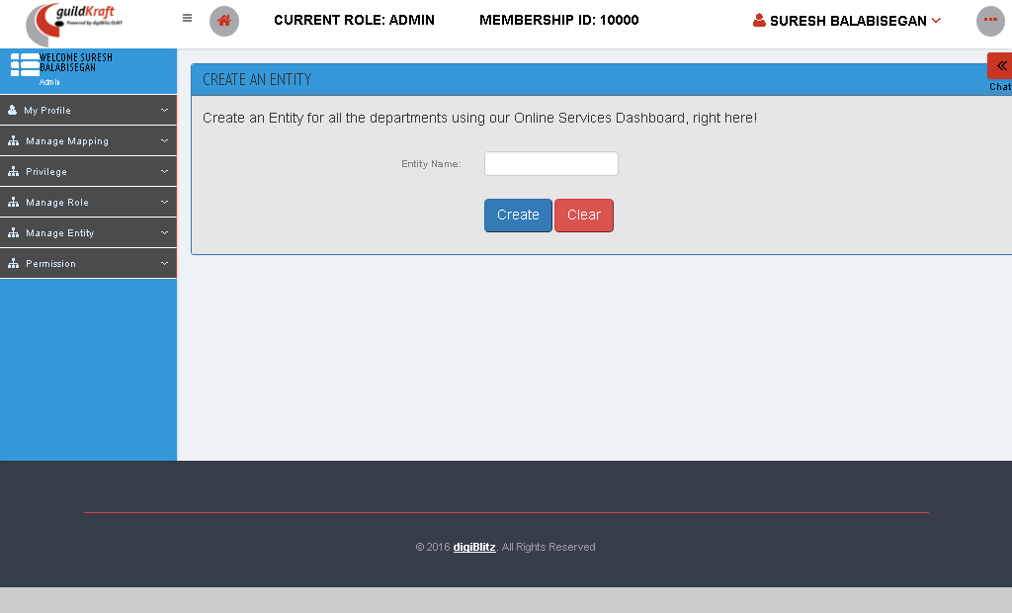

|  |  |  |
| --- | --- | --- |
| **Action** | **DB File** | **Table Name** |
| frmRolMCreateEntity.jsp file will call KlgRoleAction.javawith event nameinitCreateEntity | GeneralDBAction.java will pass values and save in database table. | tblEntityMaster |

### View edit List of Entities

To viewing the list of Entities created by you.

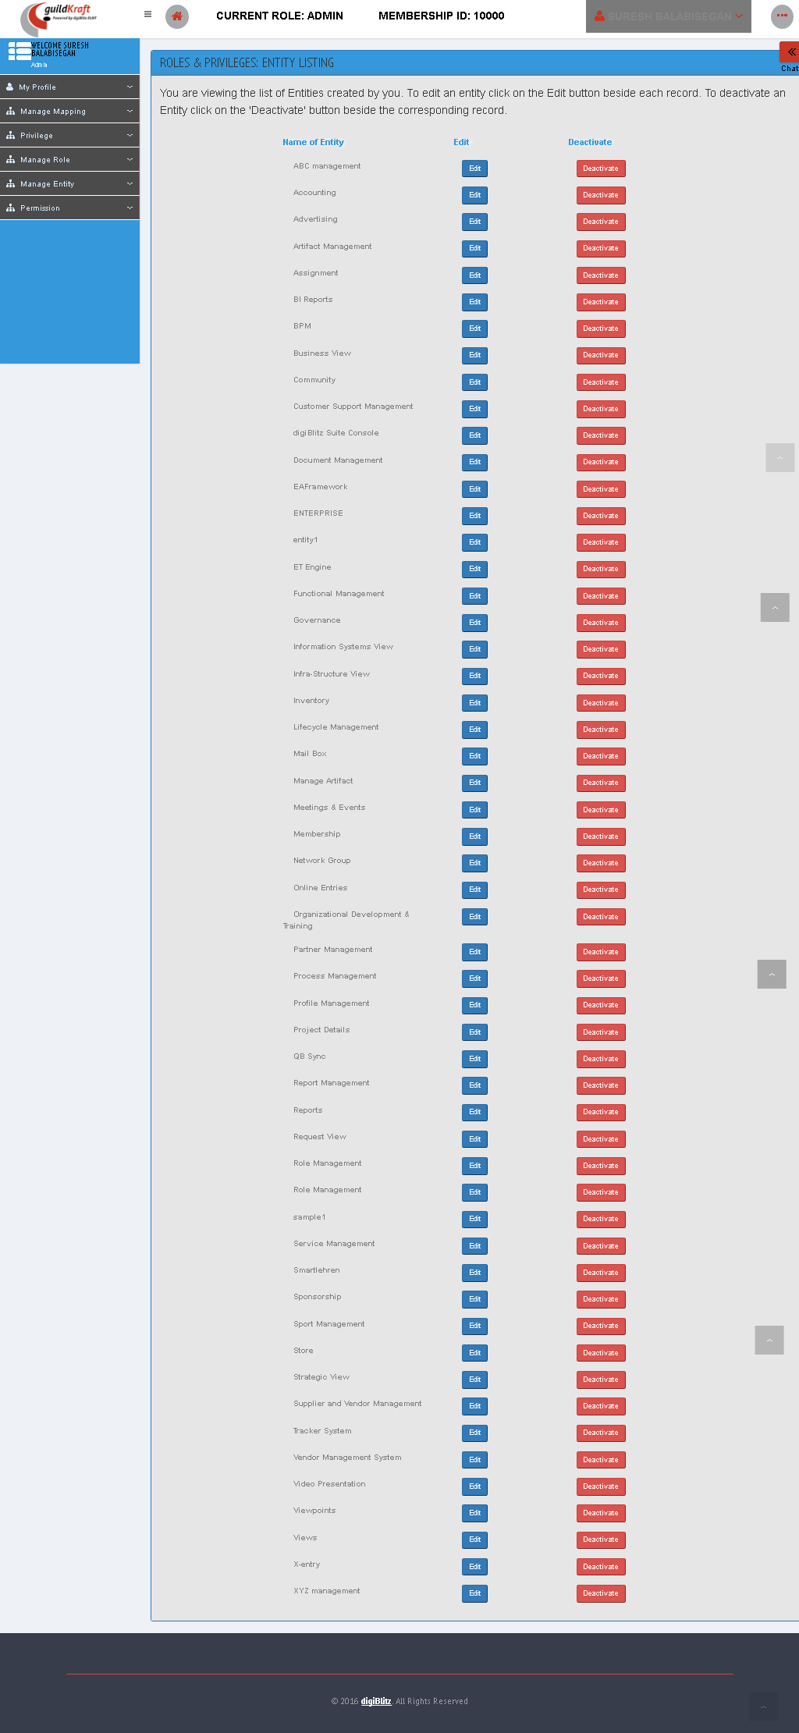

|  |  |  |
| --- | --- | --- |
| **Action** | **DB File** | **Table Name** |
| frmRolMListEntities.jsp file will call KlgRoleAction.javawith event nameentityList | GeneralDBAction.java will pass values and save in database table. | tblEntityMaster |

## Permission

### Create Permission

Create New Permissions for all the departments using our Online Services Dashboard right here.

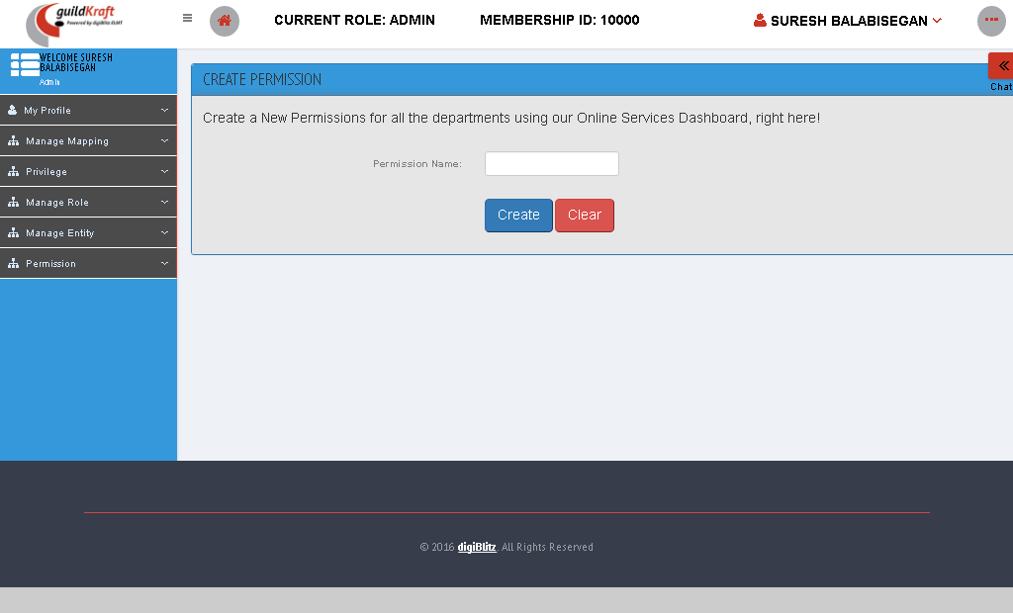

|  |  |  |
| --- | --- | --- |
| **Action** | **DB File** | **Table Name** |
| frmRolMCreatePermission.jsp file will call KlgRoleAction.javawith event nameinitCreatePerm | GeneralDBAction.java will pass values and save in database table. | tblPermissionMaster |

### Edit List of Permission

You are viewing the list of **Permissions** created by you. To edit a permission click on the **Edit** button beside each record.

|  |  |  |
| --- | --- | --- |
| **Action** | **DB File** | **Table Name** |
| frmRolMListPermissions.jsp file will call KlgRoleAction.javawith event namepermissionList | GeneralDBAction.java will pass values and save in database table. | tblPermissionMaster |

# Service Management

Service Management is a customer-focused approach to delivering information technology. ServiceManagement focuses on providing value to the customer and also on the customer relationship.

## Web Service

### BS Voting List

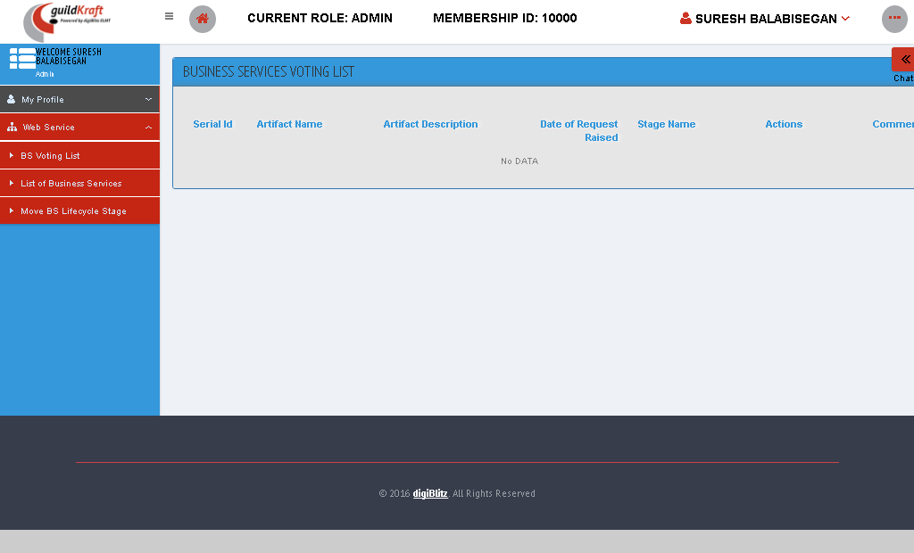

|  |  |  |
| --- | --- | --- |
| **Action** | **DB File** | **Table Name** |
| SystinetWSVotingList.jsp file will call KlgHpSystinetAction.javawith event nameWSVotingList | -- | -- |

### List of Business services

Here we can view the list of business services.

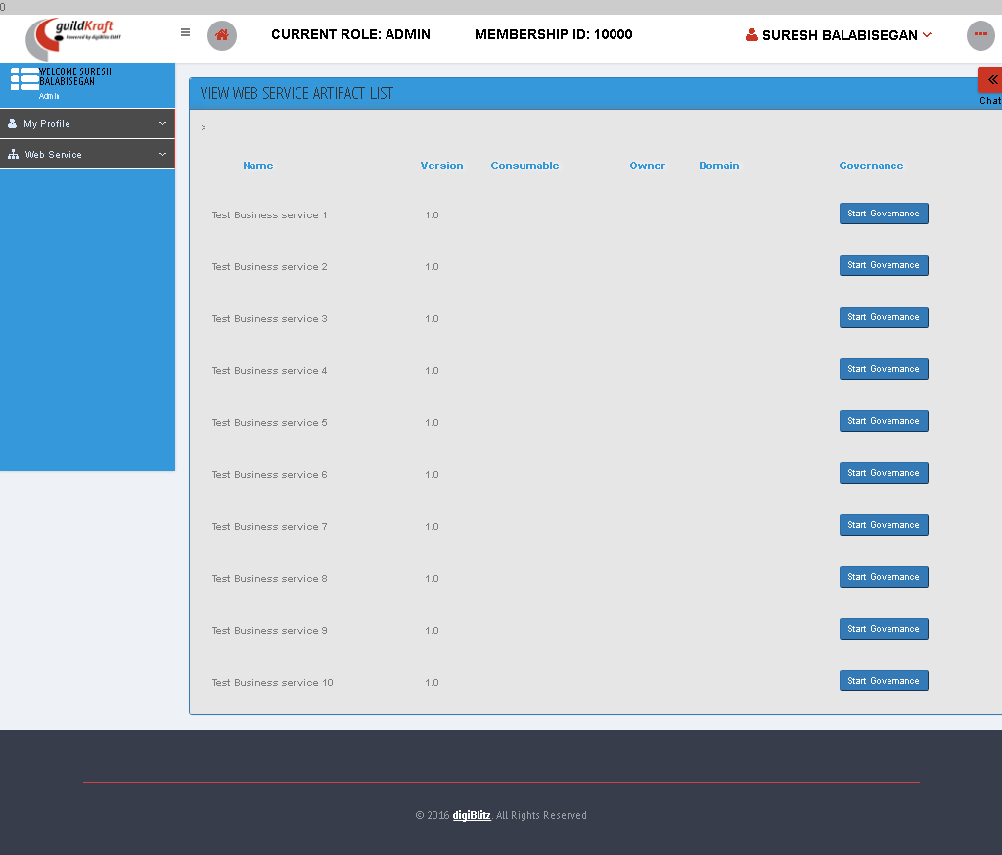

|  |  |  |
| --- | --- | --- |
| **Action** | **DB File** | **Table Name** |
| frmViewWSArtifacts.jsp file will call KlgHpSystinetAction.javawith event namecallArtifactWSList | -- | -- |

* On clicking the start governance

|  |  |  |
| --- | --- | --- |
| **Action** | **DB File** | **Table Name** |
| Systinetwebservice.jsp file will call KlgHpSystinetAction.javawith event namewebserviceProce | -- | -- |

### Move BS Life Cycle Stage

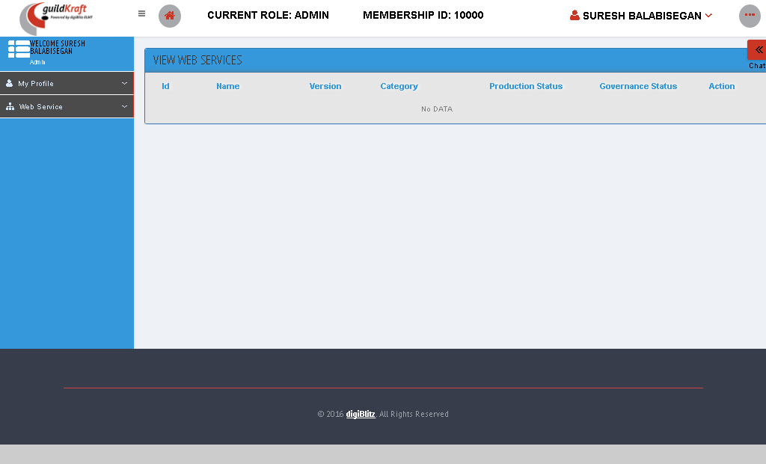

|  |  |  |
| --- | --- | --- |
| **Action** | **DB File** | **Table Name** |
| frmViewBundles.jsp file will call KlgHpSystinetAction.javawith event namecallBundles | -- | -- |